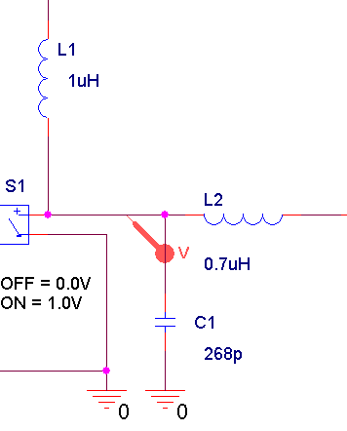
Above image was pasted from the clipboard. The image on the right is scaled to 40%

This is the same bitmap image but inserted as a .BMP file. The image on the right is copy/pasted from this document and scaled to 40%. The rendering is clearly better in this case

