BUSINESS COMMUNICATION

ASSESSMENT THREE

USER GUIDE

Presented by Yao Zhang

On 12TH JUNE 2005

Purpose
To purpose of the user guide is to tutor a simple end-user in the methodology of partition a computer hard-drive using Power Quest Partition Magic 8.0.

Aims
At the end of the tutorial, the end-user will be able to partition a hard drive on a personal computer

Audience
Target audience is simple end-users who have a basic knowledge of computer operations and applications.

Table of contents

Title page 1

Objectives 2

Table of contents 3

Introduction 4
Introduction

Part 3 formatting Partition Magic 8.0

At the end of this tutorial, you will be able to use partition magic to create a new partition on your hard-drive. This user guide will be invoice following parts:

- Open a partition magic
- Creating a new partition and separate into two parts
- Applying for the computer hardware-drive.

Step 1 Open a partition magic

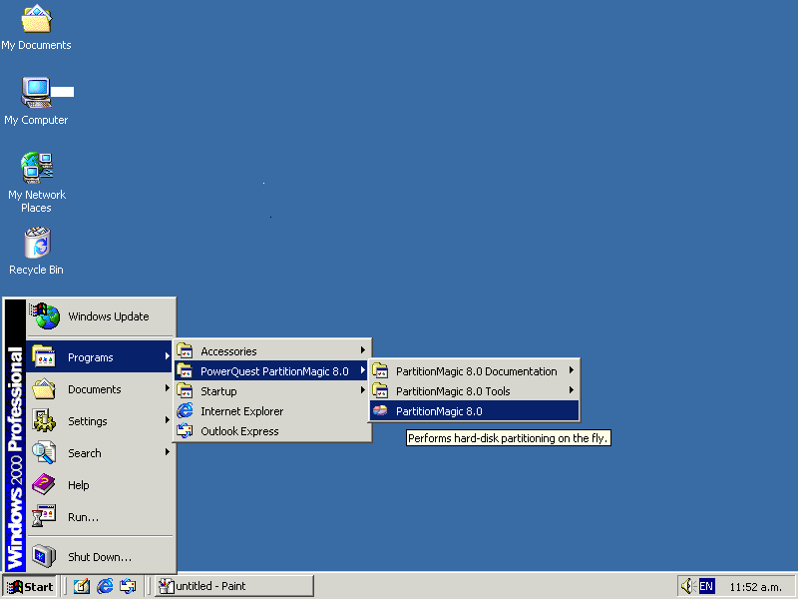

1.1. Select the Start menu
1.2. Select Program
1.3. Select Power Quest Partition Magic 8.0

1.4. Click on Partition Magic 8.0
Step 2 Select a new partition

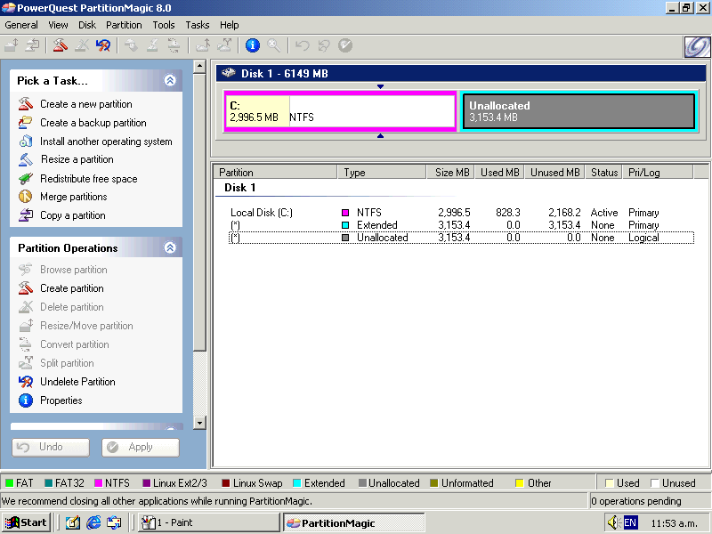
2.1 Click on Unallocated Partition
Step 3 Creating a new partition and separate into two parts

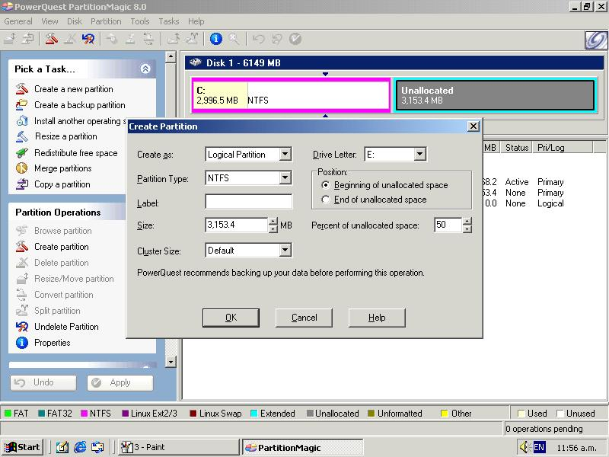
3.1 Click on Create partition

3.2 Select Logical Partition from Create as menu

3.3 Choose File system from the Partition Type menu

3.4 Type in 50% on percent of unallocated space

3.5 Click OK to finish

Notes for 3.2: there are two parts of selecting you can choose. They are logical partition and primary partition.

Notes for 3.3: you can choose Fat, Fat 32, NIFS, Linux Ext 2, Linux 3, Linux Swap, unformatted from the Partition type menu

Step 4 create another partition

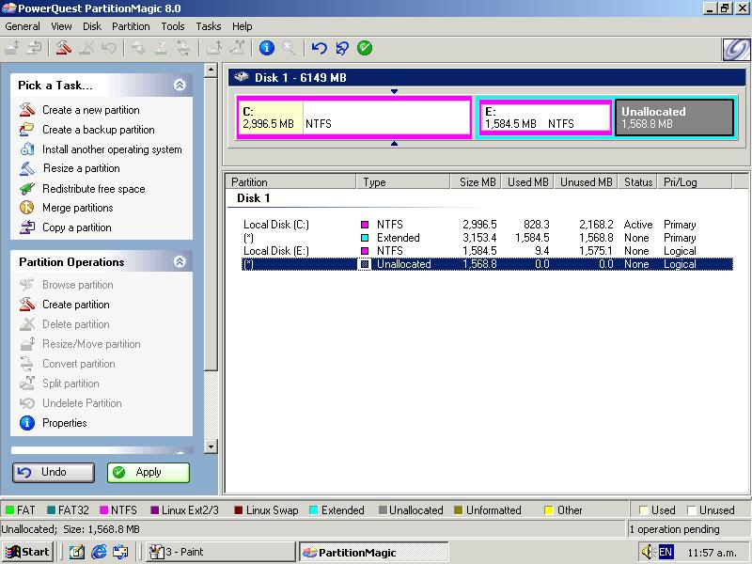
4.1 Select the Partition you want to create
Step 5 Format the partition

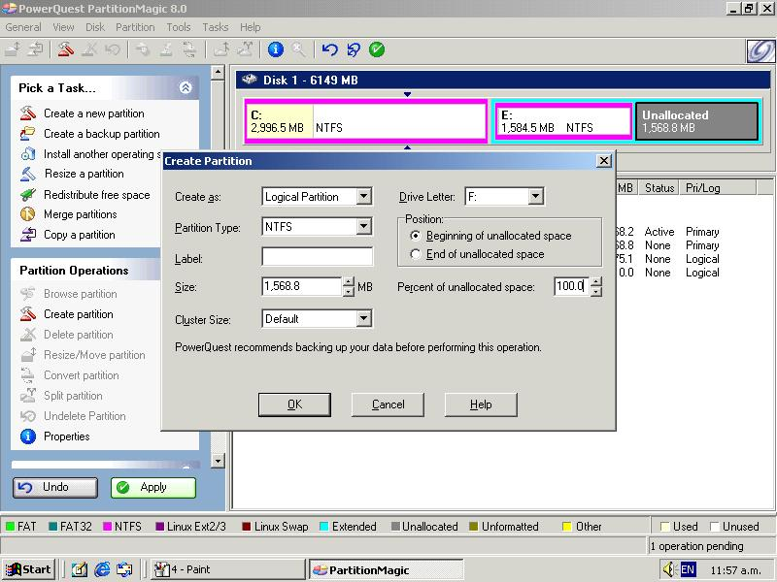
5.2 Select Logical Partition from Create as menu
5.3 Choose File system from the Partition Type menu

5.4 Click OK to finish

5.1 Click on Create partition

Notes for 5.2: there are two parts of selecting you can choose. They are logical partition and primary partition.

Notes for 5.3: you can choose Fat, Fat 32, NIFS, Linux Ext 2, Linux 3, Linux Swap, unformatted from the Partition type menu

Step 6 Apply for the changing of the Partition Magic

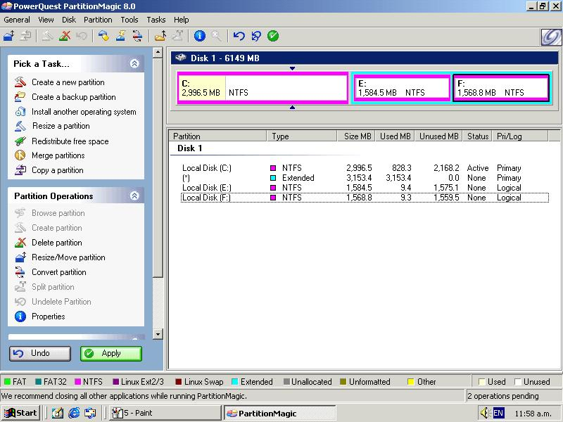

6.1 Click on Apply button, and appeal following box

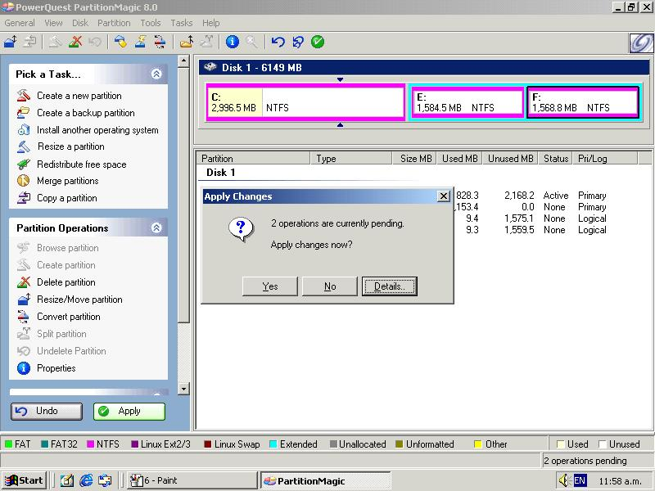

6.1 Click on Yes button

Step 7 Waiting for applying

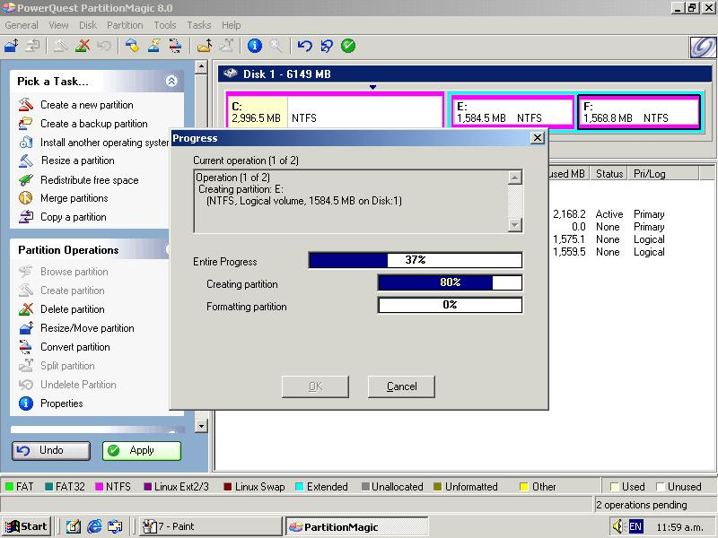

7.1 Show you the percentage that the system have done

7.2 Click on Cancel button to cancel the apply for the system

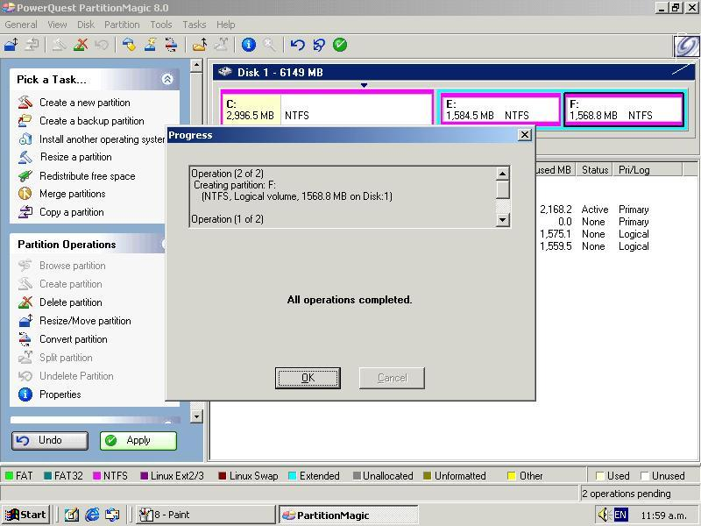
7.3 Click on Ok button to finish the program,

Glossary
Term or words | Definition
Logical | Based on earlier or otherwise known statements, events, or conditions; reasonable:
Primary | First or highest in rank, quality, or importance; principal.

