Chapter 1: Using OpenOffice.org Help
Different kinds of help are available in OpenOffice.org.
- Step-by-step instructions with full references via the Contents and Index selections of OpenOffice.org Help
- Help Tips that pop up next to the mouse pointer
- Extended tips with more detailed explanations than provided with Tips

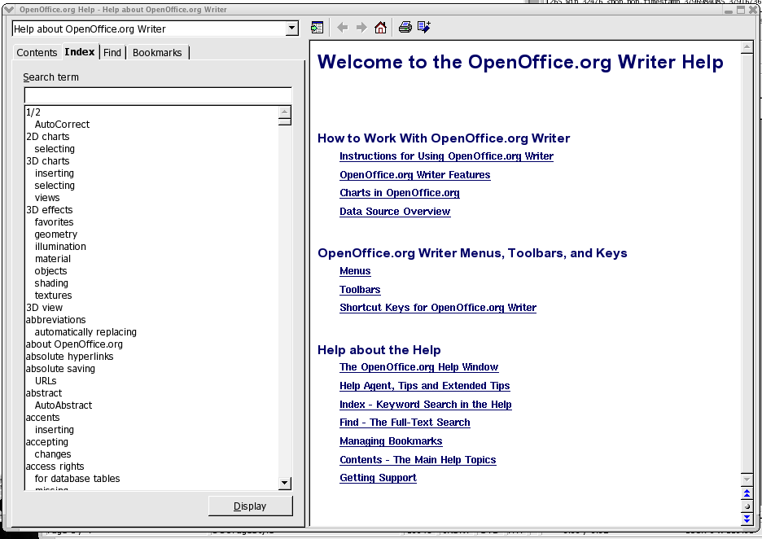

OpenOffice.org Step-by-Step Help
To access Help, use the Help menu item or click the Help buttons in the individual dialogues.

OpenOffice.org Help is context-sensitive. This means that, when Help is opened in Writer it is specific to Writer. Similarly, to get help about Calc, either first open a spreadsheet and only then look for help, or select Help for the specific module from the pull-down list at the top of the Help window. The pull-down list at the top of the Help window sets the selected module as the current section for searching.

Tips
Tips are on at installation by default and it is recommended that this feature should always be switched on. With Tips activated one can , for example, let the mouse pointer rest on an icon so that its name is displayed. Tips may also be seen in many other places in OpenOffice.org. For example, when scrolling through a table, the tip shows the row or column.

Turning tips on and off
Select Tools > Options > OpenOffice.org > General > Tips to enable or disable this feature.

Extended Tips
Switch on the Extended Tips during the first few weeks of OpenOffice.org usage. Enabling this option gives a brief description of each item on the screen when the mouse pointer is hovered over the item for a moment.

Turning extended tips on and off
Choose Tools > Options > OpenOffice.org > General > Extended Tips to turn extended tips on and off. The command is checked when the Extended Tips function is switched on.
Press Shift+F1 to turn Extended Tips on temporarily. The pointer turns into the Extended Tips pointer. Now see the Extended Tips for any element on the screen as the mouse pointer is moved. As soon as the mouse is clicked or a key pressed, the pointer returns to the normal mouse pointer.

Help Agent

When certain actions are performed in OpenOffice.org, the Help Agent automatically appears. This is a small window in a corner of the document.

The Help Agent normally remains visible for 30 seconds. When clicked, it is replaced by a help window providing some helpful advice about the current topic. If a Help Agent dealing with the same topic is repeatedly ignored or closed instead of being clicked, it does not appear again for this topic. Resetting the Help Agent restores it to the way it was when OpenOffice.org was first installed.

Turning the Help Agent on and off
- Choose Tools > Options > OpenOffice.org > General Help Agent to have the Help Agent appear. If the command is checked, the Help Agent is automatically displayed when certain actions are performed in OpenOffice.org.
- By accessing Tools > Options > OpenOffice.org > General from the main toolbar, activate, reset the Help Agent.

