Chapter 7: Databases and Data Sources
This chapter needs to be completely re-written to focus on the built-in HSQLDB database. Unfortunately the 1.9 development snapshots are incomplete at the time of writing. This chapter will therefore be updated frequently. Nonetheless, the data sources of various types may be still registered in OpenOffice.org. The following is 1.1.x but should provide some guidance.
NOTE for 2.0 dBase users: To open a connection to a dBase database, you must select the "Connect to an existing database" radio button and choose "dBase" from the drop-down list box. This should work even if you never had any dBase installed on your computer, because a basic dBase functionality is built in to %PRODUCTNAME. However, the controls should be renamed to give a better understanding. I would suggest "Connect to or open another data source", and rename the first control to "Create a new HSQLDB database". Changed this issue to be an enhancement request for an UI change in the dialogue.

Registering a Data Source
To register a data source for viewing and/or editing in OpenOffice.org, select Tools > Data Sources. This command opens the Data Source Administration dialogue, and is described in detail in Help.

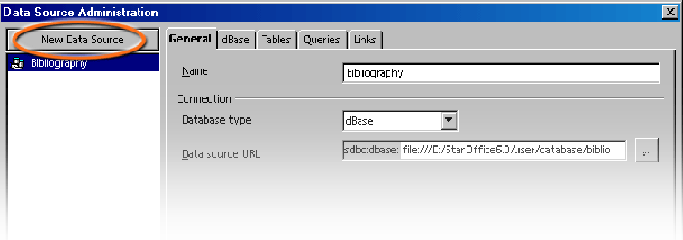
To continue registering a data source in OpenOffice.org, click New Data Source in the top left corner of the dialogue. Then choose the type of data source in the Database type pull-down list.
Select from the following database types (depending on the operating system):
Database type | Meaning
Adabas | A slightly scaled-down version of the well-known relational database system. Adabas is installed with its own setup program. (See http://www.softwareag.com/adabasd/)
JDBC | Link to databases contacted via a JDBC driver.
ODBC | Link to databases contacted via an ODBC driver.
dBase | files can be edited directly with the driver for direct access in the file system.
ADO | Link to databases contacted via the ADO driver.
Text | Register text files, such as comma-separated CSV files (read-only).
Spreadsheet | One can register OpenOffice.org Calc and MS Excel spreadsheets (read-only).
Address Book | This address book driver allows the user to register the system address book or another address book source (read-only). It also ensures that data fields are correctly assigned to the templates provided with OpenOffice.org, in form letters, for example.
How to register a new data source of a particular database type is explained in Help.
Use the data source icon on the Main Toolbar or select View > Data Sources to view and, if necessary, edit the data sources via spreadsheets and queries. At the upper edge is a window which can be shown or hidden, moved around and/or docked to another edge.
In the Data Sources view, on the left is the Data Sources Explorer and, on the right, the table view.

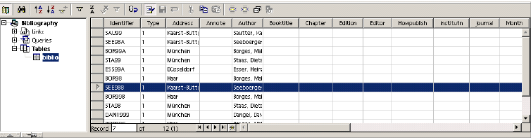
In the Data Sources Explorer on the left open a data source by clicking the plus sign in front of its name. This opens the subordinate “containers” for links, queries and tables. when a query or table is clicked, its contents appear in the table view on the right.
One can create new tables, queries and links by clicking the relevant entry in the Data Sources Explorer and right-clicking with the mouse to open the context menu.

AddressBooks

Registering an AddressBook
One of the many data sources in OpenOffice.org is an external addressbook. The contents of the data fields are then available, in fields and controls for example. An address book which may be already in use in the system environment is such a data source. For example, an LDAP server, Evolution or a Mozilla/Netscape address book.
In the templates and Wizards from OpenOffice.org, fields are used for the contents of the addressbook. When these fields are activated, the general fields used in the templates are automatically replaced with the actual fields used in the local system.
In order to call the dialogue by following the steps listed below.

Using the Wizard to import an AddressBook
Select File > Wizard > Address Data Source. This Wizard is described in Help.

Manually Registering an Existing Address Book
- Choose File > Templates > Address Book Source. The Templates: Address Book Assignment dialogue appears.

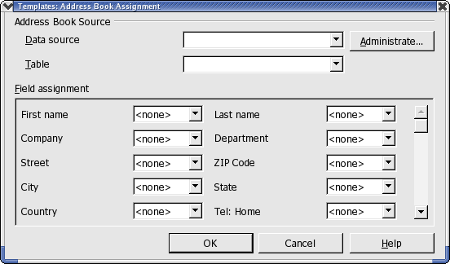
- In the Data source box, select the system address book or the data source to use as the address book.
If the system address book is not yet registered in OpenOffice.org as a data source, click the Administrate button. This opens the Administrate Data Sources dialogue, in which the address book can be registered as a new OpenOffice.org data source. Read further how to do this in the next section, System address book as data source.
- In the Table box, select the database table to use as the address book.
- Under Field assignment, set the fields for company, department, first name, et cetera to the actual field names used in the address book.
- After this point, the addressbook is recognized as an OpenOffice.org address book data source.

System Address Book as Data Source
- Select File > Templates > Address Book Source.
- Click the Administrate button to call the Data Source Administration dialogue (see also instructions above). Another way to call the same dialogue is to choose Tools > Data Sources.
- Click the New data source button.

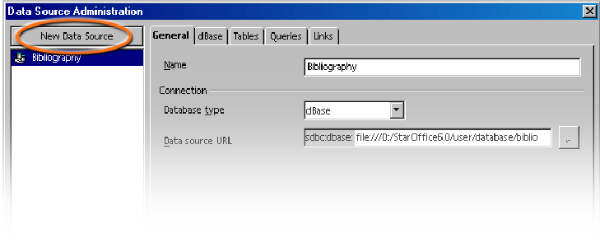
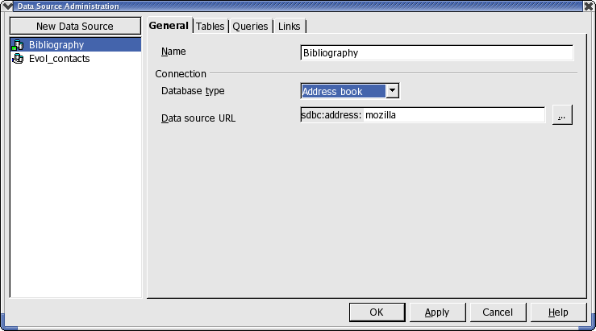
- Under Database type choose the Address book entry.
- Click the button to call the Data Source dialogue.
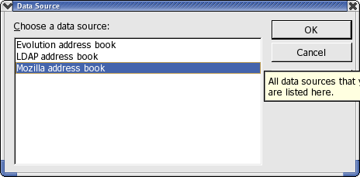
- Select the data source.
- Click OK.
If “LDAP address book” is selected, the Data Source Administration dialogue will display a LDAP tab page, where one can enter the LDAP server and its parameters.
- Go to the Tables tab page. Check the tables that should be visible in OpenOffice.org.
- On the General tab page, enter a name for this data source in the Name box.
- Close the dialogue by clicking OK.

Importing Data Into OpenOffice.org
If one is exchanging data with a database that does not have an ODBC link and which does not allow dBase import and export, it is often possible to exchange the data via a common text format.

Importing and Exporting Data in Text Format
To exchange data in a text format use the Calc import/export filter.
- Export the desired data from the source database in a text format. The CSV text format is highly recommended since it separates data fields by using commas and records by inserting line breaks.
- Open the data with the “Text CSV” file filter. Select this file filter in the Open dialogue in the Files of type list box. Select the file and click Open.
- This displays the Import text files dialogue. Here users can decide which data to include from the text document.
Once the data is in a Calc spreadsheet, it can be edited as desired. Users have two ways of saving the data in a OpenOffice.org data source:
- Save the current OpenOffice.org Calc spreadsheet in dBase format in the folder of a dBase database. To do this, choose File > Save As, then select the File Type “dBase” and the folder of the dBase database.
- Check the data range in the OpenOffice.org Calc spreadsheet and drag the area into a table container in the data source view. The table container is the area on the left of the database explorer that is designated “Tables” (see diagram). An Wizard is started automatically.

Exporting in CSV Text Format
The current Calc spreadsheet can be exported in a text format which can be read by many other applications.
- Choose File > Save as.
- In Save as type select the filter “Text CSV”.
- Enter a file name.
- Click Save.
- This opens the Export of text files dialogue, in which to select the character set, field delimiter and text delimiter.
- Click OK. A warning informs users that only the active sheet was saved.

Database Tables
This section describes how to create a new database table via the OpenOffice.org design view.

Table Design
Open the data source browser (F4). Open a data source by clicking the plus sign in front of the name. The tables container, called “Tables” can now be seen. Open the table container and click a table. Right-click the table name to open the context menu. Choose New Table Design to create a new table.
In the Design view, create the fields for the table.
- Enter new fields from top to bottom row-by-row. Click the cell at the far left and enter a field name for each data field.
- In the adjacent cell to the right, define the field type. When one clicks in the cell, a field type can be selected from the drop down list box
Note: Each field can only accept data corresponding to the specified field type. It is not possible to enter text, for example, in a number field. Memo fields in dBase III format are references to internally-managed text files which can hold up to 64KB text.
If the user wishes, an optional Description for each field can also be entered. The text of the description will appear as a tip on the column headings in the table view.

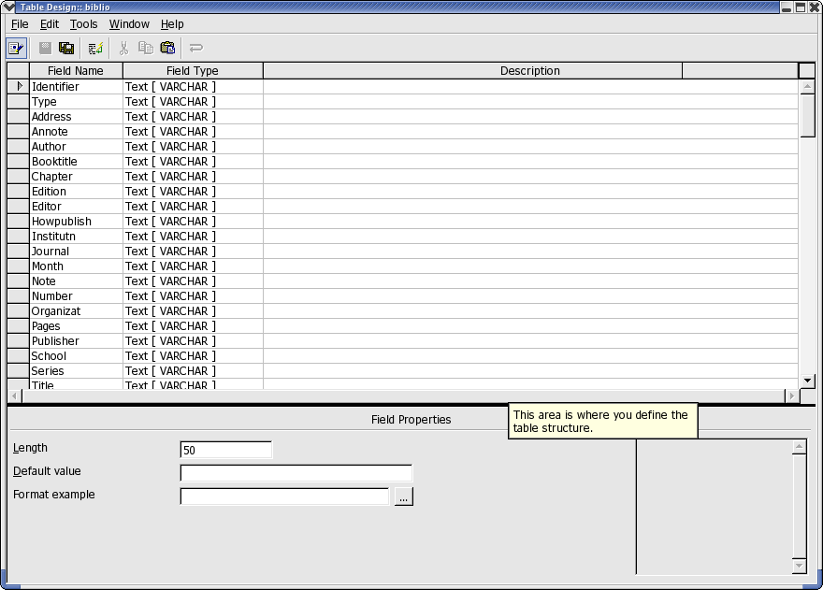

Field Properties
Enter properties for each selected data field. Depending on the database type, it is possible that not all input facilities will be available.
In the Default box, enter the contents that should be entered for every new record. This can, of course, be subsequently modified.
In the Entry required box, specify whether or not the field may remain empty.
No matter which field type, a list box provides the available types
Note: To change the name or type of a data field after-the-fact, please note that the table itself may not be opened during this modification; only the design view may be opened.

Form Design
Any OpenOffice.org document can be expanded into a form. One simply adds one or more form functions.

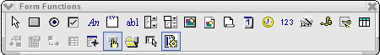
The Form icon on the main toolbar opens a floating toolbar by long clicking the icon. This floating toolbar contains the basic functions to edit a form. One will find again many of these functions in the object bar if a form element is elected in the document.
If one clicks a form element in the editing mode, Object bar, Format menu commands and context menus offer context-sensitive editing functions. In the form design, the designer can include controls, Apply properties to them, define Form properties and Define subforms.
The Form Navigator is useful in designing a form. Click the icon on the object bar or the floating toolbar.
Clicking the Open in Design Mode icon controls whether the form document can be saved such that it always opens in editing mode or not.
If an error is received when assigning the properties for the objects contained in the form (for example, when assigning a non-existent database table to an object), a corresponding error message will be seen. This error message can have an More button. If one clicks More, then a dialogue displaying clear information, warnings and errors about the current problem is displayed.

Forms in OpenOffice.org Tutorial
In some situations, a user may want to create a document that contains some fixed text, but allows others to enter some items and perhaps take some actions on those items. Such a document is called a form, analogous to the preprinted forms everyone has filled out dozens of times. One can create custom forms in most of the OpenOffice.org applications; forms that one creates without using the Form Wizard do not have to connect to a data source (though they can -- see below). If the form isn't connected to a data source, any information the user enters is simply saved with the form. (This method is handy when sending a form to a group of people for them to fill out and return.) Writer (text and html), Calc, Impress, and Draw all support forms.
To create a form, start with a document in the appropriate application. Open the Form Controls toolbar from View > Toolbars. (In some cases, you may have to add the button to the toolbar first.) The Form Functions toolbar (Figure 1.) appears. The toolbar includes an assortment of controls you can put on your forms, as well as buttons for managing the form as a whole.

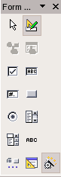Figure 1. Use the Form Controls toolbar to add controls to a document to create an input form.
As with the other toolbars , docking it is an option. When designing a form involving a number of controls, this can be a very handy feature.
The items in the first row of the Form Functions toolbar are controls. The second row contains a variety of options for working with forms and controls. Most of them are discussed later in this article.
To add a control to a form, click it on the Form Functions toolbar. The cursor changes to crosshairs. Click and drag where you want to place the new control.
Once you choose a control from the Form Functions toolbar, you can continue dropping that type of control. To turn off that control type, either click another control to select it, click the form itself without dragging, click the same control on the Form Functions toolbar, or click the Select button on the Form Functions toolbar.

Available controls
OpenOffice.org offers a wide variety of controls from the general to the specific. Table 1 lists them.

Control | Use
Push Button | Used to execute commands.
Option Button | Used, with one or more other option buttons, to allow choice among mutually exclusive options. See Group Box.
Check Box | Used for on/off or yes/no choices.
Label Field | Used to provide labels for other controls. Doesn't accept input.
Group Box | Used to visually combine several controls, as well as create groups of option buttons.
Text Box | Used to enter free-form text.
List Box | Offers a list of choices. User can choose one or, in some cases, several.
Combo Box | Offers a list of choices. User can choose one or enter a new value.
Image Button | Used to execute commands; has a picture rather than a text caption.
Image Control | Displays a picture on the form.
File Selection | Allows user to point to a file.
Date Field | Used to enter a date. Supports up arrow and down arrow to change portions of the date.
Time Field | Used to enter a time. Supports up arrow and down arrow to change portions of the time.
Numerical Field | Used to enter numbers. Optionally has spinner arrows to change value with the mouse.
Formatted Field | Used to enter text applying formatting codes as in Calc.
Currency Field | Used to enter monetary values. Supports up arrow and down arrow to change value. Optionally has spinner arrows to change value with the mouse.
Pattern Field | Used to enter text, applying a specific formatting pattern.
Table Control | Used to display data from a table or query in a grid format.
Table 1. The selection of controls available for use in forms is extensive. Controls are shown here in the order in which they appear on the Form Functions toolbar.

Customizing controls
With some controls, you can simply drop them on a form and use them as is. That works for things like a Text Box, Date Field, or Time Field. With others, though, once you add the control, you need to provide additional information. Even for those that work immediately, you may want to customize their appearance or behaviour.
To set up a control, click it to select it (green sizing handles appear around the edges), and then choose Control... from the shortcut menu, Format | Control... from the menu, or Control Properties... from the Form Functions toolbar. The Properties dialogue for the control appears. The contents of the Properties dialogue vary, depending on the type of control.
Just as the contents of the Properties dialogue vary with the type of control, so does what you need to do to get it working. Table 2 lists some of the items common to a number of controls.

Table 2. The Properties dialogues for the various controls let you set them up as you want. The properties shown here are common to a number of the controls.

Property | Meaning
Name | Identifies the control. In some cases, including option buttons, assigning the same name to several controls turns them into a group.
Label | The caption that appears on the control.
Label field | Links the control to a Label Field control. Used for controls (like Text Boxes) that don't have their own label.
Enabled | Determines whether the control is available to the user.
Tabstop | Determines whether the control is part of the tab order, that is, whether the user can reach it by tabbing from one control to the next.
Order | Determines the position of the control in the tab order.
Character set | Specifies the font characteristics for the control.
Default value | Specifies the initial value displayed in the control.
Background colour | Specifies the background colour for the control.
Help text | Specifies the tooltip for the control.

Individual controls have additional properties related to their purpose. For example, a Check Box has a Default Status property that determines whether it's initially checked and a Text Box has a MultiLine input property that determines whether you can put multiple lines of text into the control.
Some controls need certain properties specified in order to be useful. In some cases, wizards are available to help you specify the necessary information. The next few sections consider some of those controls.

Creating a group of option buttons
Option buttons (also known as "radio buttons") let you choose one item from among a mutually exclusive group.
There are a couple of ways to set up a group of option buttons, but the easiest is to make sure the wizards On/Off button on the Form Functions toolbar is on. (When it's on, it has a thin border around it.) Next, put a Group Box on the form. When you do so, the wizard Group Element appears to guide you through the creation of an option group. On the first page, specify the options to appear in the group. For each, type it in, and then press Enter or click the >> button. When all the items have been entered, click Next.
On the second page, indicate which item in the list should be initially selected. You can also specify no item be selected. Click Next to go to the third page, which allows you to associate a value with each item. Specifying a value is particularly significant when data on the form is tied to a data source. (See "How do I associate a form with a data source?" below.) To specify the value for an item, click that item in the list, and then type the appropriate value in the text box. By default, character items are associated with numbers starting from 1. Click Next to move to the Database Field page.
The Database Field page lets you automatically save the user's choice to a field in a table. If you prefer, you can specify that the value is available only in the form. Click Next to reach the final page of the wizard. On this page, you specify a name for the option group-the name appears as a caption on the surrounding box. Click Create to exit the wizard and create the option group.

Setting up a combo box
Like an option group, a combo box lets a user choose from among a mutually exclusive group of options. However, a combo box usually takes up less space than an option group and also allows the user to type in a value not on the list. Again, the easiest way to configure a combo box is to use the wizard.
Make sure the wizard's On/Off button is on and put a combo box on the form. The wizard Combo Box opens. Combo boxes always draw their contents from a data source. If you haven't associated a data source with the form yet (either by using it for another control or by explicitly doing so -- see "How do I associate a form with a data source?" below), the first page that appears lets you choose a data source and table for the form. Click Next to move to the Table Selection page once you choose a data source.
If the form already has a data source, the wizard opens on the Table Selection page. The data you display in the combo box doesn't have to come from the table the form is linked to, and in fact, often comes from another table that contains look-up information. Click Next once you choose the table that contains the list of items to appear in the combo box.
The Field Selection page lists the fields from the specified table. Choose the one to use in the combo box. The specified field not only provides both the list of items the user sees, but also the value to store based on the user's choice. (With a combo box, there's no way to display data from one field, but store the value from a different field. List boxes do provide that option; see the next section "How do I set up a list box?") Click Next to move to the Database Field page to indicate where to store the user's choice. Click Create to create the combo box.

How to set up a list box
A list box has a lot in common with a combo box, so it's not surprising the method for specifying a list box isn't much different from that for a combo box. Like a combo box, the easiest way to set up a list box is with the wizard.
A list box must be tied to data from a data source. It draws data from a table and stores its results in a table. Usually, the data comes from one table (a look-up table) and the results are stored in another table. Unlike a combo box, a list box can store data from a different field than is displayed.
As with a combo box, if no data source is associated with the form, the first page of the wizard lets you choose one. Once you finish and click Next, choose the table that contains the data to appear in the list. After clicking Next, the process continues as with a combo box. On the next page, you specify the field to appear in the list box.
At this point, list boxes part company from combo boxes. When you click Next, you reach the Field Link page of the wizard. On this page, you link a field from the form's data source table to a field from the list box's table. The link indicates that when the user makes a choice from the list box, the value of the specified field of the list box's table is copied to the specified field of the form's table.
When you click Create, the list box is created. By default, it's a drop-down list that looks like a combo box, but doesn't allow the user to type in a new value. To change it to a regular list box, with a number of items displayed at once, choose Control from the list box's shortcut menu or with the list box selected, choose Control Properties... from the Form Functions toolbar or Format | Control from the menu. Change the Drop-down property to No.
Do any other controls have an wizard?
Most of the remaining controls are simple enough to configure that no wizard is needed or provided. However, the Table control is fairly complex. It provides a grid type display of the data in a table, along with navigation controls. The Table Element wizard lets you choose which fields display and in what order.

Attaching a data source to a form
As described in the last few sections, using the wizards for some kinds of controls requires you to specify a data source for the form. However, sometimes, you may want to do so even if you're not creating a combo box or list box.
To link a data source to a form, choose Form Properties... from the Form Functions toolbar. Choose the Data tab (Figure 2), and then choose a Data Source from the drop-down list. Once you choose a data source, choose a table from the Content drop-down list. You can also specify a query or write a SQL command directly to provide the form data by changing the Content Type, and then specifying the appropriate Content.

Associating data with a field

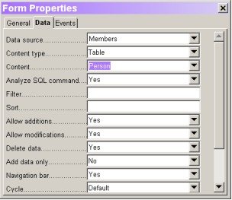
Figure 2. The Data tab of the Form Properties dialogue lets you specify the data source for a form.
Once the form has a data source, you can link fields to controls. To do so, add the control to the form, and then open its Properties dialogue. On the Data tab, choose a field from the Data Field drop-down list.
Be aware that when you link a field to a control in this way, every time you use that control, changes you make are stored in the actual data source.

Activating form controls in a document
While editing a data source is one use for forms, you may want to use a form for other things. For example, you might want to add a button to a spreadsheet to perform a calculation or to a presentation to run a video clip.
Each control has a number of events associated with it. An event is something that occurs due to user action. For example, when the mouse is moved, an event fires each time it enters the area of a control and each time it leaves that control's area. Typing a character also fires an event. So does clicking the mouse.
The Events tab of the Properties dialogue for each control lists the events available for that control. Figure 3 shows the Events tab for a text box. For each event, you can specify what happens when that event fires. You do so by clicking the ellipsis button next to the event, and then pointing to the OpenOffice.org macro that performs the desired action.

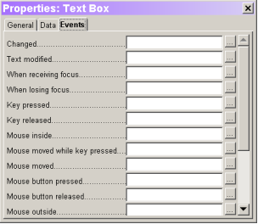
Figure 3. Every control has a number of events that occur as the user interacts with it. You can associate actions with events.
The form itself has events, as well. To access these, click the Form Properties... button on the Form Functions toolbar and go to the Events tab. As with control events, you can assign a macro to any form event.

How to use the form
Once you finish laying out a form, you can "run" it by clicking the Design Mode On/Off button on the Form Functions toolbar. When design mode is off, the controls operate as you would expect -- you can select and clear check boxes, open combo boxes and drop-down lists, and so forth.
Ordinarily, when you open a saved form, it automatically has design mode off. So, a user opening a form you supply sees it as they would expect. (Be aware, however, that a user can turn design mode on and change the form.) If you're working on a form and want it to open in design mode each time, click the Open in Design Mode button on the Form Functions toolbar before saving the form.
When a form linked to a data source has design mode turned off, the database bar appears at the bottom of the form.
OpenOffice.org doesn't have a mechanism to prevent users from changing forms to Design mode. In Microsoft Office, you can protect a form document and give it a password to prevent users from seeing inside.

Searching in Tables and Form Documents
In spreadsheets and documents in which form functions are used, one can click the Find Record icon to open a dialogue to find any text and values. Use the icon at the bottom of the form bar, not the similar looking icon on the main toolbar on the left.
Searches may be in all data records or in all data fields. Select whether the text must be at the beginning, end or any location of the data field. The ? and * wildcards can also be used, as in the Find and Replace dialogue. Additional information about the database search function can be found in Help.

Searching With a Form Filter
- Open a form.
- Switch on the design mode.
For example, open an empty text document and press F4, open the bibliography database table biblio in the data source view. While pressing Shift+Ctrl, drag a few column headers into the document so that the form fields are created there.
- Turn off the design mode. To do this, open the Form Functions floating toolbar and click the Design Mode on/off icon, so that it does not appear to be pressed.
- On the form toolbar, click the Form-based filters icon. The current document is displayed with its inserted form functions as an empty edit mask. At the bottom edge will be the filter bar.
- Enter the filter conditions into one or several fields.
When formulating filter conditions, various operators and commands are available. Apart from the relational operators there are SQL-specific commands that query the content of database fields. If these commands are used, in the OpenOffice.org syntax, OpenOffice.org automatically converts these into the corresponding SQL syntax. SQL commands can also be entered directly. The following tables give an overview of the operators and commands:

Operators
Operator | Meaning | Condition is satisfied if...
= | equal to | ... the content of the field is identical to the indicated expression. The operator = will not be displayed in the query fields. If a value without any operator is entered, the operator = will be automatically adopted.
<> | not equal to | ... the content of the field does not correspond to the specified expression.
> | greater than | ... the content of the field is greater than the specified expression.
< | less than | ... the content of the field is less than the specified expression.
>= | greater than or equal to | ... the content of the field is greater than or equal to the specified expression.
<= | less than or equal to | ... the content of the field is less than or equal to the specified expression.

Commands
OpenOffice.org command | SQL command | Meaning | Condition is satisfied if...
IS EMPTY | IS NULL | is null | ... The field name is empty. For Yes/No fields with three states, this command automatically queries the undetermined state (neither Yes nor No).
IS NOT EMPTY | IS NOT NULL | is not empty | ... the field name is not empty.
LIKE (placeholder * for any number of characters placeholder ? for exactly one character) | LIKE (% placeholder for any number of characters Placeholder _ for exactly one character) | is an element of | ... the data field contains the indicated expression. The (*) placeholder indicates whether the expression x occurs at the beginning of (x*), at the end of (*x) or inside the field content (*x*).Either the SQL % character or the familiar (*) file system placeholder can be entered as a placeholder in SQL queries in the $[officename] interface. The * or % placeholder stands for any number of characters. The question mark (?) in the $[officename] interface or the underscore (_) in SQL queries is used to represent exactly one character.
NOT LIKE | NOT LIKE | Is not an element of | ... the field name does not contain the specified expression.
BETWEEN x AND y | BETWEEN x AND y | falls within the interval [x,y] | ... the field name contains a value that lies between the two values x and y.
NOT BETWEEN x AND y | NOT BETWEEN x AND y | Does not fall within the interval [x,y] | ... the field name contains a value that does not lie between the two values x and y.
IN (a; b; c...) Note that the semicolons are used as separators in all value lists! | IN (a, b, c...) | contains a, b, c... | ... the field name contains one of the specified expressions a, b, c,... Any number of expressions can be specified, and the result of the query is determined by an Or link. The expressions a, b, c... can be either numbers or characters
NOT IN (a; b; c...) | NOT IN (a, b, c...) | does not contain a, b, c... | ... the field name does not contain one of the specified expressions a, b, c,...
= TRUE | = TRUE | has the value True | ... the field name has the value True.
= FALSE | = FALSE | has the value false | ... the field name has the value false.

Examples of Usage
Command/Operator | Result
='Ms.' | returns field names with the field content “Ms.”
LIKE 'H?llo | returns field names with field content such as “give” and “gave”
LIKE 'S*' | returns data fields with field contents such as “Sun”.
BETWEEN 10 AND 20 | returns field names with field content between the values 10 and 20. (The fields can be either text fields or number fields).
IN(1; 3; 5; 7) | returns field names with the values 1, 3, 5, 7. If the field name contains an item number, for example, create a query that returns the item having the specified number.
NOT IN ('Smith') | returns field names that do not contain “Smith”.

Remarks about possible wildcards and operators can be found in the Help > Contents > Index > Search term > queries; designing. If filter conditions are entered into several fields they will be joined by the Boolean AND.
If on the filter bar, the Apply filter icon is clicked, the filtering is performed in the database. The form bar is seen and the habitats navigated. By clicking the Close button in the filter bar, the form will be displayed without a filter.
In the form view, click the Apply Filter icon to change to the filtered view.
The filters that have been set can be removed by clicking on the icon Remove Filter/Sort.
If several filter conditions are to be connected with OR, click the Filter Navigation icon on the filter bar. The dockable Filter Navigator window appears.

The filter conditions that are set appear in the Filter Navigator. As soon as a filter is set, at the bottom of the Filter Navigator notice a blank filter level in which “Or” can be selected by clicking on it. Once the blank filter level is selected, enter other filter conditions in the form. These conditions are linked by Boolean OR to the previously defined conditions.
The context menu can be called for every entry in the Filter Navigator. Edit the filter conditions in this area directly as text. In addition users can also select the filter conditions (SQL: “Is Null” or (SQL: “Is not Null”) to check if a field has content or not. It is also possible to delete the entry by using the context menu.
Filter conditions can also be moved within a form in the Filter Navigator by Drag&Drop or copy them by holding down the Ctrl Key.
While designing a form, set the “Filter proposal” property for each text box in the Data tab of the corresponding Properties dialogue. These fields allow subsequent searches in the filter mode, selections via a pull-down list all the summarized information contained in such fields. The field contents can also be easily selected using the AutoComplete function. Please note however, that this function requires a lot of memory space especially when used in large databases and should, therefore, be used sparingly.

