The following screenshot is taken from an actual odt file. For clarity's sake, I have shown the button on the toolbar that triggers the “Arrowheads” toolbar.
The toolbar contains two identical columns of different shapes (meant for the opposite ends of the selected line.)
Logically, it should highlight the actual end-shapes selected for the selected line. But it does not. The screenshot shows that the highlight is on only the top left cell (it has a thick border around it).
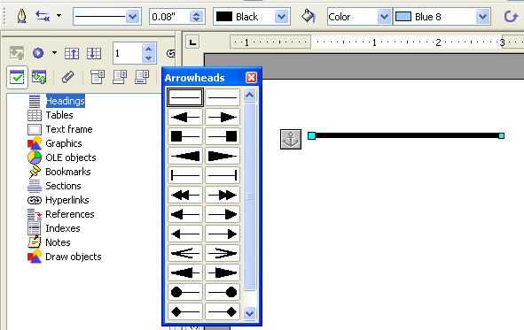
Compare the figure above with another screenshot given below. Here, I have changed the shape of both ends of the line. Yet, the Arrowhead does not highlight the selected shapes. Only the top-left cell is highlighted, as before. I have encircled the shapes that should have been highlighted.


