Doubleklick on the picture an press „original Size“
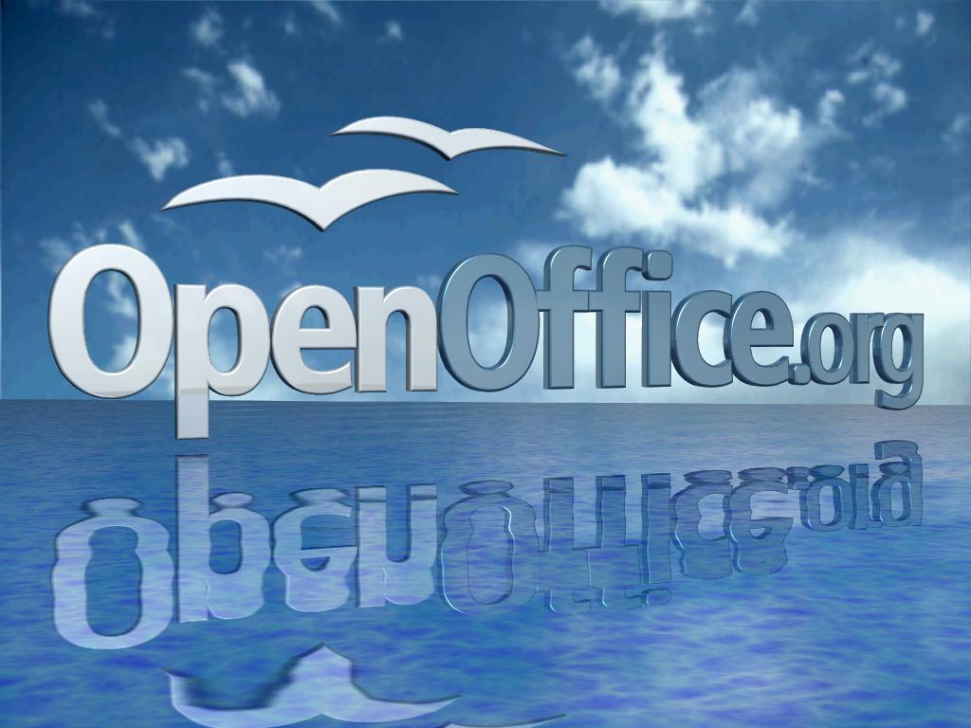
picture Size should not change, es it actually has the maximum allowed size. Instead it is scaled to the page size and the ratio is lost.
Interesting .. if you choose „relative" width , ratio is kept -> this should be the default behaviour no matter if „relative“ is enabled or not. (if original size is to large for the page, the picture should be scaled to the maximum available size, but ratio should be kept)

