Chapter 2: Working With OpenOffice.org
OpenOffice.org is reasonably intuitive but is sufficiently different to other suites that a period of familiarization required before use is fluid and effective. This chapter starts with a general explanation of the most common control features in OpenOffice.org, such as toolbars, floating toolbars and dockable windows. This is followed by information on functions that can be used in most of the program modules of OpenOffice.org.

The User Interface
OpenOffice.org provides not only the usual control elements found in other applications, such as menus and icons, but a host of other special features besides. For example, many of the special OpenOffice.org features can be accessed via a context menu, opened by right-clicking on the selected objects. Other user-friendly functions are available by dragging and dropping with the mouse.

Starting OpenOffice.org
Under Windows® , once the program is installed (see the separate setup guide that is part of the download image and is on most CDs),the OpenOffice.org group should be on the Windows® Start menu under Programs. Under *NIX, its location depends upon where it is installed and which window manager is used; however, under Gnome and KDE, the OpenOffice.org group may be found in the Main menu. To create a blank text document in Writer, click Text Document. For a blank spreadsheet in Calc, click Spreadsheet, and so on.

NOTE: Under Windows®, the OpenOffice.org Quickstarter should be in the Windows® task bar. The icon may be double-clicked or right-clicked to open its context menu. Right-clicking Quickstarter opens a submenu from which a new, blank document can be opened. Double-click Quickstarter to open the Templates and Documents dialogue.

The OpenOffice.org Writer Window
A text document is displayed and edited in the Writer window. Spreadsheet, presentations or drawings are displayed in very similar windows, except the menus and icons change automatically depending on the context.

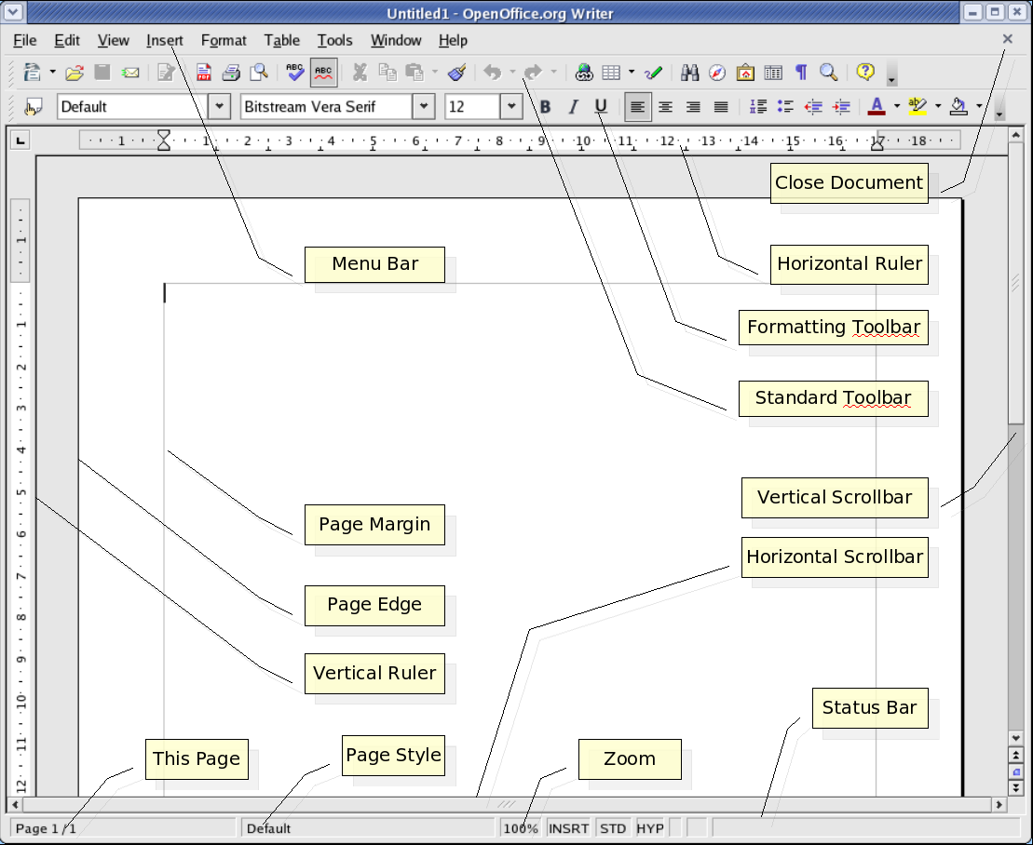

Toolbars in the OpenOffice.org Window

The Title Bar
The title bar shows the name of the program, OpenOffice.org, and usually the file name of the current document. If a document title is entered in File > Properties > Description , this title is displayed rather than the file name.

The Menu Bar
At the top of the OpenOffice.org window, immediately under the title bar, is the menu bar. Point with the mouse to a command on the menu bar and press the left mouse button. The menu opens, allowing one to choose a command from the submenu by clicking it. The menu bar can also be accessed from the keyboard, by pressing the Alt key.
The menus are organized into basic functions. The Edit menu, for example, provides the functions needed to edit the current document (cut, copy, paste, undo changes and so on), while the View menu has functions that allow control of the view of the elements displayed on the screen. In other words, the commands used for editing, viewing, sequencing, formatting and printing a document can only be used when the document is open and active. Active, in this sense, means that the document is front of any others on the screen. If the commands should correspond to an object in the document, then that object has to be selected. In addition, the menus are context sensitive,. This means that only those menu commands that are relevant to the current work will be available . For example, if the cursor is located in a text document, then only the text editing menu commands are available. Likewise, if graphics are selected in a document, then only the menu commands that can be used to edit graphics will be available. The other inactive menu items are hidden. By choosing Tools > Options >OpenOffice.org > View, one can select the Show inactive menu items field and then see the inactive menu items as gray entries in menus.
OpenOffice.org lets the user change and customize the menu bar the way as desired. Many of the toolbars and the status bar may so be modified to suit personal requirements.

The Toolbars
Below the menu bar is the Standard toolbar. This toolbar contains icons for several important commands and functions that can be used in OpenOffice.org to open a document, export to PDF, undo and redo, access the navigator, or gallery or print the current document.
Immediately above the horizontal ruler is the Formatting toolbar. This offers features that are always appropriate to the current context such as alignment, font styles, lists and indenting. For example, if a piece of normal text is selected , one will see different icons from those within a text table.
On the left edge of the document is the main toolbar. This varies depending on the document type (text, spreadsheet, presentation, drawing or formula).
Other toolbars such as the option bar and colour bar will be described later.
It is easy to change the position of the toolbars. For example, if the position of the main toolbar should be on the right edge of the document instead of on the left, simply drag the knurled handle at the far left in the toolbar to a new location around the edge of the main window.
Note: under Windows®, one only needs to use (Alt).
Some icons have small triangles to indicate that there are more functions available. These are called floating toolbars. When a long click is applied to these icons, a new window opens giving access to all those features associated with that icon. Short clicks deliver different behaviour than a long click but give the same functionality.

Examples of Floating Toolbars

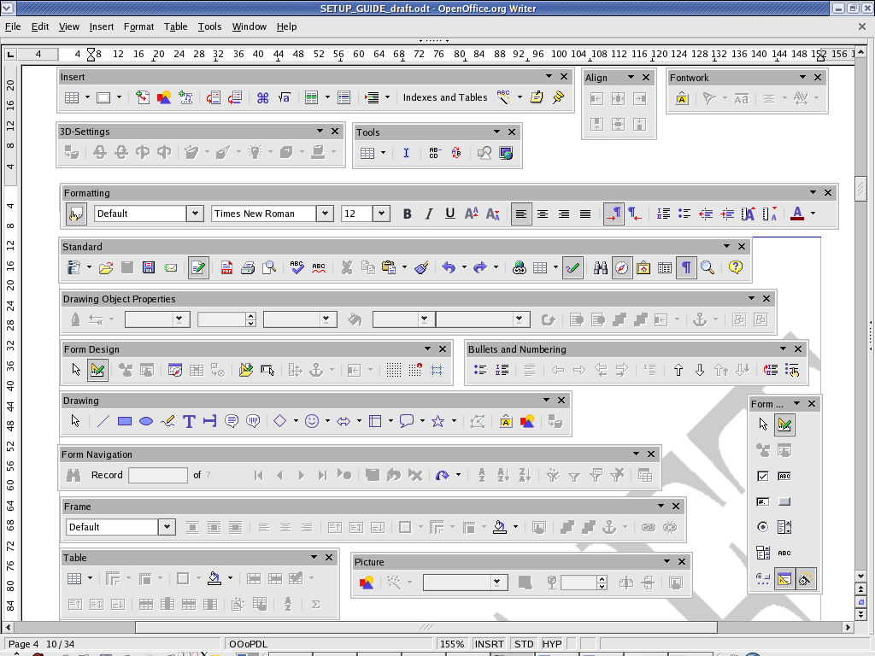

Using Floating Toolbars
When editing a text document, the Insert icon is in the Tools toolbar. Do a long click on this icon. This opens a floating toolbar containing further icons.
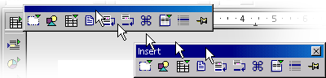
The user now has a few choices to make: either to click the icon to activate the feature, or to grab the window by its title bar and drag it away from the main toolbar while holding down the left mouse button (remember to first release the mouse button that was clicked to open the popup otherwise the title bar cannot be grabbed with the mouse). Notice that the icon, that was used previously, is still there. If one now clicks the From File icon, notice that this icon has replaced the original icon a the top of the main toolbar. Use a short click to open the directly visible function and a longer click to reopen the floating toolbar .

The document window
At the top left hand edge of the document window are the toolbars that are needed for work, and that these vary depending on the document type and context. At the bottom edge is the status bar. The status bar contains different fields displaying information appropriate to the type of document. Some of these fields give access to special functions, either by double-clicking or by opening the relevant context menu. For more detailed explanations, refer to Help.

Docking toolbars
All toolbars may be positioned as either floating windows or dockable panes. These floating windows may be docked on any of the edges of the OpenOffice.org window. On each edge several toolbars may be docked alongside each other. To undock and re-dock, drag the handle at the left or top (if vertical) of the toolbar.
In the floating state, the window floats above the workplace so that the windows below it are partially covered. Switch to the locked state to display the docked window next to the workplace. If the window is docked to the left of the workplace, the following buttons appear depending on the state:
Unhide
A hidden window can be un-hidden (shown) by clicking the arrow button.
Hide
Click the arrow button to hide a window.
Lock
Click this button to lock a floating window.

Floating
Click this button to change a locked window to a floating window.

Docking windows
Some tools in OpenOffice.org open in popups that are dockable, such as the Styles and Formatting window, the Navigator and the Gallery. These floating windows may be docked at either the left or right edges of the main OpenOffice.org window.
To dock one of these windows, drag the title bar of the window to the edge until an outline appears. This outline indicates the size and position of the pane that will contain the tool when the mouse button is released. Another window may also be docked adjacent to one which is already docked. Users can choose to have one on top of the other or side by side. As a window is moved, note that an outline displays showing where the window will dock and how big it will be.
To undock a tool and make it a floating window again, point to the grey area of the tools toolbar and drag the tool away from the edge until the outline indicates that it is no longer attached.

Changing the Visibility of Buttons on Toolbars
Tools and functions are initially grouped together on a default set of toolbars. Not all buttons are visible by default.
To quickly make a button visible or not on its toolbar:
- Click on the small down arrow at the far right of the toolbar and select Visible Buttons.
- Toggle the checked status of the button. Make sure to click the down-arrow appropriate to the toolbar because toolbars may be placed side-by-side.
Note: While buttons may be moved or duplicated across toolbars, or new toolbars may be created or removed completely, we will start with just the OpenOffice.org provided toolbars.

Opening and Saving Documents
There are multiple methods of loading or opening documents. For example, by using the File > Open dialogue, the Open icon on the Function Bar or the File > New menu.
NOTE: Under Windows®, a system dialogue is automatically displayed when opening and saving OpenOffice.org documents. Choose Tools > Options >OpenOffice.org > General and check Use OpenOffice.org dialogues. This enables a user to be presented with the OpenOffice.org dialogues shown in this guide.

Opening Documents

To open an existing document that was saved on the hard drive or on a removable disk, there are three possibilities. Either choose File > Open, click the Open File icon on the function bar, or use the Ctrl+O shortcut keys.
Is each case, the Open dialogue is displayed.
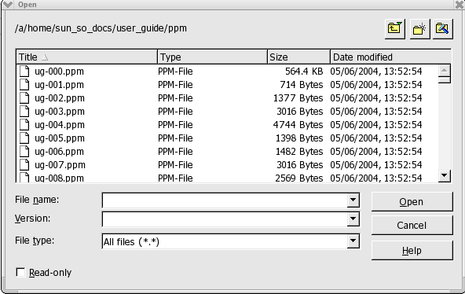
This dialogue is described in detail in the OpenOffice.org Help. However, here are a few tips:
Change the size of the dialogue by dragging the borders of the dialogue with the mouse.
Click the Default Directory icon to go straight to one's work directory. To define a work directory, see the Changing the Work Directory section
Long-click or short-click the Up One Level icon. A short click takes the user one directory higher. A long click opens a submenu with a choice of superordinate directories.
To only see files containing a certain name, enter the name with wildcards in the File name pull-down list and press Enter. If *.txt, for example, is used only the files having .txt at the end of their names will be displayed. If s* is used , all names beginning with the letter s will be displayed.
Documents may be opened with write-protection enabled. To edit a read-only document, click the Edit File icon on the function bar.

The Templates and Documents dialogue
The Templates and Documents dialogue can be regarded as a kind of command centre for OpenOffice.org documents. It provides easy access to a user's work directory and to any supplied sample documents. Here find all document templates - both the supplied ones and any personally created ones. To open the dialogue, choose File > New > Templates and Documents or press Shift+Ctrl+N. In Windows®, double-click the OpenOffice.org Quickstarter icon on the task bar.

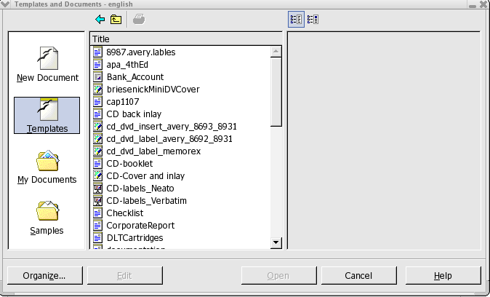
The dialogue offers the following areas, which can be selected by clicking one of the offerings in the shortcut bar on the left:
- New Document - A way to create a new, empty document from a set of prepared templates.
- Templates - Choose from the many ready-to-use document templates.
- My Documents - A quick route to the documents in a work directory. A work directory may be defined by selecting Tools > Options >OpenOffice.org > Paths and entering the path required for My Documents.
- Samples – This is an empty folder when installed; however, some examples may be downloaded from http://documentation.openoffice.org/Samples_Templates/User/template/index.html. (See New Document for example templates)

Saving Documents

Saving the current document can be done in three ways, using File > Save command, the Save Document icon on the function bar, or just press Ctrl+S.
For a first time save, use File > Save as. A dialogue box pops up to allow choosing where to store the file.

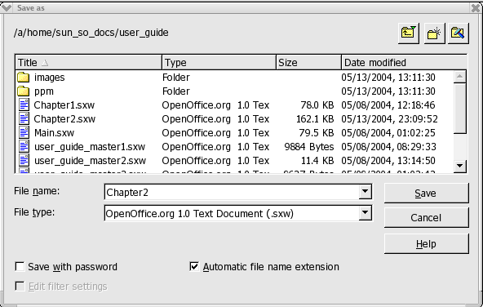
With File > Save as, one assigns the document a name whereas the other two options save without asking for the file to be named. Therefore, using the Save as feature is especially important when saving files for the first time. For the most part, choose any name desired (limited only by the restrictions imposed by the operating system). When the document is to be opened later, find it under that name.
Save documents regularly as work progresses. The simplest way is to save the current document by pressing Ctrl-S. This replaces the document on the data medium with the current document.
Note: An untitled document must be given a unique name for AutoSave to obey the settings in Tools > Options > Load and Save > General. Disabling AutoSave is not recommended.

Changing the Work Directory
When the Open dialogue comes up, the work directory is displayed. The user can change this directory as follows:
- Select Tools > Options >OpenOffice.org > Paths.
- Double-click My Documents to open the edit dialogue.
- In the Select Path dialogue, enter the work directory wanted and click Select.
- Close with OK.
Likewise, other directories can be selected using the same method. For example, to display a different default directory for inserting graphics, change the path for the entry Graphics.

Saving Documents Automatically

Backup a File Automatically
To create a backup copy of a document every time a document is saved:
- Select Tools > Options > Load/Save > General.
- Check Always create a backup copy.
If the current document is saved, using the same path and file name with which it was first opened, using File > Save or Ctrl+S, the old version will be overwritten by the new version. If the Always create backup copy is checked, the old version is first copied to the backup directory.
- The default backup directory is $HOME/OpenOffice.org<release>/user/backup. Change this, as described above, in Tools > Options >OpenOffice.org > Paths > Backups entry.
- The backup copy retains the same name as the document, but the extension is changed to .BAK. If the backup folder already contains such a file, it is overwritten without warning!

Saving Recovery Information Automatically Every 'n' Minutes
- Select Tools > Options > Load/Save > General.
- Check Save AutoRecovery information every and select the time interval in the list box.

OpenOffice.org File Formats
OpenOffice.org uses an XML file format as the default for saving and opening documents.

XML file format names
In saving and opening OpenOffice.org documents if no other file type is selected,OpenOffice.org uses the following XML formats:
Application File | extension
OpenOffice.org Writer | *.odt
OpenOffice.org Writer templates | *.ott
HTML Document | *.html
HTML Document Template | *.oth
OpenOffice.org Calc | *.ods
OpenOffice.org Calc templates | *.ots
OpenOffice.org Impress | *.odp
OpenOffice.org Impress templates | *.otp
OpenOffice.org Draw | *.odg
OpenOffice.org Draw templates | *.otg
OpenOffice.org Formula/Math | *.odf
Master documents | *.odm

These file name extensions permit reasonable differentiation when searching though a lot of files of different file types in a directory. Since these are compressed XML files , it should be evident that these must first be unpacked before being manipulated, for example, by a text editor.
Note: If a user wants to work permanently with another file format, define this as the default. Select Tools > Options > Load/Save > General for alternative file formats that can be selected for each OpenOffice.org document type.

OpenOffice.org XML file structure
The OpenOffice.org XML file formats follow the OASIS OpenDocument standard and are compressed and packed using ZIP. Use an unpacking program, such as WinZip on Windows® or unzip on *NIX, to unpack the contents of an XML file. The structure is similar to the following illustration.
Archive: example.odt
Length | Method | Size | Ratio | Date | Time | CRC-32 | Name
-------- | --------- | ------ | ------- | ------- | ------- | ------- | --------
30 | Stored | 30 | 0.00% | 15/05/05 | 15:25 | 3931a5e1 | mimetype
4260 | Stored | 4260 | 0.00% | 15/05/05 | 15:25 | a10af03b | Pictures/100010DA222DD884.gif
9022 | Defl:N | 2147 | 76.00% | 15/05/05 | 15:25 | cd8d5105 | content.xml
2447 | Defl:N | 954 | 61.00% | 15/05/05 | 15:25 | 08c57cab | Basic/~wizard/Create.xml
1586 | Defl:N | 642 | 60.00% | 15/05/05 | 15:25 | 55c931dc | Basic/~wizard/Save.xml
389 | Defl:N | 223 | 43.00% | 15/05/05 | 15:25 | 756d8953 | Basic/~wizard/script-lb.xml
287 | Defl:N | 193 | 33.00% | 15/05/05 | 15:25 | 528021b8 | Basic/Standard/script-lb.xml
405 | Defl:N | 225 | 44.00% | 15/05/05 | 15:25 | 95c3869e | Basic/script-lc.xml
59152 | Defl:N | 5041 | 92.00% | 15/05/05 | 15:25 | e86699c4 | styles.xml
1381 | Stored | 1381 | 0.00% | 15/05/05 | 15:25 | 70e3c0fc | meta.xml
6674 | Defl:N | 0 | 0.00% | 15/05/05 | 15:25 | af1ecee5 | Thumbnails/thumbnail.png
6841 | Defl:N | 1230 | 82.00% | 15/05/05 | 15:25 | 0d922df6 | settings.xml
1602 | Defl:N | 349 | 78.00% | 15/05/05 | 15:25 | 8e61970e | META-INF/manifest.xml
-------- | ------- | --- |  |  |  |  | -------
87402 | 16675 | 81.00% |  |  |  |  | 12 files

Note: Under Windows®, output should be similar to the above.
- The text content of the document is located in content.xml. This file can be viewed with, for example, a pure text editor.
By default, content.xml is stored without indents or any other type of formatting so that the time needed for saving and opening is minimized. By unchecking Tools > Options > Load/Save > General > Size optimization for XML format this procedure can be changed so that the lines saved are structured in a more human readable format.
- meta.xml contains the meta information on the document, which is entered via File > Properties.
In documents saved with security, meta.xml remains unsecured.
- settings.xml contains further information on settings for this document, for example on the printer, on the recording of changes, the associated data sources and so on.
- styles.xml retains the styles defined for the document. For example, these can be seen in the Styles and Formatting window.
meta-inf/manifest.xml file describes the structure of the XML file.
Additional files can be contained in the packed file format. For example, Graphics can be found in the Pictures subdirectory, Basic code in the Basic subdirectory and linked Basic libraries are found in further subdirectories of Basic.

Definition of the XML formats
The DTD (Document Type Description) files can be found in $HOME/OpenOffice.org<release>/share/dtd.
Note that the formats are subject to certain licenses. Notes on the licenses are found at the start of the DTD files. More detailed information can be found on the OpenOffice.org website.

Setting Tabstops
OpenOffice.org offers multiple ways by which one can set and edit the tabstops used in a document. The procedures for setting and editing tabstops are described in Help > OpenOffice.org Help > Index > Search term > tab stops and are quite complete.

Sending Documents as E-Mail

Single Messages
Working in OpenOffice.org, one can send the current document as an e-mail attachment providing that the default e-mail program up is set up correctly.
Note: To set up this feature, select Tools > Options >Internet > E-Mail and configure the program to use.
- Choose File > Send > Document as E-mail.
- When the e-mail composer window appears, enter a recipient, subject and any text and send the e-mail.

MailMerge
As of OpenOffice.org 2.0.1, users have the opportunity to use email to send messages to multiple recipients. This feature also allows printing of these for delivery by post.
- Choose Tools > Mail Merge Wizard
- Follow the dialogues.

Printing Documents
Upon creating a document, normally one will want to print it out on paper for distribution.
Print the current document either directly to a printer, or”to file”. When printing to a file, all the information that would otherwise be sent to the printer is initially written to a file. On another computer, the file can then be copied directly to the printer connected to it.
Note: OpenOffice.org Writer always formats documents so that they are printed as well as possible with the selected printer. Therefore, always define a default printer, even if there is no available printer.


Click the Print File icon on the function bar to print the current document without the intervention of a dialogue.
To retain finer control of printing, either select File > Print, or use the keyboard shortcut Ctrl+P.
In the File > Print dialogue, select a specific printer (if there is more than one installed printer). Under Print range, determine how many pages to print (or only certain pages), and how many copies are wanted.

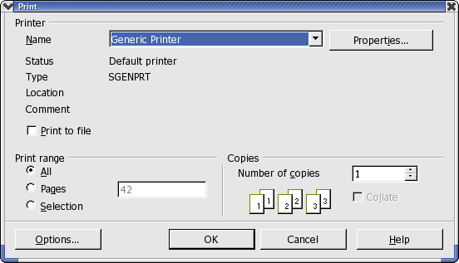
In addition to the general printing options already mentioned, one can choose special printer options for the different document types in OpenOffice.org using additional dialogues that allow the user to control the way the contents or the pages of the document are printed. Define these printer options for the current print job by clicking the Options button in the Print dialogue. Select Tools > Options > (name of document type) > Print to create a general definition for normal use.
Note: There are many different printers with widely varying properties. The printing functions differ according to the operating system, printer driver and printer model used. The selected printer defines the width and height of the characters, and hence also the line and page breaks. OpenOffice.org Writer and Calc always format the pages in the way they will appear when printed.

Displaying Print Previews
Before printing out a document, reviewing how the printed document will appear on paper is often a good idea. OpenOffice.org offers a Print Preview feature for this purpose thereby allowing adjustment of margin widths, optimization of page breaks et cetera.
- Switch to the document for preview.
- Select File > Page Preview.
- Use the icons on the object bar to zoom in or out.

- Use the arrow keys or object bar icons to scroll through the pages of the document and check how they will appear in print.

Reduced Printing of Documents
To get a reduced printout of a text document, choose File > Page Preview. Here, decide whether to have two, four or any number of pages beside and on top of each other.

To print two pages beside one another on one sheet of paper
- Choose File > Page Preview.

- Locate the Page Preview icon . If there are more or fewer pages than desired, long click the icon to the right of the grayed out Page Preview: Two Pages on the object bar and select the number of pages needed for previewing.
- Click on the Print page view icon.
Clicking the Print options page view icon opens a dialogue where one can enter settings for reduced printing.
- Click OK to confirm.

Printing in Black and White
If there is a colour printer installed but printing should be restricted to black and white only, use one of the following options:

Printing text and graphics in black and white
- Select File > Print. This opens the Print dialogue.
- Click on Properties. This opens the properties dialogue for the printer.
- Choose the option to print in black and white. For further information, refer to the help for the printer or read the printer manual.
- Confirm the Properties dialogue and click OK in the Print dialogue.
- The current document will be printed in black and white.

Printing all Draw and Impress documents in black and white
- Choose Tools > Options > OpenOffice.org Impress or Tools > Options > OpenOffice.org Draw, as appropriate.
- Then choose Print.
- Under Quality select either Grayscale or Black & White and click OK. From now on, all presentations or drawings will be printed without colour.
Selecting the Default quality option allows documents to be printed in colour again later on.
Grayscale converts everything to a maximum of 256 gradations from black to white.
Black & White converts everything into the two values black and white.

Printing only text in black and white
In Writer, the user can choose to print colour-formatted text in black and white. This can be specified either for all text documents to be printed subsequently, or only for a printing process of the current text document.

Printing all Writer documents with black and white text
- Choose Tools > Options > OpenOffice.org Writer or Tools > Options > OpenOffice.org Web/Writer.
- Then choose Print.
- Under Contents mark Print black and click OK.
All text documents or HTML documents will from now on be printed with black text.

Printing the current Writer document with black and white text
- Choose File > Print. This opens the Print dialogue.
- Click the Options button. This opens the Printer Options dialogue.
- Under Contents mark Print black and click OK.
The text document or HTML document now being printed will be printed in black text.

Printing Brochures
OpenOffice.org text documents consisting of more than one page can be printed automatically as a brochure. Two pages of a text document will be reduced in size and printed next to each other on a page in landscape (horizontal) orientation. Both sides of the page will be printed (most printers require that users take out the paper after the first half of the printing process and feed it in again n such a way as to print on the blank side). OpenOffice.org will automatically print the pages so that they can be read as a brochure. OpenOffice.org automatically arranges the pages in such a way that the text can be read continuously by laying the pages together, fold them in the centre and stapling them in the fold.
To make a brochure using the current document, select File > Print. In the dialogue that opens, do the following;
- In Printer > Properties make sure Orientation is set to landscape
- While still in this dialogue, set the Paper size of the *document* to A4 or US letter, as needed.
- Click OK to close the dialogue.
- Click the Options button in the lower left of the Print dialogue.
- Next select whether to print right and left pages all at once, right pages or left pages. The following should provide sufficient information to make a decision:
  - If the printer is capable of duplex printing, choose Left and Right pages and brochure.
  - With a single sided printer:
    - choose Left or Right and brochure.
    - Click OK then go to step 6.
    - When printing is complete, take the pages from the output tray and put them into the input tray in such a way as to print on the blank side and choose the opposite Page setting as in step 1. Repeat step (ii).
- Click OK
- Click OK

Spellcheck
OpenOffice.org has an automatic spellcheck which can be active while typing, or activated manually.

Automatic Spellcheck

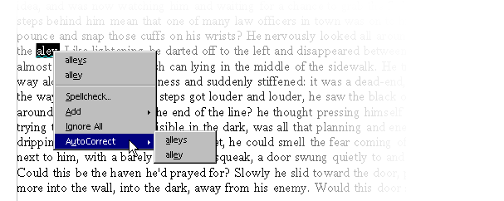
The automatic spellcheck can be turned on and off by clicking the AutoSpellingCheck on/off icon on the Standard toolbar. With automatic checking enabled, words recognized as incorrect are highlighted with a wavy red underline.
Incorrect words are recognized as incorrect if all the following conditions are met:
- a spellcheck module is installed for the language of the word,
- this module is enabled,
- the word is not found in the installed dictionaries.
- the word is not in any active user dictionary.
Users can create any number of custom/user dictionaries.
Create a user dictionary by selecting Tools > Options > Language Settings > Writing Aids.
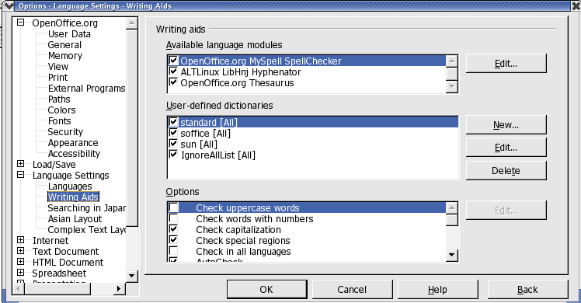

As text is proofread, the wavy red underlines draw attention to possible spelling mistakes. Of course, Spellcheck will not catch spelling mistakes that form other recognizable words (such as “fun” instead of “run”). As long as the automatic spellcheck is activated, the red markings can be seen on the screen but are not printed.
The easiest way to correct a red-underlined word is to right-click it. This opens a context menu that offers suggested corrected spellings, and options to add the word to the dictionary or to ignore it. Simply click the correct suggested spelling to replace the red-underlined word. Spellcheck not only replaces the red-underlined word with the suggestion selected, it also remembers this replacement while the document is open. If the same typing error is made again, Spellcheck automatically replaces the mistyped word with the corrected spelling.
If the word is spelled correctly, it may be added to a dictionary by clicking Add and specifying to which dictionary it is to be added. To ignore a correctly spelled, but infrequently used word, click Ignore All.

Checking Multilingual Texts
OpenOffice.org Writer can manage spellcheck(plus thesaurus and hyphenation) in multiple languages (33 at the time of writing). The OpenOffice.org setup program offers this via “Custom Installation” and, after installation via the “Modify” option in setup, where one can choose which language modules to install.
Select the language of an entire text document with Tools > Options > Language Settings > Languages. If it applies to the user's needs, check For the current document only. For all paragraphs formatted with the same Paragraph Style, apply a language via the Paragraph Style. A language can be defined for individual words via Character Styles, or directly with Format > Character.
In Tools > Options > Language Settings > Writing Aids , check the option Check in All Languages. Now, Spellcheck will take all installed languages into account. Words that are correctly typed in any of the installed languages are regarded as correctly typed, irrespective of their language attribute. In multilingual texts, the automatic checking that was enabled by clicking the icon on the Standard toolbar, offers another facility as well. In the context menu of a red-underlined word that is recognized as incorrect, specify that the word or the whole paragraph is one of the other installed languages. The language of the underlined characters or all characters of the paragraph is automatically assigned as a character format.

Starting Spellcheck
To check the entire text for spelling mistakes in the “classic” way (i.e. letting Spellcheckgo through the whole document on its own), go to the Tools menu and choose Spellcheck. The Spellcheck dialogue will only appear if there are words in a text unknown to the Spellcheck. The various options to be seen in the Spellcheck dialogue are described in detail in the OpenOffice.org Help. In the Spellcheck dialogue, if an unrecognized word is included in a user dictionary, the user can also define the permitted hyphens for the automatic hyphenation. Enter the hyphens in the word as an equals sign (=).
Note: placing an equals sign at the end of the word means that this word will not be automatically hyphenated.
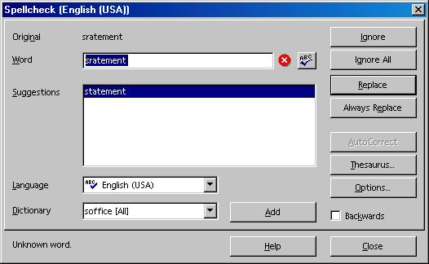

Excluding Text From the Spellcheck
If certain areas, words or tables should not be spell checked because they are, say, in a foreign language for which there is no installed module, then specify "Unknown" as the language to be checked by Spellcheck. Do this by either using direct formatting by selecting the text and then choosing Format > Character > Font or by modifying the corresponding Style for the text (e.g. open the context menu and choose Edit Paragraph Style...).

Using Automatic Functions
OpenOffice.org has all kinds of intelligent assistants to help, all of which have names beginning with “auto”.
The section introduces a few of these auto-functions. For detailed explanations, refer to the OpenOffice.org Help.

Using AutoCorrect and AutoFormat
In addition to catching typing errors, OpenOffice.org can format documents while typing or afterwards. AutoFormat and AutoCorrect permit the user to draft documents much more efficiently by automatically formatting and correcting common errors while the user types. Here are a couple of examples.
- AutoCorrect is useful if one often makes the same typing errors. For example, if one tends to capitalize not only the first letter of some words but also the second, simply select the AutoCorrect function that corrects mistakes of this sort while typing.
- AutoFormat formats texts. One AutoFormat feature automatically will detect paragraphs beginning with a hyphen followed by a tab or space, and reformat the paragraph as a bullet point. The automatic bulleting is then applied to any paragraphs that follow as well. Automatic bulleting ends when the user enters a blank paragraph containing only a Return.
In text documents, toggle AutoFormat on or off by selecting Format >AutoFormat. A submenu with three selections appears. To automatically format while typing, check the While Typing selection. To have Writer automatically format the entire document or the current selection at a later time, check the menu selection Apply. Selecting Apply and Edit Changes lets the user see all document changes made via AutoFormat. The user then may accept or reject all changes or may review each change separately.
One may also select and set the options in Tools > AutoCorrect. AutoCorrect offers many options that can be selectively turned on and off. Some of these offer different methods for formatting while typing and post-processing. The Replace and Exceptions lists are language dependent. OpenOffice.org first searches in the list of the language of the text, then the list for the higher ranking language family, and finally in all installed languages (For example, first in "English (US)", then in "English", then in "All Languages").

The following graphic shows the various functions available in this dialogue. A detailed explanation of each function is given in OpenOffice.org Help.

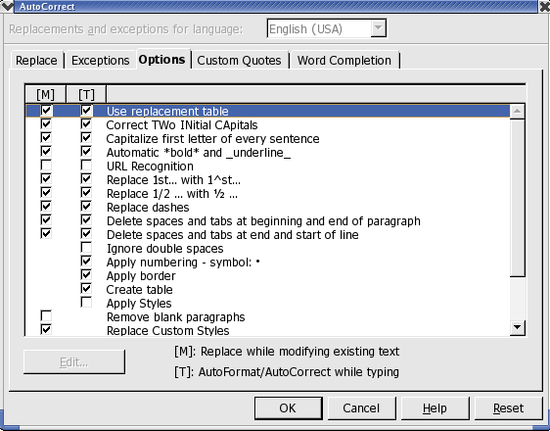
In addition to the functions shown here, one can also select Custom Quotes. This means that all quotation marks entered as a simple computer character with Shift+2 are automatically turned into correct typographer's quotes. Users can choose the characters to be used for this purpose.

Turning off URL Recognition by AutoCorrect
When text is entered,OpenOffice.org automatically recognizes a word that may be a URL and replaces the word with a hyperlink. OpenOffice.org formats the hyperlink with direct font attributes (colour and underline) the properties of which are obtained from certain Character Styles.
If OpenOffice.org should not automatically recognize URLs while typing, turn off this feature using one of the following methods.

Undo URL recognition
- Press Ctrl+Z to undo text that has been automatically converted into a hyperlink.
- Select the hyperlink and choose Format > Default if this conversion is not noticed until later.

Turn off URL recognition
- Load a document of the type in which URL recognition is to be modified. For example, if modifying URL recognition for text documents, open a text document.
- In OpenOffice.org Writer select Tools > AutoCorrect ... .
- In the AutoCorrect dialogue, choose the Options tab.
- Deselect URL Recognition, so that words will no longer be automatically replaced with hyperlinks.
In Writer there are two checkboxes in front of URL Recognition. The field in the first column is for modifying in a post-edit session while the field in the second column enables AutoCorrect to make the corrections while typing.

Other AutoCorrect functions
The Tools > AutoCorrect > Replace tab has a default list of items that will be automatically replaced provided that Use replacement table on the Tools > AutoCorrect > Options tab page is checked. One can add all of their most frequent typos to this list and have AutoCorrect replace them with the right text. Also use this feature to enter special characters or phrases that are keyboard intensive to do normally. For example, (C) is immediately turned into the copyright symbol.
Note: The fonts supplied with OpenOffice.org include the Euro symbol. If working with other fonts, one can easily insert the Euro symbol from another font using AutoCorrect. When working in a text document, choose Insert > Special Character. Look for the Euro symbol and click OK.
Enter in the Abbreviation text box eu, for example. The Text only box should not be marked. Click New. Now close the dialogue. As soon as the eu is entered followed by a space or at the end of a sentence, a Euro symbol will be inserted.

On the Exceptions tab, enter any exceptions for the two types of automatic correction:
- Assuming the Replace option is enabled to automatically start each sentence with a capital (uppercase) letter, and“e.g.” is entered and is followed by a lowercase “d” then the “d” would be capitalized. So to compensate for this behaviour, enter “e.g.” into the Exception list to prevent this type of correction.
- Again, assuming the Replace option is enabled to automatically convert the second of two capital letters at the beginning of a word to a lowercase letter, enter any exceptions that are correctly written with two capital letters, such as PC and CD.
These exceptions can also be automatically included by selecting the Autoinclude checkboxes on the Exceptions tab. When this feature is enabled and one then uses an idiom in the text that is automatically corrected but which should not be corrected, immediately press Ctrl+Z. Doing this not only undoes the automatic “correction”, but also sees to it that this particular “correction” will not be made automatically again in the session.
AutoCorrect can also be used to replace one word or abbreviation with something more appropriate. For example, replace “ASAP” with the text “as soon as possible”; however, the OpenOffice.org AutoText function is a better choice for doing this.

Creating a Letter Template With the Wizard
If one is writing a personal letter, the Wizard and standard AutoTexts are not essential, but in formal business correspondence these aids can save a lot of time and make work much easier.
Note: To produce a standard letter, have a look at the supplied templates. Simply press the shortcut keys Shift+Ctr+N or choose File > New > Templates and Documents.
Start the Wizard with the File > Wizards > Letter menu command.

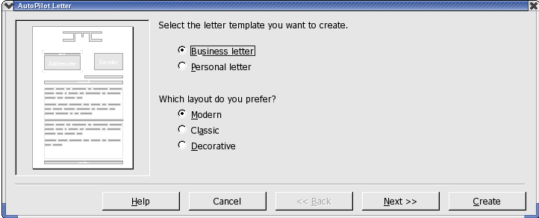
Treat this section as a tutorial on the OpenOffice.org template Wizard. Although the Wizard does produce a document that can immediately be filled in, printed, and sent, using the Wizard is really meant to help create customized templates. Customized templates for such things as business letters, faxes and other types of documents for which there is a Wizard ensures that correspondence has a consistent format.

While one may, there is no need to go through all the steps of the Wizard each time one wants to write a letter. However, in order to get the most from the following, it is recommended that one accept all the defaults provided without changing them, and then print the result. Click Next on each dialogue page, so that every page is seen at least once during the learning process. Examine each of the Wizard pages while going through the process of creating a letter template. Enter data or modify options on each page as necessary. Each page allows modifications according to each user's preferences including sender and recipient addresses, both of which can also be entered manually. (For example, sender information is automatically taken from the personal details that each user enters at the time of installation. These details may be changed at any time by selecting Tools > Options >OpenOffice.org > User Data and entering new information or editing existing details.) Predefined elements will appear but users always have the final say on what to include in their letter.
Thanks to the Wizard, one doesn't have to start from scratch but can use preexisting texts when creating custom templates, whether for business letters, faxes, memos, or other documents.

Find & Replace
When working with a computer it is often useful to be able to locate certain pieces of text quickly. The Find function in OpenOffice.org Writer, Calc, Impress and Draw is the tool to use for this purpose. Find can also locate variations in the given search term or limit the search to certain places in the document, such as the beginning of a word or the end of a paragraph.
Text strings found in the text can be replaced by other strings with or without confirmation, although sometimes manual editing is still necessary where, for example, there are deviations in gender found in other languages.

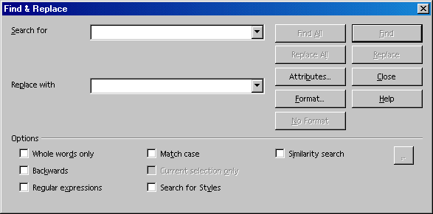

Finding a Word in Text
Let's say the word “Holland” appears somewhere in a long text and the user wishes to locate it. Activate the Find function with Ctrl+F. Enter the string one wants to find in the Search for field and press Enter. OpenOffice.org starts searching from the current cursor position toward the end of the document. Upon reaching the end of the document, a new dialogue appears asking whether or not to continue the search at the beginning of the document. Tap the Enter key to confirm. If the text string is found, it is highlighted.

OpenOffice.org starts searching from the current cursor position toward the end of the document. Upon reaching the end of the document, a new dialogue appears asking whether or not to continue the search at the beginning of the document. Click the Enter key to confirm. If the text string is found, it is highlighted.
The Find & Replace dialogue can remain open without interfering with text entry and it can be moved to any place on the screen. However, when it is closed, it remembers the previously entered strings so they do not need to be reentered for the next search, but can be selected from the list box.
One very useful feature is the multi-selection facility Find All. For instance, using Find All, one could set every occurrence of the word “document” in the text to boldface. Enter the search term in the Search for field and then click Find All. All occurrences are now selected. Place the cursor in the Replace field, and click the Bold icon in the text object bar to boldface all occurrences of the search term.
The dialogue graphic above illustrates that there are several ways of expanding or restricting searches by combining selections from the Options group box and the buttons. Examples for each option are described below.

Searching for Whole Words Only
Select the Whole words only option to find whole words that match the searched for word. For instance, if the word “in” is entered as the search term in the Search for field, all instances of “in,” or “In,” as stand-alone words in the text will be found. Words like “bin” or “chin” will not be found if this checkbox is selected. If searching using regular expressions or for Styles, do not select this option.

Match Case
When this checkbox is selected, the search is case-sensitive to uppercase and lowercase letters. So if searching for “in,” it will be found, but not the word “In,” Combine a Match case search with the Whole words only option as needed.

Searching for Text With Wildcards
1. Start Find by selecting Edit > Find & Replace dialogue or use Ctrl+F.
2. Check the More Options > Regular expressions box.
3. Enter the search term with the desired wildcards and click Find.
Regular expressions are entered using text combined with keyboard characters and symbols that have special meaning in this context:
- The wildcard for any number of a given character is the character itself followed by an asterisk (*). Note that this is different to the way '*' is used in file names.
Example: Enter “Hawai*” in the Search for field. This means that any number of “i's”, including none at all, may follow “Hawa”. Thus the words “Hawa”, “Hawai” and “Hawaii” will be found.
- The wildcard for a single character is the period or dot (.). This is equivalent to the wildcard '?' in file names.
- Combining the above two rules, the wildcard for several unspecified characters in succession is '.*' (period and asterisk). This is equivalent to the wildcard '*' in file names.
- A paragraph end can be found with the dollar sign ($), and the first character at the beginning of a paragraph with the string '^.' (caret and period).
- Regular expressions may only be searched within paragraphs.
There are many other wildcards that can be used that are listed in Help > OpenOffice.org Help with a search term of “Regular expression”. This complete List of Regular Expressions is included in this document.

Searching Backward
When locating a frequently appearing word in a long text, the user might click find once too often by mistake. Check the Backward box and click again on Find to return to the location of the previously found item.

Current Selection Only
Check the Current selection only box option to limit the search rather than causing the entire document to be searched. The search will be restricted to the lines that are highlighted in the document. If text is selected before activating the Find command, the search will automatically take place only within that selected range.

Searching for Styles
Quickly reformat all or part of a text using this feature. For example, text formatted with the Style “Heading 2” can be replaced with the Style “Heading 3.” Select the Paragraph Style in the list box under Search for. Then select the new Paragraph Style in the Replace with field. Start the replacement process with the Replace button. All matching styles found in the text will be displayed in sequence. The user can decide each time whether or not to do the single replacement, replace all matching styles found in the text, or to cancel the process.

Searching for Text Attributes
Select Attributes to open a dialogue from which to select those text attributes to be employed to search within a document. OpenOffice.org then finds all attributes that differ from the format of the Paragraph Style. For example. in this dialogue, if the Font Weight checkbox is selected, the program can find all words that have a heavier font than normal. These could be words that have has the Bold attribute applied, either through direct or indirect formatting, or that have been highlighted with a font previously defined as a bold font, such as ones containing the words "Bold" or "Black" in their name. By default, Find searches only for direct attributes. However, after searching for the attributes, one may enable the Including Styles checkbox in the groups section of the Find & Replace dialogue where Search for Styles was previously. Then, the search extends from the direct attributes we selected previously to include indirect attributes, such as. those set with styles.

Searching for Special Formats
By clicking the Format button, one opens a dialogue from which to select the specific formats in the search. For example, if one has manually centered a few lines in the text, find them using the options of Format in the Find & Replace dialogue. Now let's say that the found attribute must be replaced with another, to do this take the following steps:
- Position the cursor in the Replace with field.
- Click the Format button.
- Choose the replacement attribute.
The chosen attributes are listed under the Search for and Replace with fields. If no replacement is indicated for the attribute found in the text, the default settings are automatically applied.

Similarity Search
This function seeks not only for the search term, but also for similarly typed words. As needed, fine-tune the degree of similarity by clicking the button immediately to the right of the “Similarity search” checkbox.

List of Regular Expressions
This list is also in Help but is included here as a convenience.

Character | Result/Use
. | Represents any single character. The search term "sh.rt" finds both "shirt" and "short".
^ | Using ^Peter will find this search term only if it appears at the beginning of a paragraph. Special characters (for example, blank spaces and character-anchored frames) at the beginning of a paragraph are ignored.
$ | This symbol represents the paragraph mark for use in a regular expression. For example, using $ will only find the search term if it appears at the end of a paragraph. So, if one searches for, say, Peter at the end of a paragraph, enter Peter$ in the Search for box. Special characters (for example, blank spaces and character-anchored frames) at the end of a paragraph are ignored.
^$ | Enter ^$ in the Search box to find empty paragraphs.
* | Finds zero or more of the character immediately in front of the "*". For example, "Ab*c" finds "Ac", "Abc", "Abbc", "Abbbc", and so on.
+ | The character before this symbol must appear at least once: "AX+4" finds "AX4", “AXX4”, but not "A4".
? | Finds zero or one of the characters in front of the "?". For example, "Texts?" finds the words "Texts" and "Text".
\ | Only finds the character (no digits) that is specified. Used to turn off any special interpretation of the character by OpenOffice. For example, if one searches for “\*+” , ”*”, “**” and “***” will be found. That is, the regular expression interpretation of '*' is turned off only for that one instance.
\n | Finds a hard row break that was inserted with Shift+Enter. To change row breaks into paragraph breaks, enter \n in the Search for and Replace with boxes, and then click the Replace all button.
\t | Finds a tab space. Users can also use this expression in the Replace with box.
\> | Only finds the search term if it appears at the end of a word. For example, "book\>" finds "checkbook", but not "bookmark".
\< | Only finds the search term if it appears at the beginning of a word. For example, "\>book" finds "bookmark", but not "checkbook".
^$ | Searches for empty paragraphs.
^. | Searches for the first character of a paragraph.
& | Use this character in the Replace with box to add the characters that matched the search criteria when a replacement is made.  For example, if one enters "window" in the Search for box and "&frame" in the Replace with box, the word “window” is replaced with "window frame".  Users can also enter a “&” in the Replace with box to modify the Attributes or a different Format of the search criteria entered in the Search for box.
[abc123] | Finds the characters that are between the brackets.
[a-e] | Finds the characters that are between a and e.
[a-eh-x] | Finds the characters that are between a-e and h-x.
[^a-s] | Finds all characters except for a-s
\xXXXX | Finds a special character based on its four-digit hexadecimal code (XXXX).  The code for the special character depends on the font used. Users can view the codes by choosing Insert - Special Character.
| | Finds the search terms that occur before and after the "|". For example, "this|that" finds both "this" and "that" in the search.
{2} | Defines the number of times that the character in front of the opening bracket occurs. For example, "tre{2}" finds "tree".
{1,2} | Defines the number of times that the character in front of the opening bracket can occur. For example, "tre{1,2}" finds both "tree" and "treated".
( ) | Defines the characters inside the brackets as a reference. One can then refer to the first reference in the current expression with "\1", to the second reference with "\2", and so on.  For example, if the text contains the number 13487889 and one searches using the regular expression (8)7\1\1, "8788" is found.
[:digit:]? | Finds a single digit number. To find a number with more than one digit, use [:digit:]*.
[:space:]? | Finds white space such as spaces and tabs.
[:print:]? | Finds printable characters.
[:cntrl:]? | Finds nonprinting characters.
[:alnum:]? | Finds alphanumeric characters (numbers and text characters).
[:alpha:]? | Finds alphabetic characters.
[:lower:]? | Finds lowercase characters if Match case is selected in the Options area.
[:upper:]? | Finds uppercase characters if Match case is selected in the Options area.

Note: The longest possible text within the paragraph is always found. If the paragraph contains the text “AX4 A4”, the search term “A.*4” finds the first A to the last 4, i.e. “AX4 A4”.
Note: The '()' and '\1..\9' reference RE combinations will be familiar to programmers who have used standard RE's, however the OpenOffice.org version is confined to the search term. The '\1..\9' cannot be used in the replace term as would normally be expected for standard REs. Use '&' to transfer the entire matching search term to the replace term

