Chapter 5: Creating Presentations With Impress
Presentations have more than just drawings and graphics to offer. Use presentations to link several slides to form a slide show, to animate the elements on the slides and to assign special transition effects between slides. Slides often contain text which, in the outline view mode, is displayed and entered in a hierarchical structure. Change the text or rearrange the order of the slides at any time.
There are several ways to create a presentation:
Use Wizard Presentation.
- Use the templates and sample documents supplied, which are modified as necessary.
- Start with an empty document.
OpenOffice.org Impress provides many graphics features for creating presentations, all of which are found in OpenOffice.org Draw, too. Please take the time to read chapter 6 on OpenOffice.org Draw to discover the complete capabilities of Impress.
The sample documents referenced in this section may be found, at the time of writing, at http://www.pathtech.org/OpenOffice.org/templates/Samples/.

OpenOffice.org Impress Toolbars and Windows®
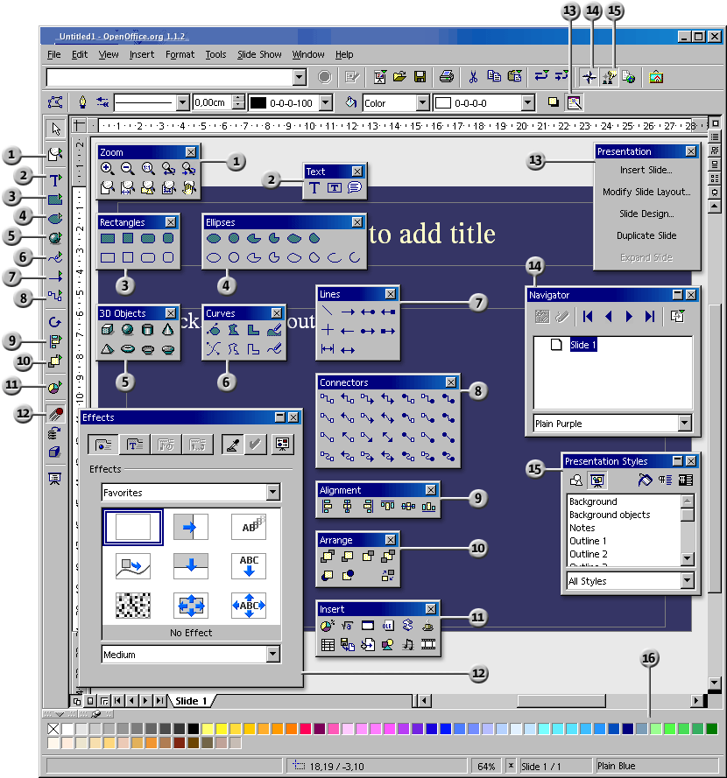
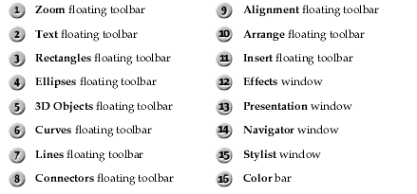

How to Create a Basic Presentation
The following brief step-by-step example demonstrates different methods of how to create a presentation document.
As with text documents, there are various ways to start creating a presentation:
- Open the Wizard Presentation by choosing File > Wizards > Presentation. The Wizard starts automatically each time a new presentation is created. If desired, switch off the automatic mode on the first page of the Wizard. The Wizard is described in detail in the Help.
- By turning off the Wizard in Tools > Options > OpenOffice.org Impress > General, a new, empty document (for example, by choosing File > New> Presentation) is opened.
- Alternatively open an existing presentation document that is modified and saved under a different name.
- Or use one of the many templates available in the Templates and Documents dialogue. Pressing Shift+Ctrl+N opens this dialogue or use File > New > Templates and Documents.
For more information on the various dialogues used here, refer to Help.

Creating a Presentation With the Wizard
- Choose File > New > Presentation.

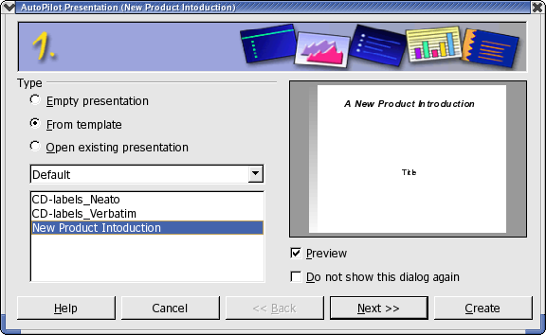
The Wizard Presentation opens automatically. The first page allows starting with an empty presentation, a template or the last presentation opened. By clicking the From template option,OpenOffice.org Impress collects all existing presentation templates and displays them in the list box.
- For the purposes of this example, select the template “new_product_intro” and click Next. On page two of the Wizard dialogue choose another Page Style if needed. The selection of presentation layouts available to choose from are from the predefined template directories. As on the first page of the Wizard, all templates are displayed as Page Styles.

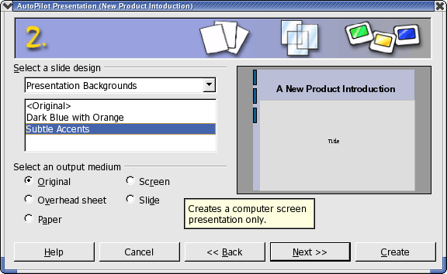
On this page, however, the default is “Presentation Backgrounds”. From this page, select the presentation medium for the presentation: Slide, Overhead, Screen or Paper. The dimensions, margins, and orientation of the presentation will depend on these selections.
- To continue following this example, do not change the background or medium of the presentation. Click Next.

- Page three of the Wizard deals with the slide transition.
  - In the first list box select the slide effect “Cross-Fade From Left”.
  - Select the default “Medium” for the speed of change.

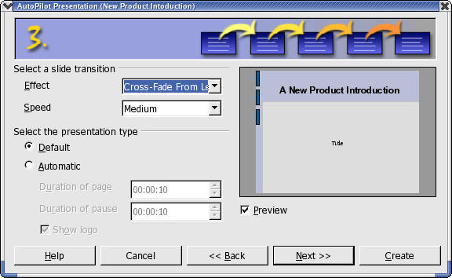
- Select Automatically as the presentation type (i.e. repeatedly runs through presentation, with fixed time lapses, until the Escape key is pressed).
- Now one can determine further parameters:
  - Use the Duration of page spin box to determine how long each slide is shown before the next one appears. Once the presentation is completed, a different duration for each slide can be set individually.
  - Use the Duration of pause spin box to determine how long the pause will be at end of the presentation before it starts again. If the Show Logo check box is marked, the “Created with OpenOffice.org” logo will be displayed on the pause page. The Default presentation type runs the presentation from beginning to end with manual slide transition, e.g. by mouse click.

- Click Next.

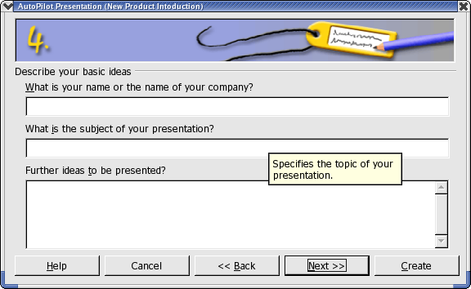
- Enter additional text which that should appear in the presentation on page four.

- Click Next.
The fifth and final page of the Wizard determines the number of the slides needed in the presentation. A list of names of all the slides in the presentation is also presented. If there are some slides to be removed from the presentation, click the Page icon with the green check mark next to the name. The check mark will disappear, which indicates that that slide will not be included in the presentation. To reverse this action, click the page icon again.

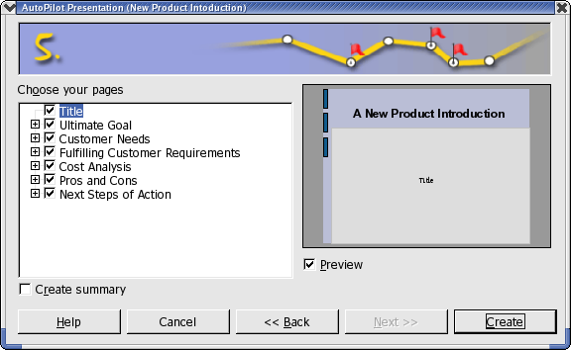
- Click the plus sign in front of a slide, the headings from the first outline level will be shown.
- By checking the Create summary check box, the Auto Pilot creates an additional last slide with a summary of all the titles of the previous slides in the presentation. Normally this is not necessary, since most templates already include such a page.
- Click Create to create the presentation.
  - Clicking Create on any of the Wizard pages creates the document and eliminates the need to go through all the pages of the Auto Pilot.
  - Once created, edit, save, and print or run the presentation, et cetera.
To start a presentation on a computer screen, simply press Ctrl+F2 key or click the Presentation icon on the main toolbar.

Creating a Simple Presentation Without the Wizard
This section explains, with the help of a simple example, how to create a presentation based on one of the existing templates.
- Open a new presentation document based on one of the supplied templates by choosing File > New > Templates and Documents, or with Shift+Ctrl+N.
- In the Templates and Documents dialogue that appears, click the Templates icon on the left and then double-click “Presentation Backgrounds”. Double-click one of the templates, such as “Note Pad”.
- Now there is a slide in which any predefined text can be replace with the text of choice.
Note: If the document is in the Master view mode when opened, switch to the Slide view mode using the respective icon in the lower left corner of the document window. A document will always be opened in the view in which it was last saved. If Tips and/or Extended tips is enables, hovering the mouse pointer over one of these will popup which is which.

To create a second slide, click the Insert Slide... command in the small Presentation window. (If the small presentation window is not visible, click the Presentation Box On/Off icon on the Object bar). In the next dialogue, select a page layout and confirm with OK.
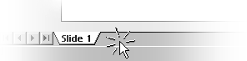
Alternatively one can also click in the area right of the “Slide 1” tab to create a new slide, without any selection dialogue. The new slide has the same layout as the current slide.
- The user will then see “Slide 2”.
- Press OK.
- Click once on the lower text frame and delete it, say, with the Delete key.
- Click in the text frame at the top and enter a title.

- Next insert a 3D object by long-clicking the 3D Objects icon to open its floating toolbar.
- Select the Sphere icon.
- Click on the slide below the Live in 3D text, drag open a 3D rectangle, and then release the mouse button. Voila, a 3D sphere.
- Drag the sphere into the centre of the slide and enlarge it by dragging one of the handles in one of the corners. When dragging, hold down the Shift key so that the sphere remains a sphere.

- Assign an interesting colour or colour gradient to the sphere by way of the list boxes on the object bar. Placing a bitmap as a pattern on a 3D object, for example, a world map from the Gallery is covered in another chapter.

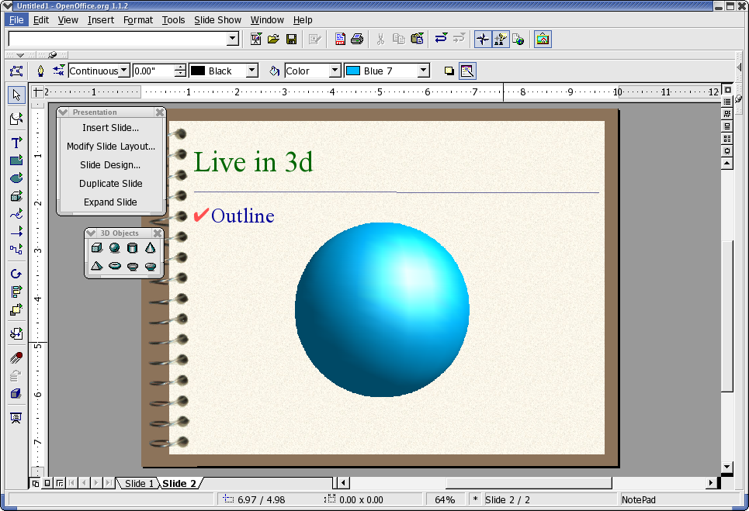
Save the presentation by either pressing the Ctrl+S shortcut keys and specifying the name and location for the file or use File > Save as and again specify the location for storage.

Switching Presentation Views
To the right, above the vertical scroll bar, there are some icons for switching views and for starting the presentation.
Drawing View
Outline View
Slide View
Notes View
Handout View
Start Slide Show

To the left of the horizontal scroll bar in the drawing view, notes view and handout view, see the following icons:
Slide View | Master View | Layer View | Navigation

Arranging Slides
Switch to the Slide View by clicking the respective icon above the vertical scroll bar located at the right of the screen. Now the position of individual slides can be rearranged and effects defined for the transition between slides.

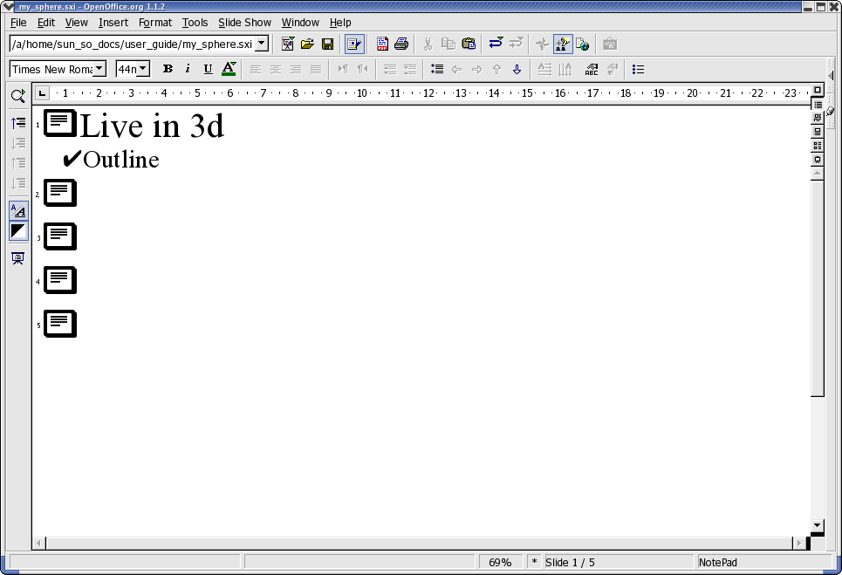
Outline view
In the slide view, change the sequence of the slides by dragging them to any other position in the presentation.
Long-click a slide in the slide view to copy the slide using drag and drop while pressing the Ctrl key. The mouse pointer will have a small plus sign next to it when dragging to indicate a copy. Drag and drop is also possible between the slide views of OpenOffice.org Impress documents.
If the context menu of a selected slide is called up, the Show/Hide Slide command will be seen. One can use this command to temporarily remove the current slide from the presentation, without deleting it from the actual document. A slide that is not shown in the presentation receives a name highlighted in gray.

Incorporating Slide Show Effects
In the Slide View mode, define transition effects to precede the display of each slide:
- Click on the second slide once to select it.
- On the object bar under Transition, select “Automatic” and enter the desired display time for the first slide, for example 00:01:00. That means that the second slide will be displayed for one minute.
- Select a desired effect from the Effects list on the object bar.
- Click the small button to the left underneath the second slide to preview the selected effects.
- Save the presentation again using Ctrl+S or from File > Save menu item.

Showing a Presentation
By following the previous steps there is now a finished presentation ready for display.

To run it, click the Slide Show icon on the main toolbar, and the presentation will start automatically in default mode, that is to say, in full-screen mode.
Click once with the mouse and the second slide will be displayed (preceded by the defined transition effect). After the last slide, a black slide is displayed, which means that the presentation is over. End the presentation by pressing the Escape key. The Escape key may also be used to stop the presentation before the end, as necessary.
At this point, more slides may be added to the presentation or some of the other effects attempted.

Editing Presentations
This section shows how to use the versatile features of Impress to fine tune a presentation. Many of the methods available in Draw can also be used in Impress, such as entering text and converting it into 3D, turning objects into curves and polygons, editing connectors and glue points and so on. For details, please refer to the chapter on Draw.

Defining Background colours
The background of a slide in a presentation or drawing document can be handled either in the master view or by assigning another Page Style to the slides or by modifying the current Page Style.
- Switch to the master view by using the icon in the lower left-hand corner of the work area.
The master view permits editing the background for all slides. All objects that are entered in this view, whether company logos, lines or text, are displayed in the background on all slides that use the current Page Style (the master page). This allows headers and footers on to be reproduced on all presentation slides. Objects inserted in the Master View cannot be modified in the normal Slide View.
- Change only the background used in the presentation using the following steps:
  - Right click in any slide
  - Choose Slide > Page Setup
  - Select the Background tab
  - Choose a colour, gradient, hatching or bitmap for the background.
  - Click OK
  - The next dialogue asks if the settings should apply to all slides or just to the current slide. By answering “Yes” to the question “Background settings for all slides?", the Background Presentation Style will be modified for the current master page and all slides with this Page Style will have the modified background. Answering “No”, means that only the background of the current slide is modified.
- Modify the Presentation Styles in the Styles and Formatting window by following these steps:
  - Open the Styles and Formatting window,
  - Click the Presentation Styles icon, if it is not already selected, to see all existing Styles of this type in the Styles and Formatting window.
  - Select the Background Style.
  - Right-click to open the context menu for this Style and choose Modify.
  - Choose the background for all slides with the current Page Style.
  - Click OK.
Note that this modification is only valid for the current presentation document.

Switching Page Styles
The subordinate designs which make up the slide design determine the way an object looks, including its background. The slide design can also be called a “Master Slide”. In Impress, assign a different slide design to each slide as desired.
- Go to the slide that is to have a different Master page.
- Select Format > Styles > Slide Design... to open the dialogue
- Click Load.... to see the Load Slide Design dialogue.
- Select a new slide design from the dialogue, e.g. from the area “Presentation Backgrounds”
- Confirm this with OK.
- If the Exchange background page check box is checked, the new slide design applies to all pages of the current document. If there is no check mark in it, then this action only applies to the current slide. This provides the flexibility to define a different slide design, and thus a different background, for example, for one single slide. Assuming, that Exchange background page is not checked, the background selected will now be assigned to the slide currently in use.

Presentation Styles
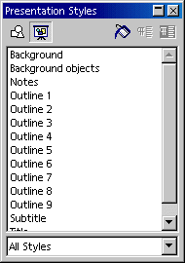
As part of slide design there are a whole set of Presentation Styles that may be assigned to the slides. Open the Styles and Formatting window to see a list of the predefined Styles. Existing Styles may be modified but any modifications are valid only for those slides in the current document that uses this slide design or new Styles created.
The built-in Styles, Outline 1 through Outline 9, enable the user to give the outlined headings and topics on the slides a uniform look.
Open a new, empty presentation with a slide layout that allows greater structural depth. The slide layout called “Title, Text” is suitable for this purpose.

- Activate the outline view mode by clicking View > Master View > Outline View (starting in the Menu bar) or by pressing the F12 key.
Note: The slide layout chosen determines the number of levels of outline. If a slide layout which does not permit any outline is chosen, notice that the outline functions are not available.

Using Outline View
One way to create a completely new presentation is in the Outline View mode. All slide titles appear in a list along with the headings and sub-topics. The hierarchy of the headings as well as the sequence of the slides can be easily modified.
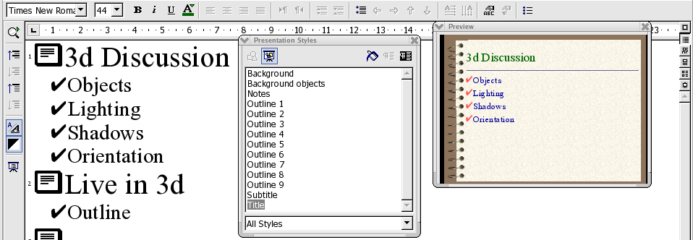
- The preview window should have opened; if not, it can be shown by choosing View > Preview. The Preview window enables the user to view the slide layout, including text, background, and background objects. The Preview window can be at the window border by pressing the Ctrl key and dragging the window to the position of choice.
- Now open the Styles and Formatting window either by choosing Format > Styles and Formatting or with the F11 key or opening it if it is docked.
- The cursor should now be blinking next to the small icon for slide 1.
- Enter the desired text, for example First Page. This will be the title for slide 1.
- Press the Enter key. This displays a small icon for slide 2 in the next line of the Outline view.
- Enter a title for the second slide, for example, Second Page.
- Press the Enter key again to get the small icon for slide 3.
- Now press the Tab key before entering any text. This action ensures that the text entered here will be a subtitle on slide 2.
- Continue to enter more subtitles of the first level on page two.
- Pressing Shift + Tab moves one level up. Thus enabling the user to make a new slide out of a first level sub-topic.
The levels created by following these steps automatically contain the Presentation Styles title, outline 1, outline 2, et cetera. These Styles can be modified by having a new slide design assigned to them, for example, a new font, font size and font colour. These designs can, of course, be edited (for example, via the Styles and Formatting window's context menu).

Slide Transitions, Effects and Animation
With Impress, grabbing an audience's attention using animated objects and interesting slide transitions is easy.

Automatic Slide Transition
When showing a series of slides, use the slide transition effects to present them in an interesting way. For example, the current slide can roll out of the window while the new slides rolls in. This effect is called “roll from left”.
The best thing to do is to assign this effect in the Slide View. Simply click on the third icon from the top in the scroll bar on the right of the presentation window or choose View > Master View > Slide View.

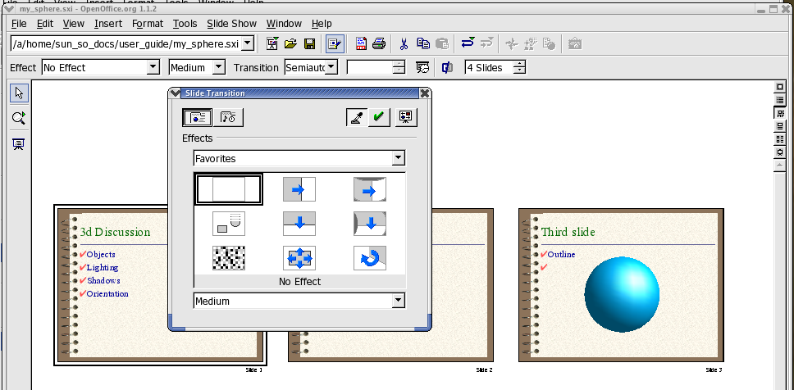
In the slide view, all slides which have a slide transition effect, have a small button. Click this button to preview the selected effect.
The Slide Transition window is described in detail in OpenOffice.org Help.

Effects for Objects
The objects in a slide can have various effects, for example, they can roll into the presentation from the left side, the text can be slowly drawn on screen, et cetera.
- All these effects can be assigned using the Drawing View (View > Master > Drawing).
- Access the Effects window, i.e. with the Effects icon in the Main toolbar.
- Select the object to which to apply the effect.
- Open the Effects window
- Select the desired effect.
- Click the Assign icon in the Effects window, or double-click the effect to assign it.
- An object can also be faded in (Effects button) and, additionally, faded out (in the Effects window, on the Extras tab click the Object Invisible icon) per mouse-click.
The Effects window is described in detail in OpenOffice.org Help.

Selecting Hidden Objects
- To select an object that is completely covered by another object, click on its position while holding down the Alt key.
- If several objects are lying on top of one another, every Alt+click selects a different object lying in this position. Hold down Shift as well to click through the objects in the reverse order.
- Press the Tab key to select an object. Press Tab again to select the next object. Press Shift+Tab to go through the objects in the reverse order.

Individual Presentations
A slide show presents the slides in sequence, from beginning to end. To start presenting the slides in the presentation, either click the Slide Show icon on the main toolbar, or use the keyboard shortcut Ctrl+F2.
Presentations usually start with the first slide; however, to begin with the currently selected slide, proceed as follows:
- Choose Tools > Options > OpenOffice.org Impress > General.
- In the area Starting the presentation, check the Always with current slide box.
Note: that this setting has priority over the Individual Presentation described below.
Other options permit the user to show only or to never show certain slides:
- To prevent display of a slide, go to the Slide View (for example by choosing View > Master View > Slides View), select the slide and select Slide Show > Show/Hide Slide .
The name of the selected slide will now appear highlighted in gray, meaning that the slide will not be shown.
- Choose Presentation > Show/Hide Slide again when the slide should be included again.

A more elegant way to keep individual slides hidden in certain presentations can be found under Presentation > Custom Slide Shows.

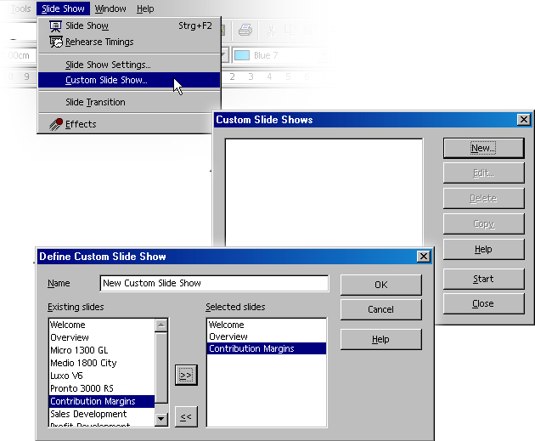
- Open the Slide Show > Custom Slide Shows dialogue,
- Click the New button. The Define Custom Slide Show dialogue appears.
- In this dialogue, enter a name for the presentation. On the left, there is a list of the existing slides. Select a slide to show in the custom presentation and click the button with the arrows pointing to the right.
- The slide will be inserted in the right field. Any slide listed on the right will be shown in the custom slide show.
- Rearrange the order of the slides in the right field via Drag&Drop.

Exporting, Printing and Presenting
There are many possible ways of outputting finished presentation documents. For example, electronically display finished presentations, print the pages in colour on paper or print high resolution transparencies, or transfer them wholly or partially to other applications and then use them within those applications. Printing offers a choice between outputting the document directly to a printer, or printing it to a file that may then be copied to a printer.

Printing a Presentation Slide
In Impress, the current document is easily printed by clicking the Print File Directly icon in the function bar. Printing is immediate, according to the printer default settings, and no dialogue appears. There is an exception in text documents where a certain area of text is selected and, in this instance, a dialogue appears upon clicking the Print icon. This dialogue asks for confirmation of printing the whole text or only the selected area.
When printing via the Print dialogue, Impress offers choices of whether to print only a selected range of pages, only certain pages identified by their page numbers or all pages of the document. Take a look at the print dialogue, which is opened via File > Print or by pressing Ctrl+P.
The appearance of the Print dialogue may vary according to the selected printer. However, in most cases, there are options to specify whether to print the entire presentation, certain slides, or only the current selection. Other options specify how many copies to print and how these should be collated.
Click the Options... button in the Print dialogue to display additional options. When printing text, drawing and presentation documents, the Brochure option is available for two-to-a-page text on a single sheet. The size of the pages is reduced and printed in two columns per page and double-sided, so that the pages need only be folded and fastened in the middle to create a complete brochure.
Since presentation objects are usually in the form of vector graphics, they can be printed out in any resolution supported by the local printer or film recorder. Where the slides are to be sent to a film recording service or to be printed on a high-resolution colour printer in a print shop, mark the Print to file check box in the Print dialogue. It will then be printed to a file that can be sent to the film recording service or commercial printer.
Note: first install and select the printer driver for the printer or film recorder that will be used by the printing or film recording service. Most printing and film recording services require files created for a PostScript printer. If there is no PostScript printer available, OpenOffice.org permits installation of a PostScript printer driver that can be used to print to a file. On UNIX-based systems, use spadmin to active this driver.

Exporting Presentations as Web Pages
When the Web Page export file format is chosen, Impress automatically starts an Wizard to help produce an attractive HTML presentation. A number of HTML pages are created that are connected to one another by hyperlinks and in which the graphics are saved as GIF or JPEG images. One can work on these HTML pages in Writer to give them headings and additional hyperlinks, for example.
- Select File > Export...
- Choose the file format HTML.
- Enter a file name
- Click Save.
This opens the HTML Export Wizard. This Wizard is described, in detail, in OpenOffice.org Help.
In the HTML Export Wizard, choose whether the created Internet presentation should contain frames, be navigates using graphic buttons or with text links and whether a link should be offered on the home page allowing the user to download the original Impress presentation.

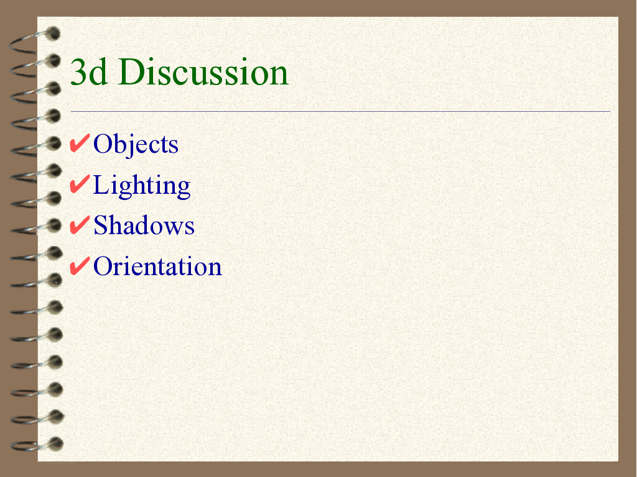
In addition to the export of default HTML documents and HTML documents with frames, Impress documents can be exported as WebCast or in the automatic mode.
- WebCast export automatically produces scripts for web servers with Perl or ASP support. This format allows a presenter (e.g. during a telephone press conference with accompanying slide show over the Internet) to change the slides on the viewers' browsers.
Note: Examples can be found in <instdir>/OpenOffice.org<release>/share/config/webcast where <instdir> is the directory in which the network or standalone installation is located.
- Automatic export takes over the settings for the viewing time of each page in the presentation. A default HTML presentation is the result, in which the pages are “turned” automatically.
Sound reminders for turning the pages can also be exported, if desired. The sound files would then be copied in the target directory and played back when a HTML page is loaded.

Exchanging Data via the Clipboard
Objects in a drawing or presentation document can also be copied to the clipboard and then inserted elsewhere. The objects are stored as vector graphics on the clipboard using the following procedure:
- Select an object in the current document
- Copy it to the clipboard with Ctrl+C.
- Switch to the application into which to insert the object.
- Insert the contents of the clipboard at the desired location with Ctrl+V.

Creating a Business Report
This section explains how to create a business report for a presentation. In the following example, it is assumed that the presentation will be shown via a computer.

Creating a Business Report in Presentation Form
Since OpenOffice.org Impress has no business report template, this section will start with a completely new document. To start, follow these steps:
- Create an empty presentation document (File > New > Presentation). Using Wizard Presentation is described quite well in OpenOffice.org Help.
- Select Empty presentation
- Click Create. This brings up the Modify Slide dialogue where the appearance of the first slide can be defined.
- Enter a name and select the desired layout, e.g. Title slide.

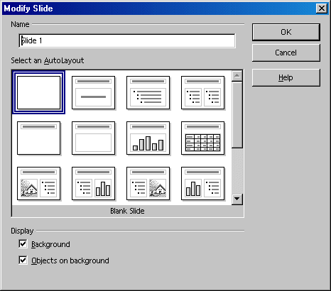
- On the “Title slide” click on the existing text and overwrite it with appropriate text, for example “Elegy Software” and “Annual Report 2003”.
- To insert another slide, click the area next to the tab at the bottom of the screen. Assign a name for the new slide and choose a layout (in the context menu of the slide tab, click Modify Slide).
Note: Do not assign a name like “Slide2.” If the order of the slides needs to be changed later, the label might not describe the content of this slide. Clear, descriptive names like “Overview” or “Introduction” are more useful.
Insert additional slides, as necessary, from the insert menu on the main toolbar (a long click may be needed). The corresponding tabs appear at the bottom of the screen. Click the tab of the slide to edit, e.g. Overview, and then click the Outline View icon above the vertical scroll bar.

Entering Text in the Outline View
To establish an outline, use the Outline View mode. Using the icons in the object bar, promote or demote an outline point one level, or move it up or down in the hierarchy. The icons in the main toolbar can also be used to determine which outline levels are to be displayed.
In the Outline view, all slides in the presentation document are listed hierarchically, and the title of each slide is preceded by a slide icon.
Enter the desired text and use the icons in the Main toolbar to structure the outline. Create a subsection to a slide by placing the cursor at the start of the respective line and pressing the Tab key. Use the Shift+Tab key combination to move the line up one level in the hierarchy. After completing the edit of the presentation outline, click the Drawing View icon (directly above the Outline View icon) to return to the normal view.

Changing the Slide Layout
Changing the slide layout can only be done while in the Drawing View (the first icon in the vertical scroll bar). Double-click the tab of the slide to modify and select the desired layout from the predefined layouts.

Designing Slides
Designing a slide can only be done in the Drawing View, and the Select tool must be activated.
To change the font size and style of the title, for example, select it and assign new attributes from the Font and Font Size fields in the Object bar.
Borders may be defined by clicking the paragraph to which to apply the border and defining the attributes in the list boxes Line Width and Line Style.
To apply a uniform background and recurring elements (company name, subject) to all slides, click the Master View icon to the left of the horizontal scroll bar. The default texts in the master view may be safely ignored as these are not visible on the slides. The only text visible on the slides is that which is entered by the user. Using the Text floating toolbar on the main toolbar, a frame can be opened for background text.
Using the Styles and Formatting window is an excellent method for managing the appearance the slides. Here is a step-by-step procedure:
- Open the Styles and Formatting window by clicking the Styles and Formatting icon in the Formatting toolbar.
- Click the Presentation Styles icon.
- Select a background style, and
- Open the Modify dialogue via the context menu.
- Click the corresponding slide tab and make any changes.
By modifying the Background Style, all slides can be assigned the same background.

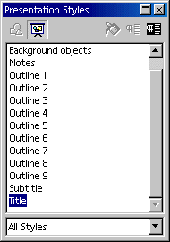
Note: Since the Master View can be activated at any time, it is always possible to make changes at a later time.

Creating a Slide Show
In completing a slide show, it is necessary to take a few additional steps to ensure a successful presentation.


Defining or Changing Slide Order
To change the slide order, click the Slide View icon above the vertical scroll bar. In this mode, all slides in the presentation document are displayed in reduced size. Click the slide to be moved and drag it with the mouse to the desired position. The position where the slide will be inserted is indicated by a vertical black bar.

Creating Cross-Fade Effects
To apply cross-fade effects, one must have Impress in the Slide View or Drawing View.

Click on the slide when in the Slide View mode. Set the effect and transition period that is to apply to the slide Transition using the two left list boxes.
In Drawing View, choose Slide Show > Slide Transition to bring up the dialogue in which slide transition effects are defined. In the Slide Transition dialogue, select the option Manual Transition which will switch from one slide to the next in the presentation on clicking the mouse or pressing the right arrow key.

Starting Presentations
The easiest way to start a presentation is by clicking the Slide Show icon on the main toolbar or choose Slide Show > Slide Show. The on-screen presentation starts immediately. Presentation settings can be adjusted under Slide Show > Slide Show Settings.
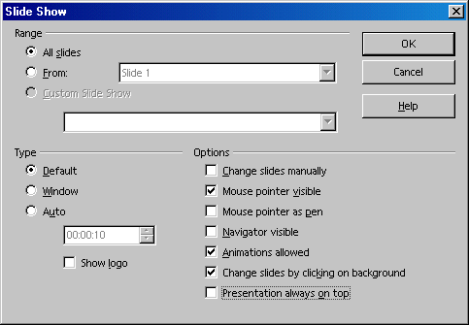
This dialogue also lets the user determine which slides to include in the presentation. Select any other desired options, and click OK.

Working with Connectors
In addition to the individual frames, connectors are important components of an organization chart because they help represent the relationships within the organization. Impress provides a variety of connector types. Click on the Connectors icon in the Main toolbar, and a floating window with the available types appears.

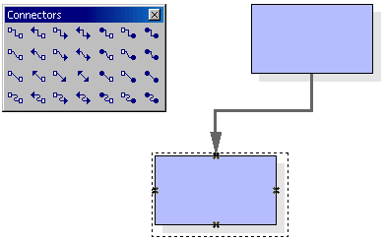
Frames and connectors can be linked either from “edge to edge” or from “middle to middle,” or a combination of both. These possibilities are described below.

"Edge to Edge” Connectors
Select the desired connector by clicking it, and then drag it to the first frame. A small symbol is displayed on every edge of the frame. Put the mouse pointer on one of the symbols (the symbol will be given a dashed-line border). Press the mouse button and drag the connector to the desired frame. As soon as the mouse touches the frame, symbols appear on each edge here as well. Continue dragging the connector to the desired symbol(that symbol also receives a small, black border) and release the mouse button.
When a frame that is connected to another frame is moved, notice that the connector also changes position. The actual connection line between the two frames remains the same, so that for minor shifting of the frames, the connector usually does not have to be edited. With major frame movements, however, it is often necessary to reedit, because the connector may shift to a different position.
To change the position of a connector, simply click on it. Small points appear, at both the beginning and end of the connector. If the cursor is rested on one of the points, a small square appears next to the mouse pointer. Press the mouse button and drag the beginning or end point to the desired frame.

"Middle to Middle” Connectors
If a connector is selected from the Connectors floating toolbar and click in the middle of one of the frames, a black, dashed-line border appears around the entire frame. Press the mouse button and drag the connector into the middle of another frame, which also receives a black border, and release the mouse button.
The advantage of this method is that when the frames are moved later, the connector fits perfectly, so that the beginning and end of the connectors lie in the middle of each frame. This function comes in handy in switching the position of two frames because the connectors need not be edited manually.

Editing Connectors
To change the properties of a connector, select it and click Connector... in the context menu to open the Connector dialogue.

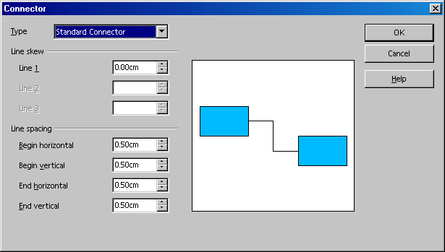
Choose the desired connector type from the list box. The Standard Connector is the default. The user can also modify the line skew and the line spacing in this dialogue. All changes will be shown in the small Preview window. To apply a different colour to the connector, open the Line dialogue with the context menu. Hints and Tips for a Successful Presentation

Using a Snap Grid
To work with greater precision, use the grid function. To display a grid, click the option Use Snap Grid under Tools > Options > OpenOffice.org Impress > Grid. In addition, one can also select Visible Grid to help position the objects more easily.

Editing Glue Points
By default, the connectors dock to the handles in the centre of the object pages. However, using the glue points, the user can make the connectors dock to any point of an object. For detailed instructions, refer to the Help > Contents > Index > Search term > glue points; using.

Hints and Tips for a Successful Presentation

Using the Mouse as a Pointer
There are occasions when using the mouse as a pointer is preferable to other methods, such a a laser pointer. To use the mouse, select the option Mouse pointer as pen in the Slide Show dialogue. This allows highlighting charts or pointing to important aspects during a presentation. To change slides manually, double-click the mouse.

Changing Bullet Symbols in Outline View
To change a bullet symbol whilst in the Outline view, place the cursor in the desired line/paragraph and click the Bullets and Numbering icon (only visible in the Object bar of the Outline view). A dialogue appears from which to choose a different symbol.

Inserting, Deleting and Renaming Slides
- To insert an additional slide, do the following:
  - Select the slide that precedes where the new slide will be put.
  - Now click the empty space between that tab and the horizontal scroll bar and a new slide appears with the page layout of the previous slide.
Alternatively, choose Insert Slide from the context menu of the slide tab area. In the Insert Slide dialogue, assign a name to the new slide and define a layout.
- Deleting a slide is easy.
  - Click the tab at the bottom of the work area to activate it and
  - Open the context menu.
  - Choose Delete Slide and
  - Confirm the subsequent warning with Yes to delete the slide.
- Likewise renaming a slide is simple. To rename:
  - Select the respective slide by clicking the name on the tab,
  - Press the Alt key and
  - Click the slide name again. The old name will be selected and can then be overwritten.

Creating and Printing Handouts
Providing handouts, to help the audience follow a presentation, is often useful. To prepare handouts, use the Handout View mode. Since the handouts contain both the individual slides and space for notes, they can be a very helpful presentation aid.
In the vertical scroll bar, click the Handout View icon. Open the Modify Slide dialogue via the context menu (Slide - Modify Slide...) to specify how many slides are printed on a single sheet of paper.
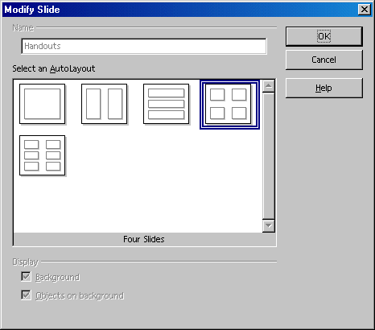
Click OK to create the handouts. To print them, choose File > Print and click Options to open a dialogue in which the user chooses how the handout should be printed.

Organizing and Printing Notes
Enter notes for individual slides in the Notes view. Access the Notes view using the Notes icon located at the right of the document window scroll bar.
- Once notes are entered, print them by selecting File > Print... then click Options.... The Printer Options dialogue appears.
- In the Printer Options dialogue, in the Contents area, select Notes. Click OK. In the Print dialogue, select the slides for printing (all or specific ones) and click OK. Be sure to go back and deselect Notes in the Printer Options dialogue, otherwise the document will always be printed with notes.
Note: The settings in Printer Tools apply only to the current document. For specific settings for all presentations, choose Tools > Options > OpenOffice.org Impress... and select the Print tab.

Using the Navigator
Move quickly from slide to slide by opening the Navigator (function key F5). All the slides of the presentation are listed here. Simply double-click the relevant slide title to jump to that slide.

Edit Jump Targets
In the bottom corners are areas for which one can define an interaction. To edit or view the interaction, click (again in background mode) on the area while pressing the Alt key and open the context menu and choose the Interaction command.

Modifying Object Size
To change the object size, drag a selection frame around the respective objects.
After selecting the frames, open the Position and Size dialogue from the context menu. In the tab Size, apply the same size to all selected frames under the group box Size.
Note: Alternatively, rather than using a selection frame, click on the individual objects and press the Shift key at the same time to make a multiple selection.

Creating Additional Objects
For additional objects, copy one and simply insert it as often as necessary. Then, position the rectangles in the document and align them using the snap lines.
Note: To display vertical and horizontal snap lines, click on the respective ruler and drag a snap line from the ruler to the desired position.

Changing Font and Font Size
Change fonts and font sizes using a Style, so that these changes once only have to be made once. Click in one of the frames and open the Styles and Formatting window. The Graphics Style Object with shadow is selected. In the context menu, choose Modify to open the Graphics Style: Object with shadow dialogue, and click on the Font tab to define the desired font type and size. Upon clicking OK, the text in all of the frames will be displayed according to the selected settings.

Modifying colours

To assign a different colour to a frame, use the mouse to drag a selection frame around the respective frame. Select Area in the context menu to open the dialogue of the same name.
Select a colour on the Object Fill tab. Further design options are available with the various colour schemes in the Gradients tab. Choose one of the existing colour gradients, all of which can also be edited and modified.

