Chapter 11: Using OpenOffice.org Math

Formula Entry
Main View of OpenOffice Formula.

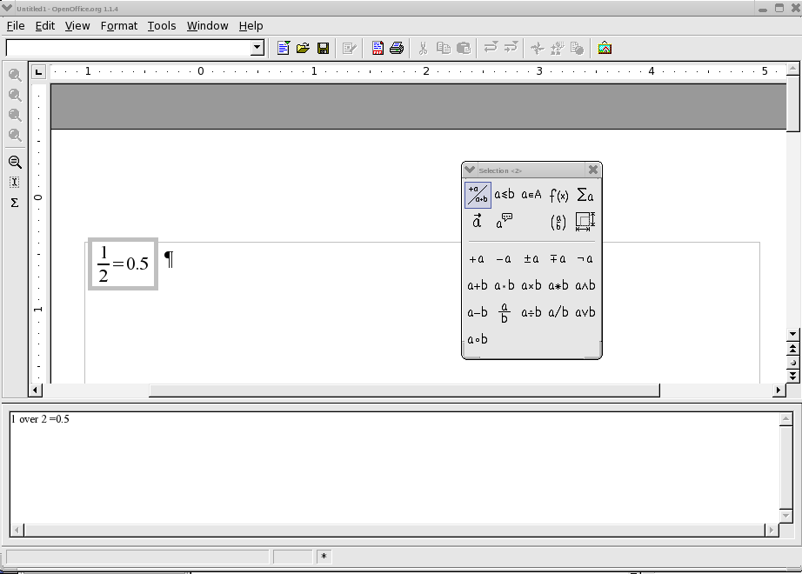

Tool bar
The tool bar is divided into two parts.
The upper part is for adjusting the on screen size of the image. The lower part contains an icon for an interactive cursor, and an icon for inserting special characters.

Command Icon Box
The command icon box provides a method of writing an equation using GUI similar to other word processors.

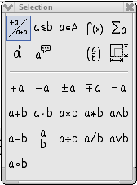
The upper two rows in the icon box are menus that call the actual command buttons into the lower portion of the command box. The command buttons are used to insert the appropriate command at the cursor position in the command field.

Command dialogue Box

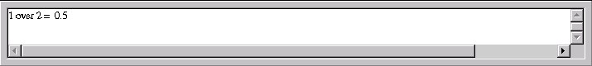
The command dialogue box displays the commands that create the equation. The dialogue box can be edited directly.

Creating an Equation with dialogue Commands
To create an equation with equation editor, enter the programming commands in logical sequence into the dialogue box. The commands entered are similar to the commands used to generate equations in TeX ( a scientific publishing format).
Maintaining logical consistency of the commands entered into the dialogue box is important. The brackets used in the dialogue box must be matched, for example all "(" must have a corresponding ")".
Here are some examples. As can be seen, it is really simple to type formulae in the dialogue box.
Command Input Field | Formula
1+1=2

The next example shows how round brackets ( ) and braces { } are used. The parenthesis are used when it is desired to display grouping in the equation, the brace is used to group the commands, but to not display. If braces are needed in an equation, then the lbrace and rbrace commands are used.
Command Input Field | Formula
(1+2) over (2+3)
{ 1+2 } over { 2+3 }
lbrace 1+2 rbrace over lbrace 2+3 rbrace

Here is a more complicated example.

Command Input Field | Formula
{{1 over 5} +4} over {5+{4+1}over{3+3+1}}

Special Formating
Of course there are many other types of groupings that can be created with Open Office.

Exponentiation:
Command Input Field | Formula
2^3
5^(1+3+3^2)

Subscripting:
Command Input Field | Formula
2_3
(1 over 2)_%alpha +4_3

Leading and trailing superscript and subscript:
Command Input Field | Formula
2 lsub ( 123 )
2 rsub ( 123 )
2 lsup ( 123 )
2 rsup ( 123 )
Bi lsup{209}+fe lsup{58} toward Mt lsup{266}lsub{109} +n lsup {1}

In the last example, the 'Mt' has both leading superscript and subscript applied. This requires only typing both commands after 'Mt'.

Centre subscript / superscript:
Command Input Field | Formula
{2-4*3} csub ( 123 )
+18 csup ( plus ) - (1+2+3+4) csub {minus}

Under brace / Over brace:
Command Input Field | Formula
+ 18 underbrace plus - ( 1 + 2 + 3 + 4) underbrace minus
+ 18 overbrace plus - ( 1 + 2 + 3 + 4) overbrace minus

Various types of Brackets
In almost all equations various types of brackets are required. OpenOffice formula allows the use of several kinds of brackets.
{ } structural braces: used to group parts of an equation for programming purposes.
( ) Parenthesis: used to group parts of an equation. Parenthesis are displayed in the final equation.
[ ] square brackets: usage is the same as parenthesis ( ).
{ } braces: as the keyboard characters { } are used for program commands and are not displayed in the resulting formula, braces must be typed as lbrace for '{' and rbrace for '}'
The size of brackets can be controlled with the commands 'left' and 'right'
Command Input Field | Formula
(1+2 - 2 cdot (2 over (2 - 1 )))
left (1+2-2 cdot left (2 over {2-1} right ) right )

left lbrace a^2+b^2=c^2 right rbrace

Special Characters
Many equations use special characters in addition to the usual characters of the alphabet. Open office provides an easy method to use Greek characters, while any other character in the available fonts can be used.
The Sigma appears in the tool bar when Open Office Formula is active. This activates the dialogue for special characters.
The Greek letters and other symbols can be entered directly into the command dialogue box by entering the name of the special character followed by %, for example %SIGMA produces and %mu gives .

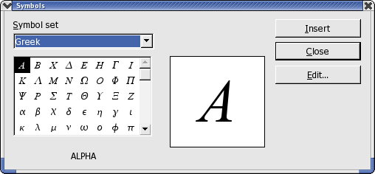

Special Operators
The following examples show the use of some special operators

Integral Sign:
Command Input Field | Formula
int from {0} to {infinity}{a^2 over 3} = "?"

Summation Character:
Command Input Field | Formula
sgn (%sigma) cdot sum from {%SIGMA in %PHI}{1 over {1 - aleph_%sigma^2}}

Product Character:
Command Input Field | Formula
prod from {i=1} to {i=100}{{ (x_i+1) cdot x_i^3} over { x_i^2 -1 } } = "?"
5^(1+3+3^2)

Vectors and Matrices
Vectors and Matrices are created by the 'stack' and 'matrix' commands respectively. These commands are used with the octothorp # to indicate elements, and double octothorp ## to indicate new line. An empty element is indicated by structural braces {}.

Vector
Vectors are composed using the 'stack' command as follows:
Command Input Field | Formula
left (stack {A # B # a+b=c } right )
left( stack {alignr 1 # 2 } right) + left( stack { 2 # 3 } right) + left( stack { 3 # 1 } right)

Matrix
Matrices are composed using the matrix command as follows:
Command Input Field | Formula
left( matrix { 1 # 2 ## 2 # 3 } right) = x
abs matrix { a # b ## c # {} } = y
abs matrix { {1 over 2} # b ## c # d } = z

Formatting
There are some additional formating commands that are available in Open Office Formula. These allow adjustment of the size, colour, and layout of the equation.

Size
The instruction size changes the size of text in the equation.
Command Input Field | Formula
size -2 { a+b} = size +10 {C}

Colour
The instruction colour changes the colour of the text in the equation.
colours available are red, blue, green, yellow, white, and black (default),
Command Input Field | Formula
colour blue A
left( matrix { { colour red 1} # { colour blue 2} ## {colour green 3} # 4 } right) = colour black {x}

Layout
Various text formating commands are available to change the layout.
Command Input Field | Formula
bold {"bold"} newline "newline"

Alignment
The alignment commands are available to change the position of the elements of an equation with respect to each other.
Command Input Field | Formula
stack{ alignr a ={} # alignr b+c+d ={}}
stack{ alignl 12 # alignl b^2-2 }
5^(1+3+3^2)

Examples
Now for the complicated examples:
Command Input Field | Formula
nroot{4}{nroot {3} {1 over 3+x^2} }

ldline R_ %alpha rdline =left ldline matrix {sin %alpha # -cos %alpha ## cos %alpha # sin %alpha} right rdline
{partial over {partial t} x(t)}+a(x)=%lambda cdot F(x,t)
matrix{
a_11 # a_12 # dotsaxis #a_{"1m"} ##
a_21 # a_22 # dotsaxis # a_{"2m"} ##
dotsvert #dotsvert #dotsdown #dotsvert ##
a_{"n1"} # a_{"n2"} # dotsaxis #a_{"nm"}
}
sqrt{1-x} = 1 - x over 2 - 1 over 2 x^2 over 4 - dotslow
t= size +6 int from {r_0} to {r_t} size -8 {dr over sqrt {2 over %my [E_cm - V(r)] - l^2 over {%my^2 r^2} } }
left ( stack{n # k} right ) = fact n over {fact k cdot fact (n-k)}
f(x) = left lbrace matrix {1# x in setZ ## 1 over x # x in setQ ##0 # x in setR } right none
[a;a_0,a_1,a_2,dotslow ] = a+{1 over {a_0+1 over {a_1+{1 over {a_2+1 over dotslow}}}}}

