Index of Tables
Table 1: First Empty Table 2
Table 2: Second Empty Table 2
Table 3: Nth Empty Table 3

You will notice that this index is designed not to support hyperlinks (note lack of button):
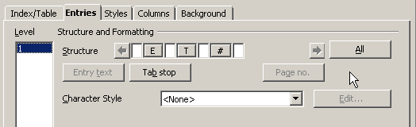
The only way I found around this is to insert the table as a Table of Contents, disable Outline, enable Additional Styles and move Style “Table” to column #1. Then, go to Tools->Outline Numbering and 'reserve' Level 9 (or 10, who cares) and assign it “Table” style. Update ToC and hyperlinks work:

List of Tables with Hyperlinks
Table 1: First Empty Table 2
Table 2: Second Empty Table 2
Table 3: Nth Empty Table 3

If you hover over the links, you get some weirdness, but it works and that's how I got around this.

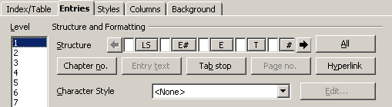
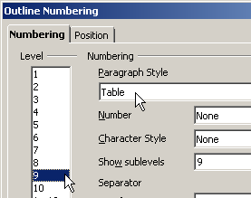

Table 1: First Empty Table

Blah blah

Table 2: Second Empty Table

Blah
Blah

Table 3: Nth Empty Table

