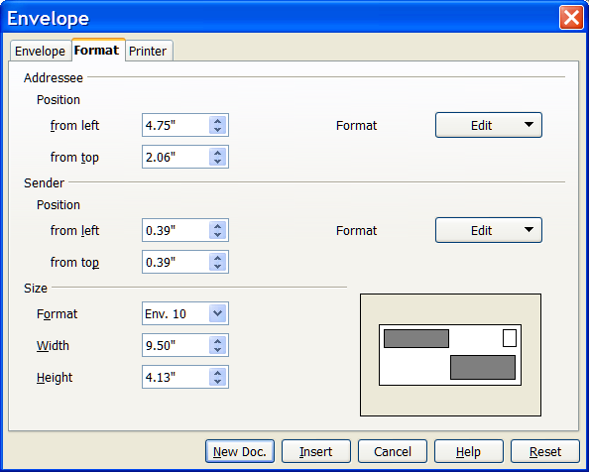
I am able to duplicate the problem in issue 73525 using Ooo 2.2 as follows. I right click on the Quick Starter icon and select Text document. After the document opens I select Insert --->Envelope. On the Format tab under Size I select Format Env.10.
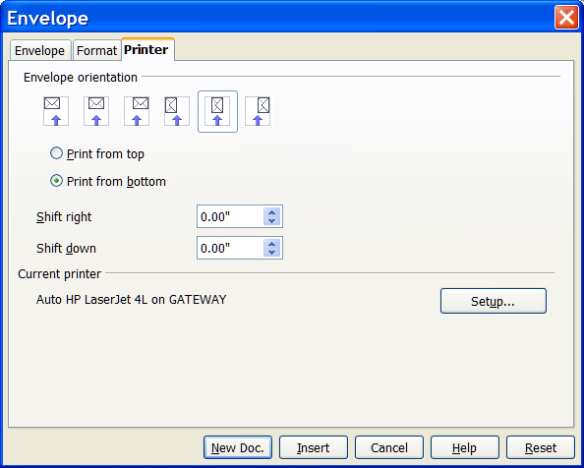
I then select the Printer Tab and under Orientation I select Print from bottom. I then select the “Print in the middle icon”(second from right) and click Insert.

After I click Insert the resulting envelope has a top margin of 2.19 inches and the Paper Format is set to User as shown in the figure below. If I click on the “Print at the right” icon in the figure above then the envelope top margin is set correctly at 0.00 inches. I have a HP Laserjet 4L and an HP Deskjet 710C and can duplicate the problem with either printer. I originally reported this problem with Ooo 2.1.
I've included the link to the original posts:
http://www.oooforum.org/forum/viewtopic.phtml?p=199928&highlight=enevlope+printing#199928



