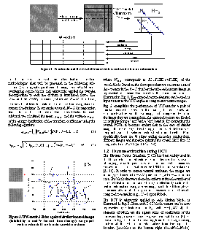
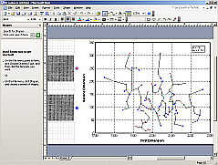
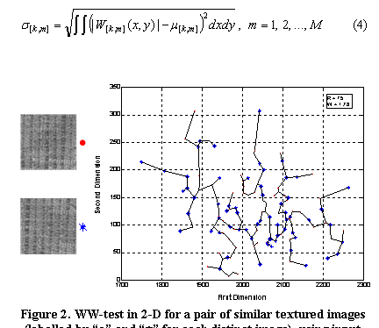Figure 1: Normal MS Office Image
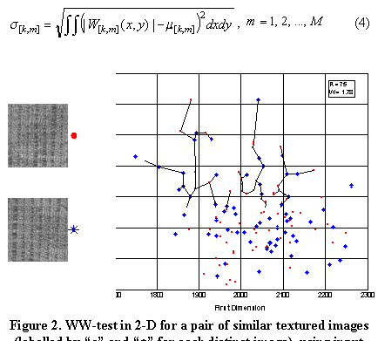Figure 2: Wrong OpenOffice Image

When I try to open a Document written in MSOffice 2003, all are imported good, except from an empeded object made in Vision 2003. This object should look as the the one of Figure 1.

Open Office really makes the figure Not only to be in "bad shape" (there are no dotted lines in the figure) but also it doesn't show some parts of the figure (vertical axis).

If I use EDIT or OPEN commands, Vision Opens to edit the figure:

I close vision and then the image in Open Office is like Figure 3.

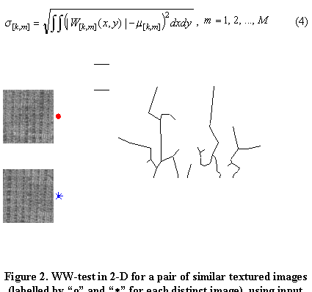Figure 3: Wrong Open Office Figure

The Schematic is totaly destroyed! And I can do nothing to revert it back, or fix it, either if I edit it in Vision.

In order to confirm that something is not working ok, take the OLE Object I get in the document. Open it with vision 2003 (sometimes it stack - i dont know why - and I close the called vision 2003 appliacation via task manager to unstack) and then exit the vision. The figure will ruined. NOTE: Although all points are connected via Lines (Fig.1), in this graph, only few points seems to be connected. There is a serious viewing problem!

Second Example:

