Draft specification for issue 56629, relative links in OOo PDF Export filter

Solved issues
i56629, i64585.

i49415: it seems solved using the feature proposed in this specification, since it refers to PDF link targets.

i40318, page names exported as bookmark in Impress (and Draw) when exporting to PDF.

Perhaps i56059, but it's not clear from the issue request if it fits in here.

Abstract
2.4.0 Relative links to file system only, export OpenOffice.org bookmark, add bookmark pane to PDF files from Impress and Draw (page names become bookmark).

Acronyms and Abbreviations
PDF named destination - defines a particular view of a document, consisting of the page of the document to be displayed, the location of the document window on that page,and the magnification (zoom) factor to use when displaying the page. In this case the destination is referred to using a name.

URI - resolve a uniform resource identifier.

Link Action to a URI – represents a hypertext link to a destination represented by a URI (see above).

Link Action as Launch Action - represents a link that launches an application, usually to open the file, represented by a file specification.

Link action as Remote Go-To Action – changes the view to a specified destination (page, location, and magnification factor) in another PDF file, specified by a file specification.

See PDF specification V. 1.4 for further details.

Goals
The PDF document exported with the OOo can contains hyperlinks that can point to targets internal to the document or external ones.

Currently the external targets are resolved as absolute links and the jump to the target is performed as an absolute “link action to a URL”.

The idea is not only to implement the relative link part, but add other useful capabilities to the PDF export filter.

The main idea is to have the possibility to go from a PDF document to a precise spot (bookmark) in another PDF document, provided that both PDF documents were generated with OpenOffice.org or the bookmarks in the target PDF document are known in advance.

Using this new capability a documentation set to be delivered in PDF format can be maintained in separated units, linked each other where the author (or the authors) consider meaningful.

The hyperlink in the OpenOffice.org document can be filled in the standard way, if the destination is for example a page in a Draw document, the hyperlink, when filled in, will look like:

“file::///Server/folder1/folder2/my doc.odg#pageone”
meaning that the destination is in document file::///Server/folder1/folder2/my doc.odg, bookmark 'pageone'.

After exporting to PDF using one of the selection proposed below, in this case “Navigate using Internet browser”, if the document being exported is in “file::///Server/folder1”, the exported link will look like:

“folder2/my doc.pdf#pageone”.

The semantic meaning of this link, for Acrobat Reader, is “open file 'folder2/my doc.pdf' relative to current file position, then go to bookmark 'pageone' ”, in the selection “Navigate...” indicated above, the operation will be performed through the Internet browser and the plug-in for PDF file available (usually Acrobat Reader plug-in); if the selection were “Navigate using reader application”, the operation will be performed by the reader, in case of Acrobat Reader by opening the file on new window if so preset in user configuration.

To have all this working the target document:

“file::///Server/folder1/folder2/my doc.odg”

should have been exported by OpenOffice.org with the selection “Export bookmarks to PDF destinations” active, and so have a destination named 'pageone' inside.

In short:
- prepare the documents the normal way by adding bookmarks where you need to jump to from another document;
- add hyperlinks using the standard OpenOffice.org dialog, connecting the documents as needed;
- generate the PDFs.

If the document is not of the PDF type, the reader application or the plug-in will behave depending on the main selection used to export the 'source' document, e.g. depending which way the hyperlink are generated.

A detailed explanation is give in section 'Behavior explanation', after the proposed dialog implementation.

Proposed implementation
A new tab is added to the current PDF export dialog.

1
2
3
4
5
6
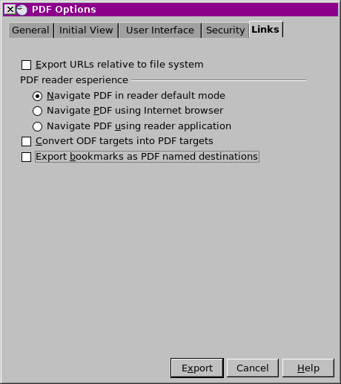Illustration 1.: Proposed new 'Links' tab (preliminary).
The new 6 controls are:

- position 1 controls if the links are to be exported relative (selected) or not (unselected) with respect to the current document file system location (the one of the document, not the one where the PDF is exported to). It works for file system only.
This selection is independent from the one in Tools > Options. Default value unchecked.
- position 2: mutually exclusive with position 3 and 4, does nothing on the links, they are all exported as URI, relative or not according to selection made on 1. This is the default
- position 3: mutually exclusive with position 2 and 4, to be selected if the produced PDF files will be explored (read) using an Internet browser with the correct plug-in
- position 4: mutually exclusive with position 2 and 3, to be selected if the produced PDF files will be explored (read) using the reader application.
- position 5: this selection is to be checked when the document extension (odt,odp,odg,ods) should be converted do pdf. This will happen in the exported PDF document only, the source document will be left untouched.
E.g. A document with the name AsimpleText.odt will be converted to AsimpleText.pdf (comment on necessity of other file extensions to check for, or to strip this out, will be much appreciated...).
This will work for open documents only. Default unchecked.
- position 6 when selected, PDF named destination will be created according to the following:
Writer documents: the bookmarks will be converted to PDF named destinations.
Calc documents: the sheet names will be converted to PDF named destinations.
Impress presentations: the page names will be converted to PDF named destinations.
Draw documents: the page names will be converted to PDF named destinations.
Default unchecked.

Behavior of 2.3.0 PDF Export dialog controls affected by this update
The “Export bookmarks“ checkbox on “General” tab now has the added ability to control the Impress and Draw page names export as bookmark for the bookmark pane in the reader application.

Behavior explanation
All the behavior was tested... (report the test part from the other doc...)

Limitations

In case of a named destination in a target PDF not generated by OpenOffice.org, the name of the target destination should obey to the 'changing' rules proposed here.

(show the way the destination name is adapted in order to work both on the browser and on the application without problem, show the 'cheaper' chars to be used for bookmarks).

On line Guide Notes

Q&A notes

