Test_SetDialogHeight_2.4.0

Starts simple dialog,
choose value to change height and see what happens with the width ..

cn 1-4-08

start
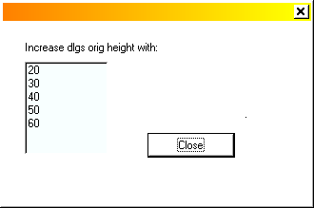
after multiple changes


