How to print an envelope using Open Office
- Remove paper from printer, and load envelope(s) face down, top edge against right side of main tray. DO NOT USE THE SLOT ABOVE THE TRAY AS THIS RESULTS IN CRUMPLED ENVELOPES. | - From the Insert menu, select Envelope...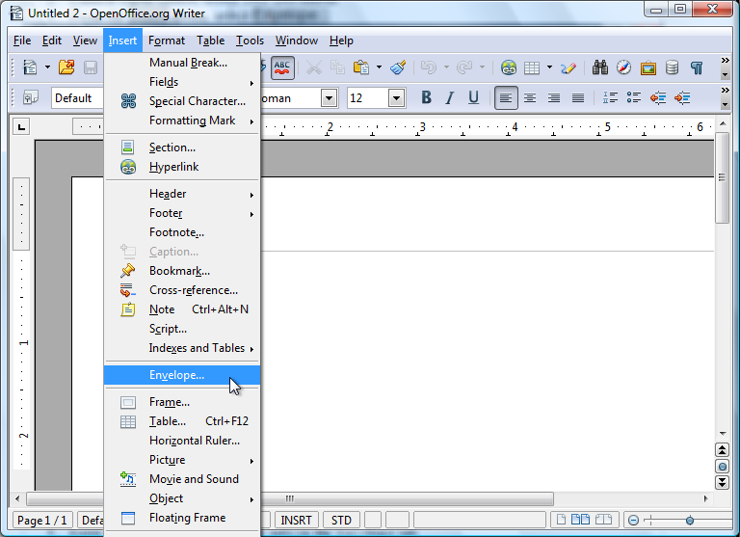
Enter the Addressee and Sender info in the Envelope tab  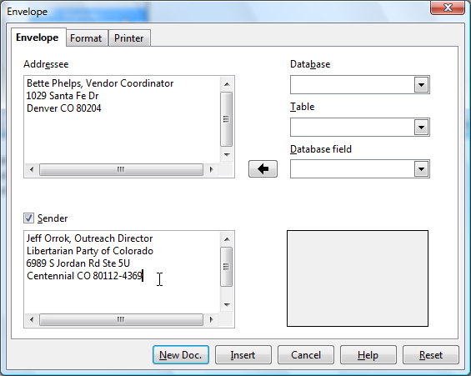 | - Select Env. 10 (or appropriate envelope size) from the Format item in the Format tab  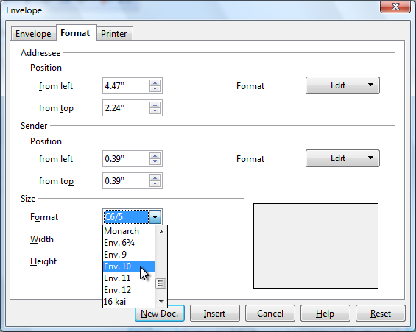
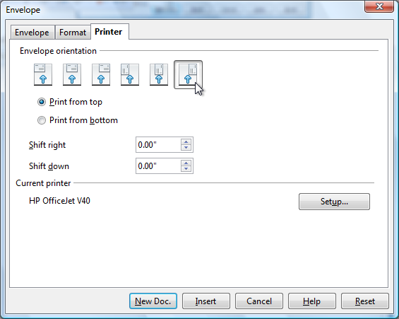  - Select the icon that matches the orientation of the loaded envelopes on the Printer tab | 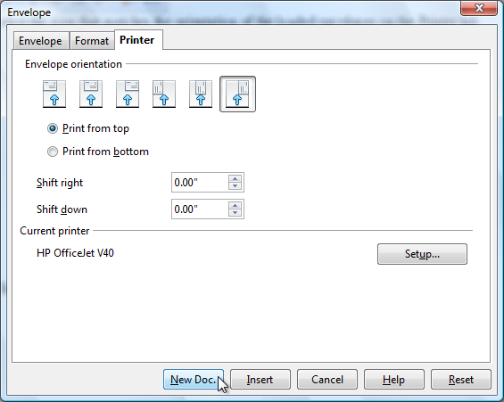  - Click the New Doc. button at the bottom of the Envelope
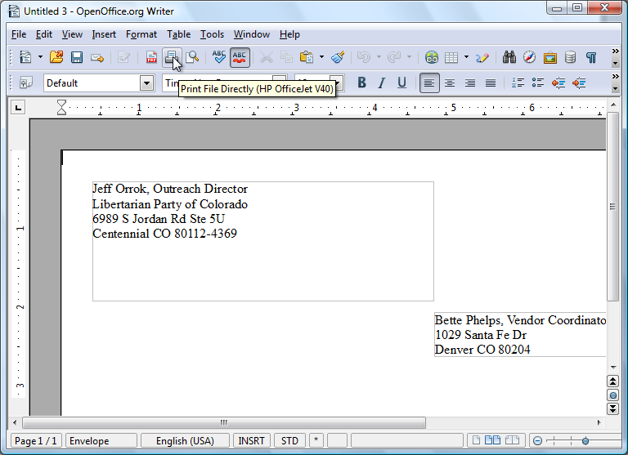
- Click the Print button on the toolbar

