Definition about issue 66028's correct behavior

1 Detailed Specification
According to the user's request, the drag-filling feature of the merged cell currently might be misunderstood in the OpenOffice.org Calc, so we will modify this feature, I suggest the following behavior:
we think the following both case can be merged.
- If the user drag the merged cell to bottom, so long as there is normal cell next to the merged cell of drag-filling(the normal cell mean the cell don't contain the merged cell), the normal cell can be merged.
- When the current merged cell filling down, the filled merged cell which be next to it must be the same size with the current merged cell,or between the current merged cell and filled merged cell, there are normal cells, the number of which must be multiple of the current merged cell.
For calculating the continuing interval, non-empty overlapped cells are treated as if they were not hidden, and empty overlapped cells are treated as if they do not exist, so we think this suggestion for empty overlapped cells will extend to all empty cells.
Drag-filling over not empty cells will replace their content without warning.

- The merged cell is from B2 to D4 and B5 to D7 are normal cells., If the user stops drag-filling with the mouse at D7, then the cells B5:D7 will be merged. For example:

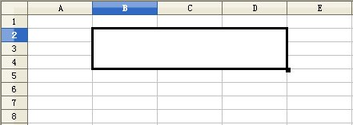
Figure 1 the user select the merged cell B2

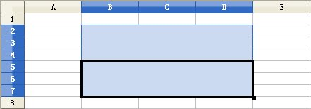
Figure 2 Drag-filling result

- If the cells B2 to D4 where marked, the result of drag-filling is the same as in Figure 2.

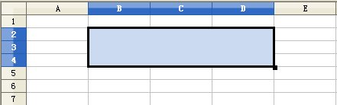
Figure 3 the user select the merged cell B2:D4

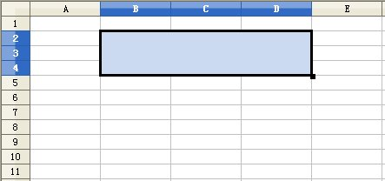
Figure 4 the user select the merged cell B2:D4

  - The merged cell is from B2 to D4, B5:D7, if the user drag the merged cell B2:D4 to bottom, the result is the same as Figure 2, for example:

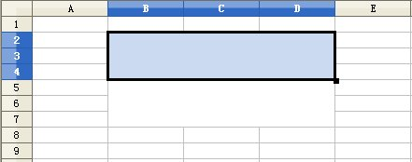
Figure 5 the user select the merged cell B2:D4

  - The merged cell is from B2 to D4, B5:B7, if the user drag the merged cell B2:D4 to bottom, the calc will pop up a warning dialog, the merged cell can't be filled,for example:

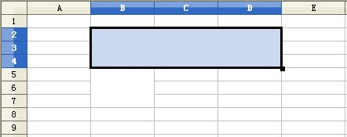
Figure 6 the user select the merged cell B2:B4

  - The merged cell is from B2 to D4, B5:B7,C5:C5,D5:D7, if the user drag the merged cell B2:D4 to bottom, the calc will pop up a warning dialog, the merged cell can't be filled,for example:

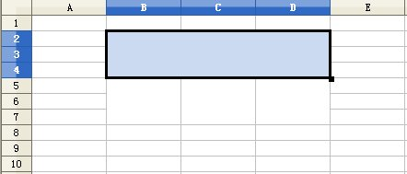
Figure 7 the user select the merged cell B2:B4

  - the cell exist some data, if the user drag the following data to bottom, for example:

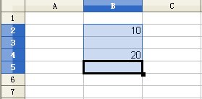
the result is

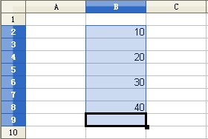
Figure 8 Drag-filling result

    - the cell of B2:C5 exist some data,the data range B2:C3 and B4:C5 will be merged,if the user drag the merged cell to bottom, for example,

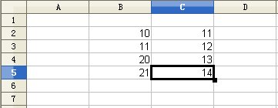
the result is

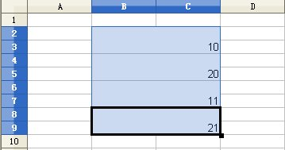
Figure 9 Drag-filling result

    - the cell of B2:C4 exist some data, the data range B2:C3 and B4:C5 will be merged, if the user drag the merged cell to bottom,for example,

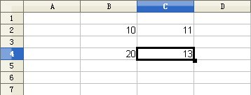
the result is

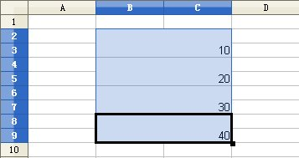
Figure 10 Drag-filling result

10.The merged cell is from B2 to D4,B5:D10 is normal cell,B11:D13 is the merged cell, the user select the data range is B2:D4, the merged cell fill to bottom, for example:

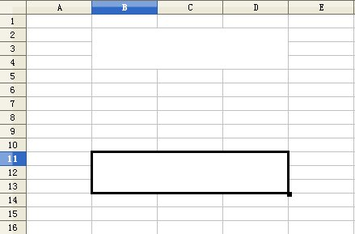
the result is

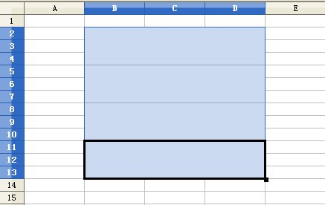
Figure 11 Drag-filling result

