cover

Contents
Safety information 2
Appliance description 3
Main components 3
Rating plate 3
Technical specifications 4
Installation 4
Package content 4
Using the Refreshment Centre 7
Signals for Users 7

Safety information
In the interest of your safety and to ensure the correct use, before installing and first using the appliance, read this user manual carefully, including its hints and warnings. To avoid unnecessary mistakes and accidents, it is important to ensure that all people using the appliance are thoroughly familiar with its operation and safety features. Save these instructions and make sure that they remain with the appliance if it is moved or sold, so that everyone using it through its life will be properly informed on appliance use and safety.

Electrical safety
To start the appliance connect the supplied plug to an electrical socket. Household electrical system must comply with all safety laws and regulations in force. If you are not sure your system does, have it checked by a specialised electrician.
In case of fault, never try to repair the appliance on your own; contact the nearest technical assistance centre
to request the intervention of a technician. If carried out by non-qualified people, repairs can cause damages.
Unplug the appliance before any cleaning or maintenance operation.
If the power cable is damaged, replace it with a new one to be requested from the dealer or from an authorised technical assistance centre.

During installation
- Move the appliance carefully in order not to damage components of the refrigeration circuit and to avoid gas leaks.
- Avoid prolonged exposure of the appliance to direct sunlight.
- Follow all the instructions in the present manual when installing and connecting the unit.
If the appliance was transported in a horizontal position, the compressor oil would risk to flow into the refrigeration circuit. It is therefore necessary to leave the appliance in a vertical position for at least 2 hours before starting it, in order to let the oil flow back into the compressor.
Do not bend excessively flexible pipes when installing the appliance.
In order for the appliance to work properly, place it in an area with good air circulation

During use
Always use the Refreshment Centre for its intended purpose only, i.e. to dispense carbonated or non-carbonated water and ice cubes. An incorrect use of the unit can cause harm to the health of people or faults in the appliance functions.
The appliance is not to be used by children or persons with reduced physical,sensory or mental capabilities, or lack of experience and knowledge, unless they have been given supervision or instruction.

Cleaning
Never use metal objects to clean the appliance, they may damage the surfaces.

Environmental protection
At the end of its working life, the appliance is to be disposed of in compliance with the laws in force and with the regulations about recyclable materials (marked with the special symbol).

Appliance description
Refreshment Centre is a household appliance that refrigerates, purifies and carbonates the water from the mains and makes ice cubes.
Its two dispensing nozzles dispense:
- Ambient water
- Carbonated cold water
- Cold water
- Ice-Cubes.

Main components

Refreshment Centre's main components

- Stainless steel front display
- Filter head
- Water dispense nozzle
- Control panel (buttons and LEDs)
- Ice dispensing nozzle
- Drip tray
- CO2 bottle
- H2O pressure reducer with gauge
- Filter cartridge
- Power supply socket
- Main on/off switch
- H2O inlet
- Water plastic tap
- H2O discharge nozzle

Rating plate
If the appliance does not work properly and you cannot solve the problem, please contact the closest Technical Assistance centre.
You will be asked to give the data and the characteristics of the appliance, to be found in the rating plate on the left side of the appliance

Technical specifications
Technical specifications
Power Supply Voltage | 230 V
Frequency | 50 Hz
Power consumption | 260 W
Cold water dispense capacity | 2lt @ 1 l/min.
Carbonated water dispense capacity | 2lt @ 1 l/min
Dispense temperature | < 13°C
Water mains pressure (water inlet) | > 0.2 MPa
CO2 pressure | 0.25-0.4 MPa
Filtration | 0.5 micron
Filter capacity | 2840 litres
Ambient temperature conditions range | 18°C-32°C
Unit dimensions L x P x H (mm) | 594x554xH378
Weight | 38 Kg
Refrigerant gas | R134a – 60gr

Installation
- Warning In order for the Refreshment Centre to work correctly, it is necessary to install the appliance properly. Make sure the cabinet has a good air circulation. The power supply and water connection data in the Technical Specifications chart (page #) are to be observed.

Installation phases:
- Positioning in the kitchen cabinet;
- frontal spacer installation;
- connection to water supply;
- filter cartridge installation;
- CO2 bottle first installation;
- Electrical connection and first starting.

Package content
Unpack the appliance and check for any damages occurred during transportation. Move it carefully avoiding falls or collisions that may damage the refrigeration circuit.
The package contains the following material:
- Refreshment Center and frontal spacer
- Sliding Rails
- Mounting base plate
- Spacers 2x1mm, 2x2mm, 2x3mm
- 10 3,5x16mm and 3 M4x8 screws
- plastic hose for water tank discharge
- Power supply cord
- H2O inlet flexible hose
- Filter cartridge
- Cleaning and sanitizing cartridge and liquid

Unit positioning
- Warning Install the product far from heat sources in cabinet with good air circulation
- Warning Install the product higher than the water main
- Warning Install the product at a max. distance of 4m from the water main. In alternative, use longer tubes.
Installing the appliance into a kitchen furniture with proper characteristics will ensure a correct functioning of the equipment.
In compliance with all safety regulations, ensure protection against possible contact with electric components or with components only covered by functional isolation through a correct installation and positioning of the appliance.
Protection devices including if present a covering panel (e.g. if the appliance is positioned at the end or at the beginning of modular furniture) need to be fixed properly so that they cannot be removed without tools.
The dimension requirements for the kitchen cabinet are:
- Height: 380mm
- Depth: 560mm
- Width: 560mm
Install the mounting base plate inside the kitchen compartment after making sure the cabinet measures match the required dimensions. If necessary, please use the spacers that adapt and fix the mounting base plate to the cabinet.
Mount the sliding rails onto the base plate using the 10 supplied 3,5x16mm self-threading screws.
Place the Refreshment Center on the sliding rails and slowly push it until the “click” sound indicates that it is locked into position.

Frontal spacer installation
- This procedure is just for asfasd and ihonniofs brands
The frontal spacer proves fundamental when installing the appliance in a composition of other appliances with various heights. To ensure a perfect alignment, please fix the frontal spacer under the frontal panel using the supplied three M4x8 screws as shown in the image below:

Water mains connection
- Warning Connect only to potable water mains. An additional connection is necessary on the cold water line. All water mains connections must be carried out by a certified plumber.
- Warning Water pressure can be set using the pressure regulator placed between the filter and the CO2 bottle. Pressure can be regulated between 2.0 and 3.0 bar after dispensing at least 500cc of carbonated water.
Connect the flexible hose to the cold water inlet;

- Warning Place the Refreshment Centre at a max. distance of 4 metres from the water mains or use other inlet tubes

Filter cartridge first installation
Holding the bottom edge, pull the Refreshment Centre from the cabinet.
Now you have easy access to the left side of the unit, where you will find the filter cartridge.
Remove the cap and connect the filter cartridge to the head rotating it counter-clockwise.
Make sure there are no water leaks. Dry the base of the appliance well before installing it in the cabinet.

CO2 bottle first installation
Disposable bottle
The CO2 bottle is placed on the left side of the appliance. Remove the green cap and screw the pressure regulator onto the bottle. Make sure the CO2 bottle is tightly fixed (pic. 11).
Open the pressure regulator valve and set pressure to approx. 3 bar (pic. 12). Pressure can be adjusted to a max. of approx. 4 bar to obtain a higher carbonation level
Rechargeable bottle
CO2 bottle is on the left side of the appliance. Together with the pressure regulator, you will find an adapting junction with its ring, that has to be screwed onto the bottle's head. For a complete installation, screw the pressure regulator onto the bottle.
Open the valve on the regulator until reaching a pressure of approx. 3 bar (pic. 12). Pressure can be adjusted to a max. of approx. 4 bar to obtain a higher carbonation level.

Electrical connection and first starting
- Warning Before plugging in the appliance, make sure the system voltage and frequency match those on the rating plate and in the technical specifications table(see page #).
Connect the appliance to a 230 V AC socket (see technical specifications table, page #) using the supplied cord.
The electrical system must comply with all safety regulations in force. If you are not sure your system does, please have it checked by a certified electrician.
- Warning The manufacturing company declines any responsibility if safety regulations are not respected.
Turn unit on through main on/off switch on the side. As soon as the light comes on, the led that indicates the presence of electric current will start to flash. The appliance will undergo an initialization process . The process is complete when the led indicating the presence of electric current stop flashing.
The touch control panel is now active Wait approx. 2 hours for the unit to reach the ideal temperature for cold water dispensing, and approx. 1 hour for the creation of ice cubes.
Ambient water, instead, is immediately ready.

Using the Refreshment Centre

Front touch panel

- Empty CO2 bottle LED
- LED indicating the presence of electric current and discharge water button
- Ambient water button
- Cold carbonated water button
- Cold water button
- Ice cubes button
- On/Off light button
- Exhaust/replacement filter LED

Startup
- Ice melting Do not insert any object in the ice cubes nozzle. This may damage the section or prevent the correct closing of the nozzle, causing an increase in the internal temperature with consequent ice melting.
- Warning Do not touch the control panel with wet or oily hands, in order not to damage the touch control
- Warning Dispense 1 litre of cold water and 1 litre of carbonated water to well rinse out the water coils.
Turn unit on through main on/off switch on the side. As soon as the light comes on, the led that indicates the presence of electric current will start to flash. The appliance will undergo an initialization process . The process is complete when the led indicating the presence of electric current stop flashing.

Dispensing
After 2 hours from the starting of the appliance, it is possible to dispense cold water as follows:
Place a glass on the drip tray, then select the desired beverage or the ice cubes. Press the button until the desired quantity has been dispensed. If sprays of CO2 come out while you dispense carbonated water, stop the dispensing and wait 20 seconds, then start dispensing again.
- Dispensing is indicated by the corresponding led.

- In order to fill a bottle or a jug, please extract dispense nozzle grabbing it and pulling it outwards.

Signals for Users
- If following to the signal below mentioned, when you restart the appliance, it doesn't work, the signal with the 6 blinking LEDs appears.
That means that it's necessary to turn off the appliance, close the inlet water and call the Assistance.
Led Indications | Message
Led indicating the presence of electric current | The LED indicates 2 working phases of the appliance:  - when it blinks, it is starting up;  - when it's on, it indicate its normal work;
Filter LED | The 2 signal phases of the filter consumption:  - when it blinks slowly, filter is about to exhaust. 2700 litres have been dispensed;  - when it's on, it indicates that 2800 litre have been dispensed. It's necessary to change the filter. You have 40lt more to dispense, then water dispensing system will be blocked.
CO2 bottle LED | When LED is on:  - Carbonated water is disabled.  - CO2 bottle is empty or missing. Replace CO2 bottle to restore carbonated water dispensing.  - Please change CO2 bottle as described in the following chapters.
Ice cubes LED | When LED is blinking:  Ice forming bin blocked  - To reset the unit switch it off and then back on pushing the on/off button on the right side of the appliance.  - If it doesn’t work, the signal with 6 blinking LEDs (except filter and CO2 bottle LEDs) appears. That means that it’s necessary to turn off the appliance, close the inlet water and call the Assistance.
Carbonated water LED | When it blink slowly:  - Carbonated water is disabled. A protection device on the pump activated. To reset the unit, please turn it off and after few seconds switch it back on pushing the on/off button on the right side of the appliance.  - If it doesn’t work, the signal with 6 blinking LEDs (except filter and CO2 bottle LEDs) appears. That means that it’s necessary to turn off the appliance, close the inlet water and call the Assistance.

Unique alarm for calling Assistance
All LEDs on simultaneously except filter and co2 LEDs
Water leakage. User could just check, pulling out the appliance from the cabinet, that no water is in the base of the machine.
If there is water in the sensor just dry it.
If water is in all the base, please turn off the appliance, close the inlet water and call the Assistance.

Maintenance and cleaning
Please do not touch the control panel with wet or oily hands, in order
to avoid the malfunctioning of the touch control.
- Warning: Ice melting Do not insert any object in the ice cubes nozzle. This may damage the section or prevent the correct closing of the nozzle, causing an increase in the internal temperature with consequent ice melting.

Discharge water tank
- Warning: In case you will left the appliance off for some days, it suggests to discharge the tank.
- Pull out the appliance
- Open the little plastic tap placed in the left side of the appliance
- place a cup under the water dispense nozzle to discharge directly in the sink;
- Place a big tray under the discharge water nozzle or connect the plastic hose to the nozzle
- Keep the “discharge water” button pressed, when there is no more water to discharge, the appliance will be operative again;
- Warning: If you stopped pressing the “discharge water” button you need to keep pressed it again in order to complete discharge.
- Close the little plastic tap;
- Warning: Remember to close the little plastic tap near to the filter

CO2 bottle replacement (for food)
When CO2 led switches on, please replace the old bottle with a new one as
described below:
- Pull out with both hands the bottom of the unit, letting the Refreshment center slide on the sliding runners (Pic.15). After pulling out the unit it is easier to access the left side, where the CO2 bottle is installed;
- grab the bottle and extract it;
- hold the pressure reducer and turn the bottle clockwise (Pic.16) to separate the bottle from the pressure reducer;
- screw the new bottle to the reducer counter-clockwise till fully tightened (Pic. 11);
- lock the new bottle on the side of the unit.
- Warning: Just use CO2 bottle for food

Sanification and filter cartridge replacement
When the “filter” led turns on, it is necessary to replace the cartridge filter as described below:
- Dispense all the ice cubes;
- Pull out the Refreshment Centre unit;
- Turn off the appliance from the main switch;
- Rotate the exhausted cartridge anticlockwise about a quarter of a turn to remove it from the head and extract it avoiding water spillage;
- Fill the sanification cartridge with “Neutral Detergent”. Insert the sanitizing cartridge on the filter head by rotating it counter-clockwise about a quarter turn;
- In case of water spillage, dry the base and make sure there are no leaks;
- Open the little plastic tap placed in the left side of the appliance and place a cup under the water dispense nozzle;
- Turn on the main switch and within 5 seconds press the “light” button till all LEDs (except CO2 and filter LEDs) begin blinking, moving through all the buttons of the frontal panel. When they finished, the discharge H2O LED will begin bliking slowly;
- Place a big tray (2.5lt) under the discharge water nozzle and press the “water discharge” button; when there is no more water to discharge, all LEDs will start again to blink moving through all the buttons of the frontal panel;
- Automatically some water will be dispensed from the water dispenser; as required in the point 7, it's necessary to place a cup under it (already placed);
- At this point is possible to remove the sanification cartridge and connect the new filter cartridge to the head as shown on filter cartridge instructions; in the meantime the appliance is going to end the sanification procedure;
- When the “discharge water” button start to blink slowly, all other LEDs will switch off, keep the “discharge water” button pressed, when there is no more water to discharge, the appliance will be operative again;
- Remember to close the little tap in the left side of the appliance.
- Push in the appliance and lock it again in position
- Warning: Dispense 1 litre of cold water and 1 litre of carbonated water to well rinse out the water coils.
- Warning: During the sanitizing procedure please do not dispense carbonated water.

Troubleshooting DRAFT
The following is a troubleshooting section for malfunctions that are not in the Alarms list above:

PROBLEM | CAUSE | RESOLUTION
Water is not dispensed | No water supply | Check water supply
Water is not dispensed | Water main inlet solenoid valve failure | Call technical assistance
Water is not dispensed | Inlet water low pressure | Check the inlet water pressure on the manometer
Small ice cubes | No water supply or low pressure of inlet water | Check water supply and its pressure
The unit has been on for over 3 hours, but no cold water nor ice is available | Probable refrigerant gas leak | Call technical assistance
 | Motor fan failure | Call technical assistance
 | Compressor failure | Call technical assistance
Low carbonation level | Brand new appliance | Utilize for few days and check carbonation
Low carbonation level | Low CO2 pressure | Increase CO2 pressure by rotating knob on CO2 pressure regulator clock-wise
Low carbonation level | CO2 bottle is nearly empty | Change CO2 bottle
Low carbonation level | Air inside carbonator | Dispense few liter of carbonated water and check carbonation
Low carbonation level | Carbonation pump malfunction | Call technical assistance
Cold water occasionally sprays CO2 gas | Non return valve on carbonator open | Call technical assistance

- Warning:All repairs should be carried out by authorized technicians

Environment care
The symbol 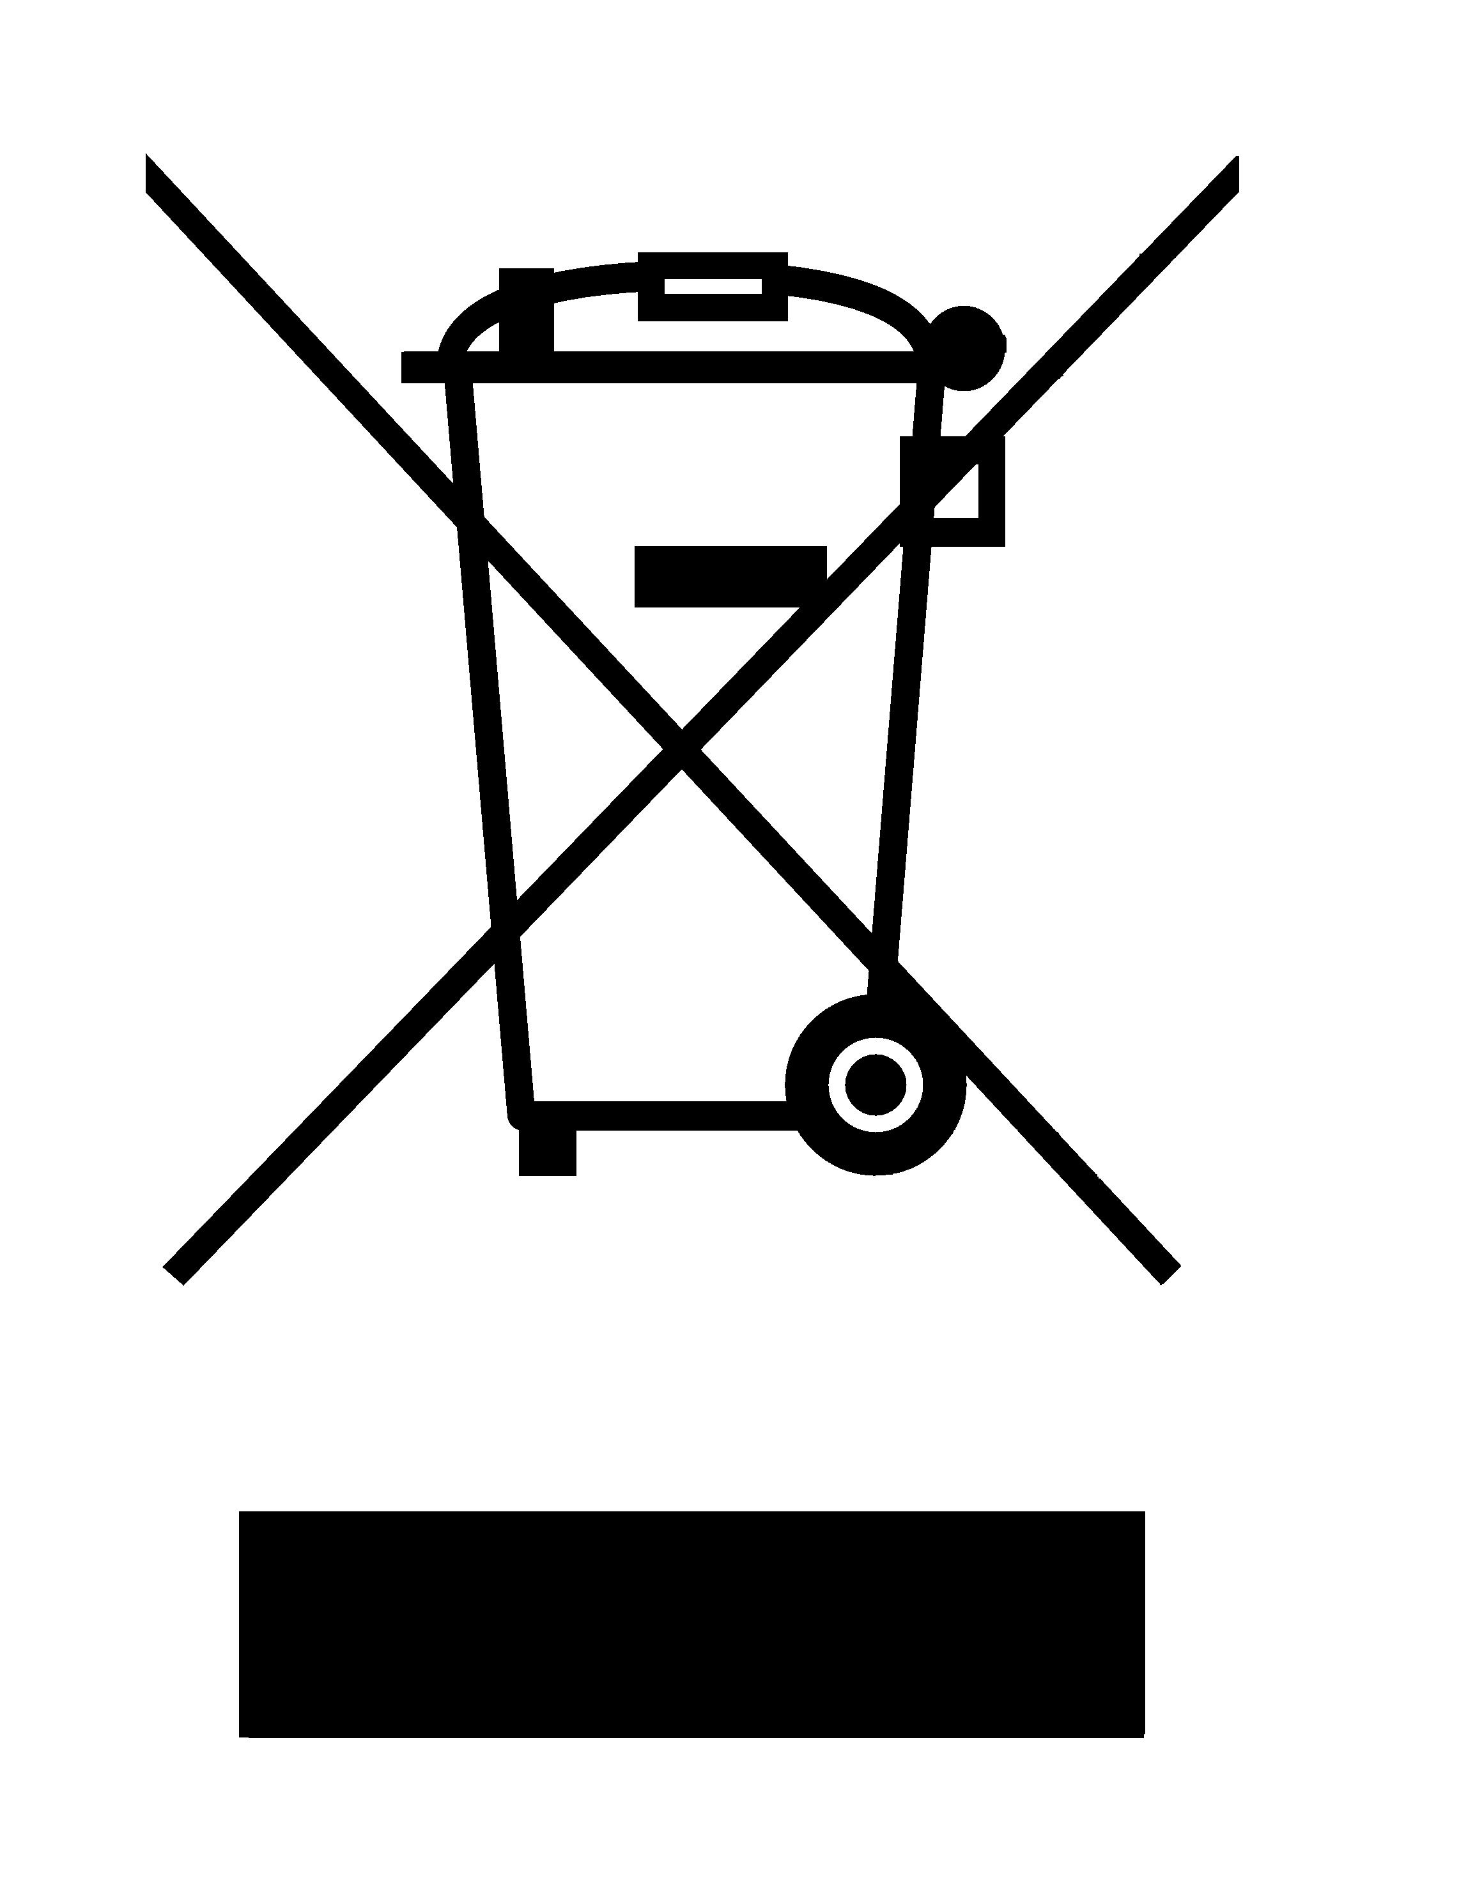on the product or on its packaging indicates that this product may not be treated as household waste. Instead it shall be handed over to the applicable collection point for the recycling of electrical and electronic equipment. By ensuring this product is disposed of correctly, you will help prevent potential negative consequences for the environment and human health, which could otherwise be caused by inappropriate waste handling of this product. For more detailed information about recycling of this product, please contact your local city office, your household waste disposal service or the shop where you purchased the product.

