The University of Texas at Austin
Applied Research Laboratories

ARL Workflow User Documentation

November 19, 2010

James Ratcliff, ARL:UT
falazar@arlut.utexas.edu

Jonathan Abbey, ARL:UT
jonabbey@arlut.utexas.edu

Table of Contents
1. Introducing the ITS Workflow System 3
1.1. What is a 'workflow'? 3
1.2. General Page Description 5
1.3. Work Item Popups 6
1.4. Job View Page 7
2. Four Webpage Sections 8
Section 1: My Work Section 9
Tab 1: Personal Work Items 9
Tab 2: Group Work Items 10
Tab 3: Active Jobs 11
Tab 4: Completed Jobs 11
Section 2: My Department Section 12
Tab 1: Work Items Pending 12
Tab 2: Work Items Completed 12
Tab 3: Active Jobs 13
Tab 4: Completed Jobs 13
Tab 5: Jobs Report 14
Tab 6: Dept. Report 14
Tab 7: Projects Report 15
Section 3: Admin Section 16
Tab 1: Jobs Report 16
Tab 2: Work Items Pending 16
Tab 3: Work Items Pending 17
Tab 4: Active Jobs – Figure 18 17
Tab 5: Completed Jobs 18
Section 4: My Preferences 18
7. Advanced and Other Topics 19
Starting a Workflow Job 20
Email Notifications 21
External URL Links 21

Introducing the ITS Workflow System
IRIS, the laboratory's business support database system, provides applications that allow personnel to manage data in the area of Human Resources, Contracts, and Purchasing. Users can create, edit, and delete records using these applications and generate and view a wide variety of reports.

Critical functions for the laboratory's operations, all, but there has been a large piece missing. Each user works with IRIS on a one-on-one basis. IRIS makes no effort to manage the sequence of steps that must be performed to see a purchase request from initial request to approval to vouchering and acquisition, provides no assistance to make sure that all relevant parties do their part when a new employee comes on board.

The ITS Workflow System is meant to augment IRIS with the ability to assist laboratory staff in coordinating processes that necessarily involve multiple users and laboratory units. Rather than passing signed pieces of paper or hand-crafted email from person to person, users will be able to perform a task on the web or in IRIS and let Workflow automatically seek and obtain approval from a supervisor or director before generating a 'signed' work order, purchase request or document in the database.

Workflow, the ITS system, is implemented as a back-end component that can send email, receive events, and synthesize tasks for personnel as is required, and a web application that users can log into to generate and perform tasks, and to review the status of processes they are involved with.

In this document we will be primarily discussing the web application that most users will come to think of as 'Workflow', but it will be helpful first to spend a bit of time on a more basic question:

What is a 'workflow'?

What is a 'workflow'?
A workflow is the movement of a document around an organization for purposes including sign-off, evaluation, authorization, co-writing, and performing activities in a process. Throughout this documentation and the web site the terms Job and Work Item will be used.

What is a 'Job'?
A Job is an instance of a workflow process, it is made up of many Work Items in a flow.
For example, when a Key Request form is filled out and turned in, this would be an example of starting a new Job in a workflow system.

What is a 'Work Item'?
A Work Item is a part of a Job, usually representing one task to be performed in the Job. Two examples of Work Items are an administrator approving a Key Request form, or a maintenance person saying that the key was made. In a typical workflow example, an employee will request a key, fill out the form, send the paperwork to their boss to have it signed, who will send it out to OSS, who will sign and send it out to have the key made, the employee will be notified, and can pick up the key. With our workflow system most of this walking around and paperwork will be eliminated, and users can fill in all forms in one convenient site, and be notified of any workflow needing their attention via email.

General Page Description
The website URL is currently: http://workflow-dev and http://workflow for the dev and live versions.

All ARL users can login using their primary Ganymede username and password. The login is timed out if there is no activity within 30 minutes.

A. Each tab in a section (under the dark blue area) can be clicked to show:
B. A panel with a spreadsheet style list of the Jobs or Work Items and some important information about them.
C. To get more information on a Job or Work Item, simply click the name link in the first column.
D. New Work Items in the My Work section are marked in bold and have the “new message”
icon: 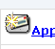
E. A “Suggestions & Comments” link is available on the bottom of all pages, or you can email support at WF-Team@arlut.utexas.edu.
Clicking on any Work Item will pull up the Work Item Popup, See Illustration 1.3
Clicking on any Job item will pull up the Job View Page, See Illustration 1.4.

B
A
C
D
E
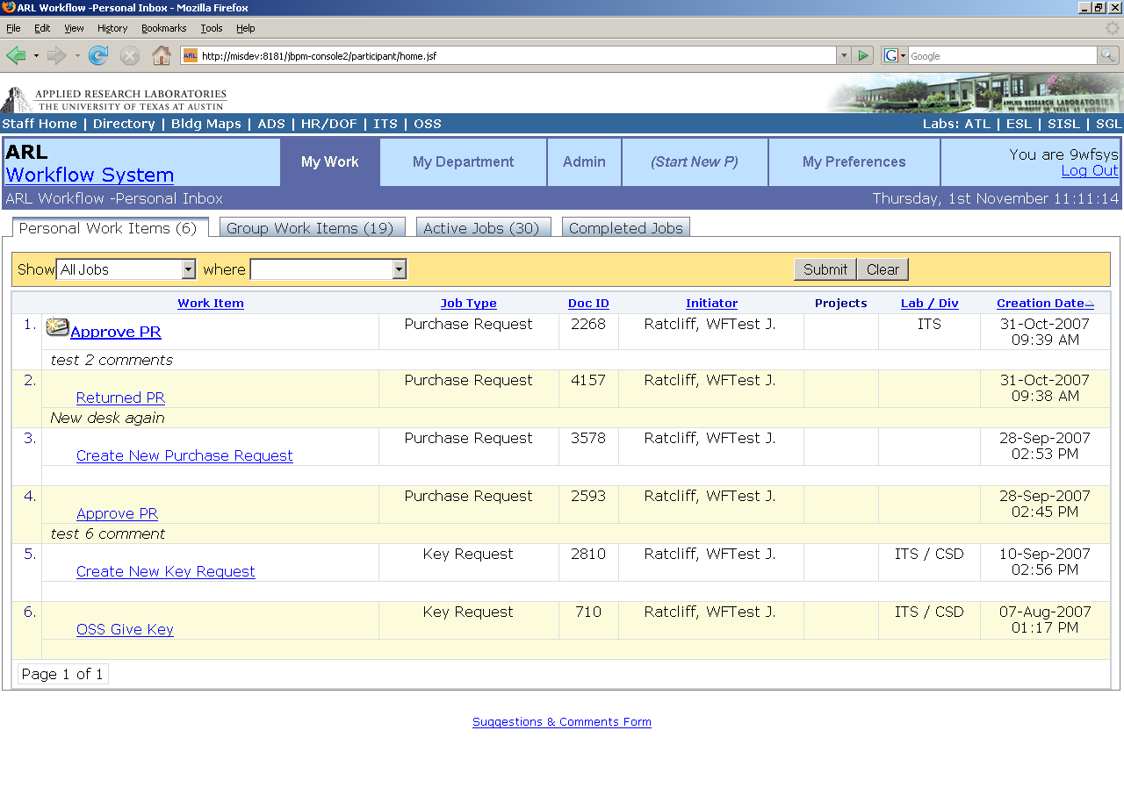Illustration 1.2

Work Item Popups
When any Work Item is selected a popup form will appear and allow you to take action on an item, if it has not been completed, and if you are authorized to do so. The form may have extra, specific information needed to make the decision, and may allow you to enter information required for the work item. After clicking on a Work Item it will be marked as read and will be shown in green in the list.
Many Work Items may have several action buttons on the bottom, such as the one shown here. This example is a purchase request that has just been submitted, and is waiting to be approved. The example below has three action buttons and you could either Approve, Return it back to the Initiator, or Cancel (cancels the Workflow Job, ends it).
If there is more information on an item, or an external report page, it will be accessible by clicking the Report URL.
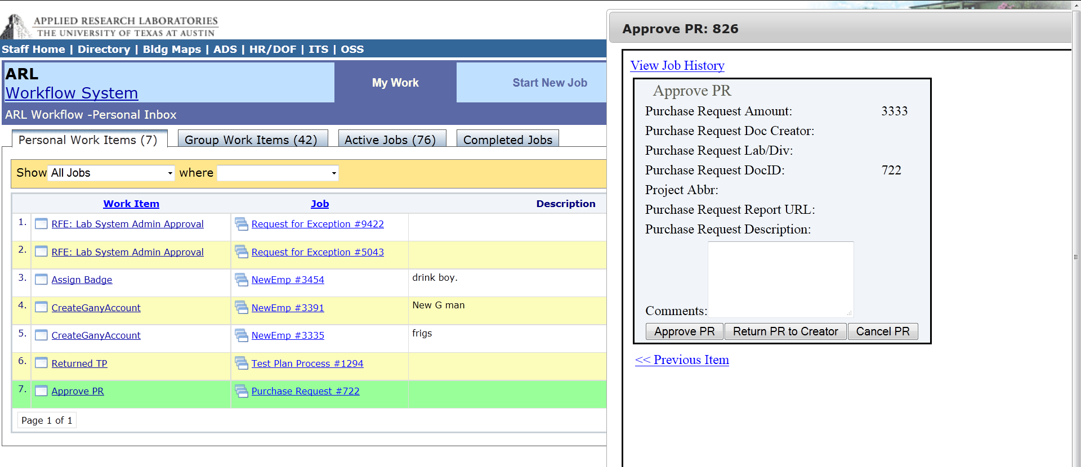Illustration 1.3
You may move and adjust the size of the popup to make the form visible, and there are several options on the bottom. You may click the Next Item or Previous Item links to go to the next or previous Work Item shown behind the popup.
A comments section may be shown here, if any are available.

Job View Page
When a Job link is clicked it will display the Job View page, which shows the history of the Workflow Job including any past Work Items performed, who performed them, and any current Work Items that have not been done. You can click on any of the completed Work Items to view it as it was when it was performed.
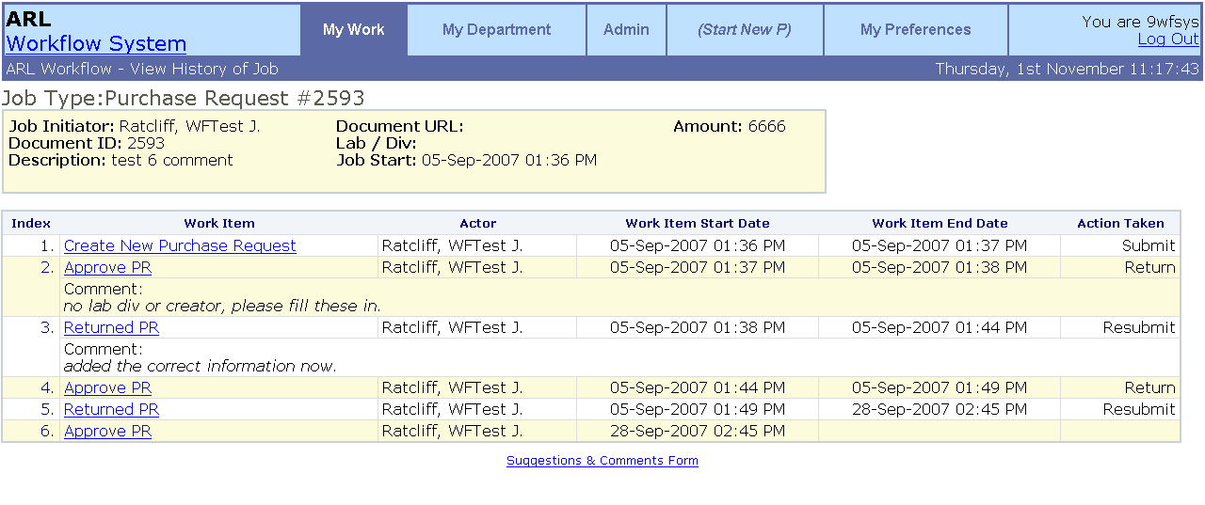Illustration 1.4

Four Webpage Sections
The ARL Workflow Web Application has four main sections. Each may be accessed by clicking the links in the light blue menu boxes at the top of the page after logging in. The My Work, My Department, and Admin sections show different Workflows you can interact with. The My Preferences section allows you to customize some parts of the user interface, and email notices. The section you are currently in will be highlighted with a darker blue background. To exit the system click the “Log Out” link to the right.
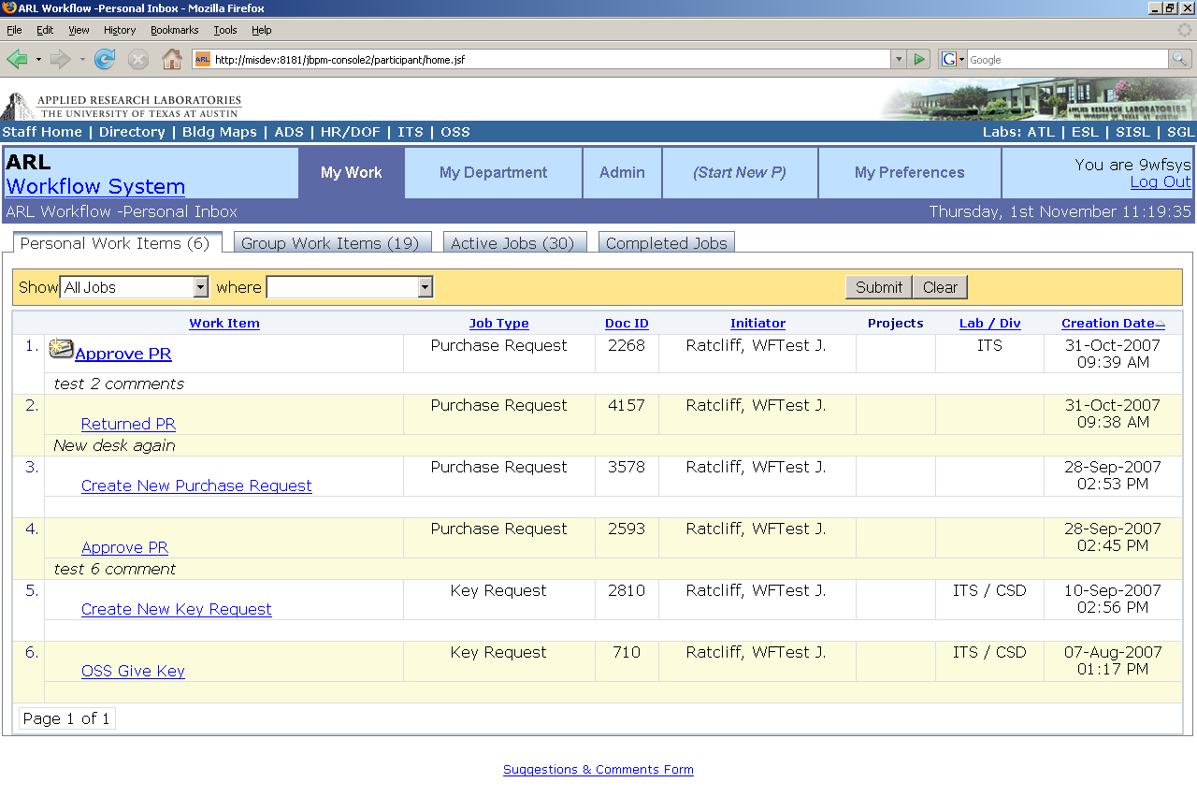Illustration 2.1

Section 1: My Work Section
The My Work section is the main section available to everyone. It shows all Work Items that are waiting for you to act upon, and Jobs that you have participated in that are active or have been completed.
The My Work section has four tabs: Personal Work Items, Group Work Items, Active Jobs, and Completed Jobs. The numbers in parentheses show the count of Work Items or Jobs on that panel.

Tab 1: Personal Work Items
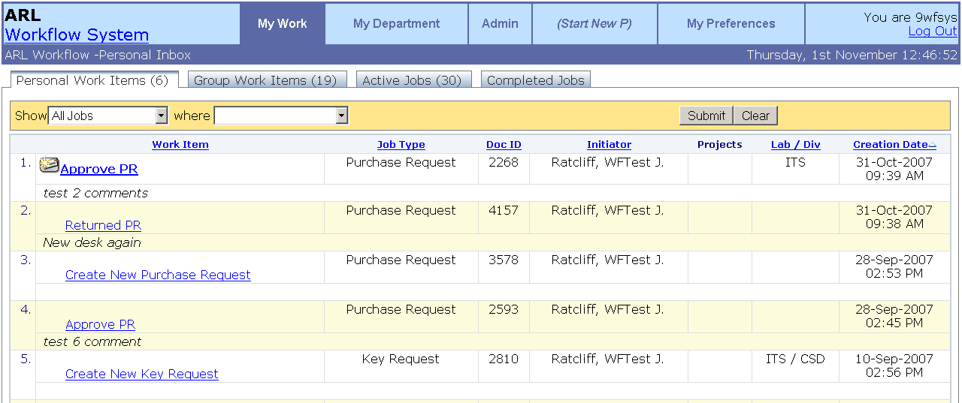Illustration 2.2
This panel shows all Work Items that are currently assigned directly to you. Click on any link in the first column to open the Work Item.

Tab 2: Group Work Items
This panel shows all Work Items that are assigned to you or any of a set of candidates. Anyone in the candidates list is able to perform this action.
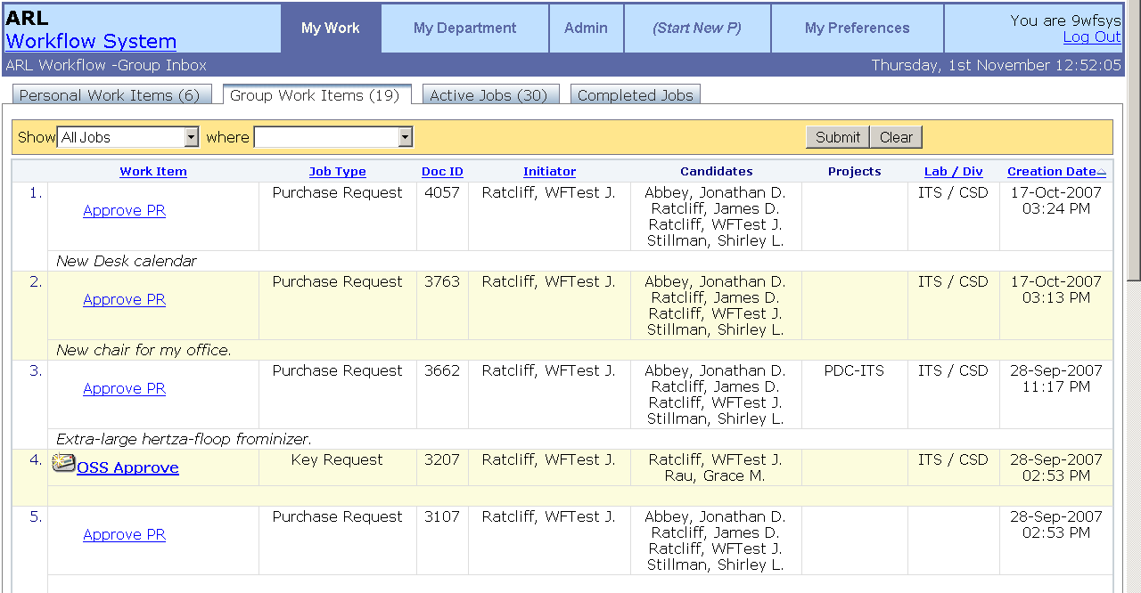Illustration 2.3

Tab 3: Active Jobs
This panel displays all Jobs that you have participated in or that are in your personal or group list that are currently still active. Click on any link in the first column to open the Job View page. The Active Jobs view shows the Pending Work Items for the Job as well as the Last Action date.
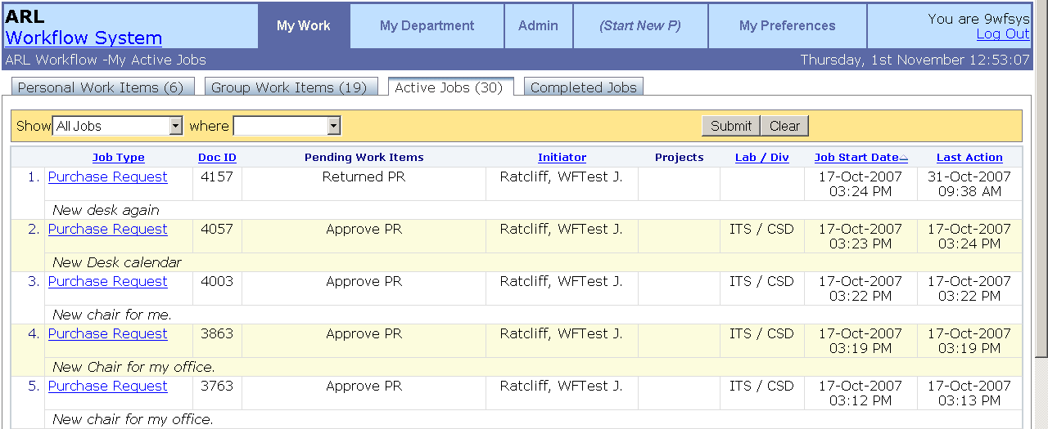Illustration 2.4

Tab 4: Completed Jobs
This panel displays all Jobs that you have participated in that have been finished. Click on any link in the first column to open the Job View page. The completed jobs panel shows the Final State of the Job, and the Job End Date.
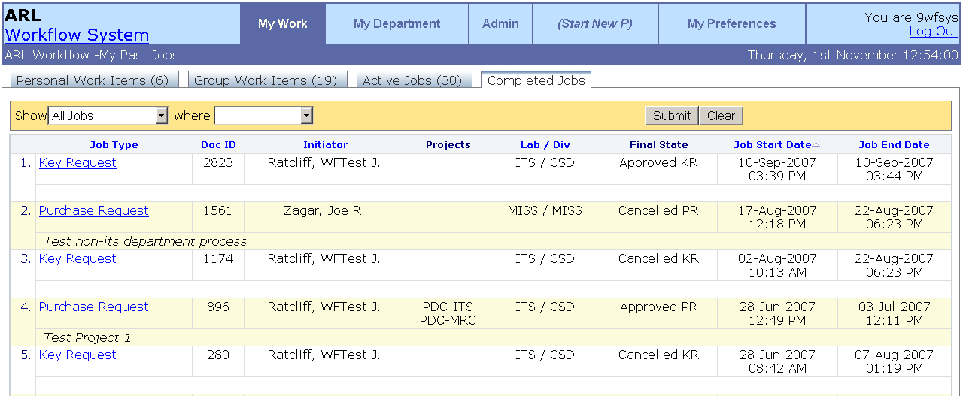Illustration 2.5

Section 2: My Department Section
My Department panel is only available to ARL Laboratory and Division heads and Project leaders. Similar to the My Work panel it shows all the Work Items and Jobs related to your department. The Candidates column is shown here so you can see who is currently able to perform this Work Item. Laboratory and Division Heads and Project Leader information is taken from the IRIS system

Tab 1: Work Items Pending
This panel shows all Work Items that are currently assigned to your department or project. Someone in your group (the candidates column) must take action on them before the Job can continue to its next stage. Click on any link in the first column to open the Work Item.
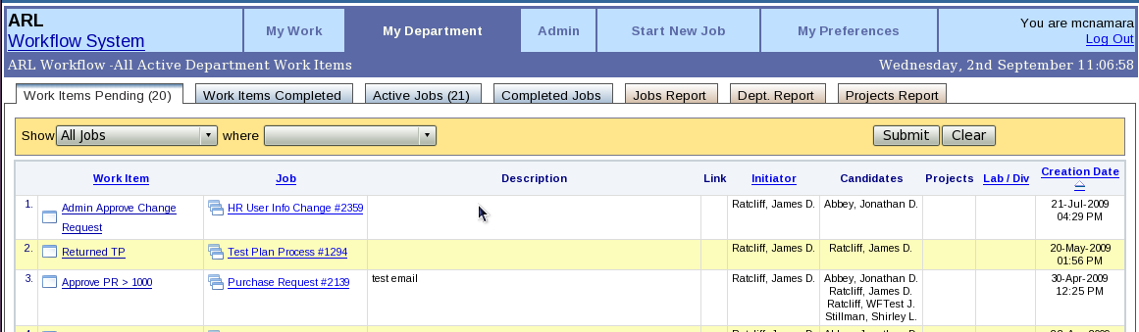Illustration 2.6

Tab 2: Work Items Completed
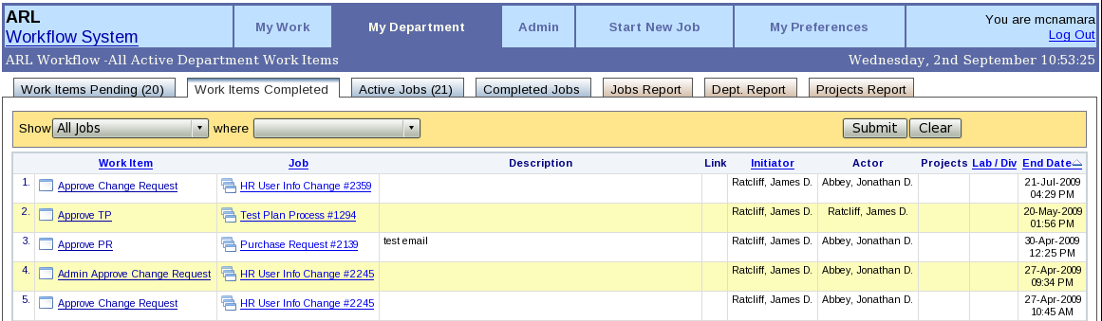Illustration 2.7
This panel shows all work items that someone in your department or project has participated in. It specifies the actor who completed the work item, and the date it was completed.

Tab 3: Active Jobs

This panel shows all active Jobs that someone in your department or project has participated in. Click on any link in the first column to open the Job View page. The Active Jobs view shows the Pending Work Items for the Job as well as the Last Action date.
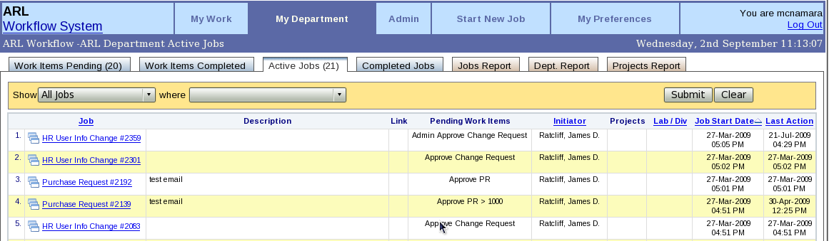Illustration 2.8

Tab 4: Completed Jobs

This panel shows all completed Jobs that someone in your department or project has participated in. The completed jobs panel shows the Final State of the Job, and the Job End Date. Click on any link in the first column to open the Job View page.
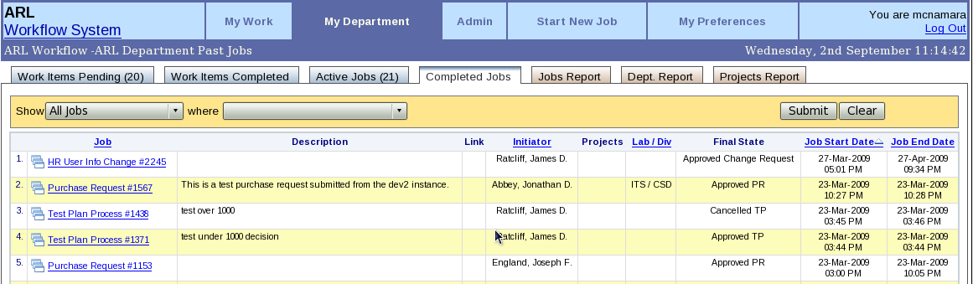Illustration 2.9

Tab 5: Jobs Report

This panel shows a report of all Jobs that were started by a member of your department, on behalf of your lab/div, or from a project you manage. You can view this either with respect to Employee Names or Job names by clicking the link in the report. You can click the number to show the list of Jobs they have initiated.
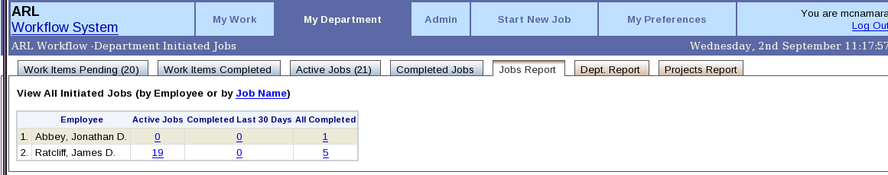Illustration 2.10

Tab 6: Dept. Report

This report tab will only show up for authorized Department heads. This is a special report page showing a list of any employees in your department who have Work Items pending for them. You can view this either with respect to Employee Names or Job names by clicking the link in the report. You can click the number to show the list of Work Items that are pending.
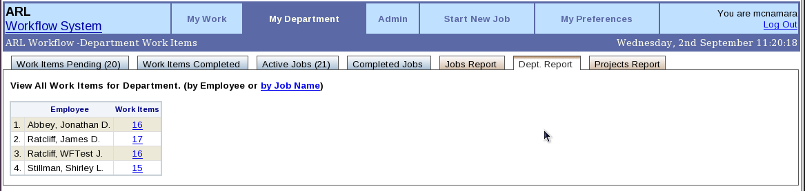Illustration 2.11
A second report page shows all Work Items pending, grouped by Job name, which can be accessed by clicking the Job Name link.

Tab 7: Projects Report

This report tab will only show up for authorized Project leaders. This is a special report page showing a list of any projects in your department that have Jobs. You can click the numbers to show the list of jobs for that project.
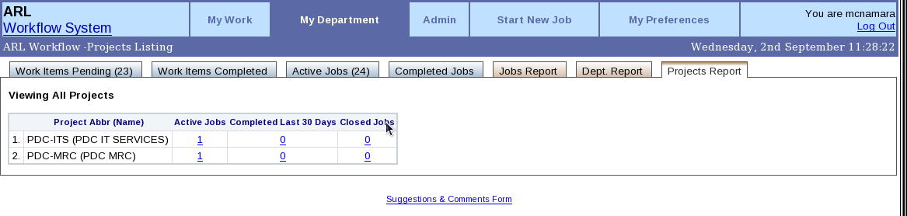Illustration 2.12

Section 3: Admin Section
The Admin section is only available to System Administrators or Job Administrators. A System Administrator may view all Jobs in the system. A Job Administrator may see all Job Types they have permission to view, set within the system. System Administrators and Job Administrators are setup and managed currently by the Workflow System.

Tab 1: Jobs Report

This is a report page grouping all Jobs in the system together. (Or for all Job Types authorized for that Job Administrator.)
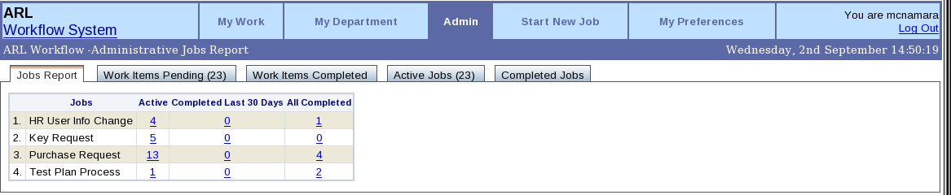Illustration 2.13

Tab 2: Work Items Pending
This tab shows all Work Items in the system. (Or for all Job Types authorized for that Job Administrator.)
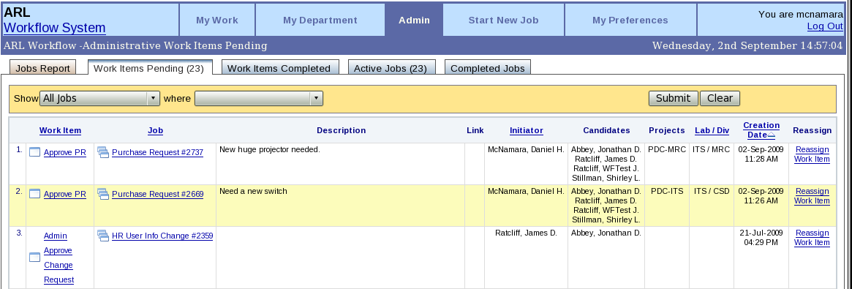Illustration 2.14
A System Admin (but not a Job Admin) may Reassign any work item to another user here, by clicking the 'Reassign Work Item' link. Or they may release a work item from a single person assigned, back to a group of candidates.

Tab 3: Work Items Pending

This tab shows all Completed Work Items in the system. (Or for all Job Types authorized for that Job Administrator.)
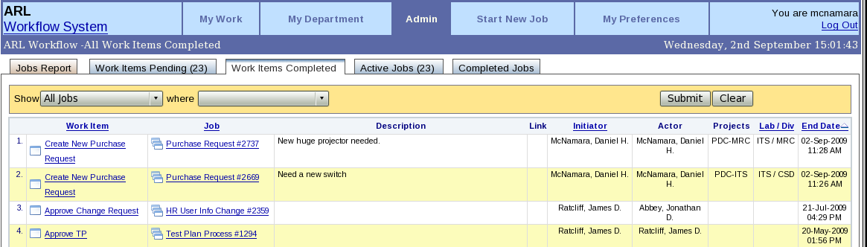Illustration 2.15

Tab 4: Active Jobs – Figure 18

This list shows all unfinished Jobs in the system (Or for all Job Types authorized for that Job Administrator). The Active Jobs view shows the Pending Work Items for the Job as well as the Last Action date.
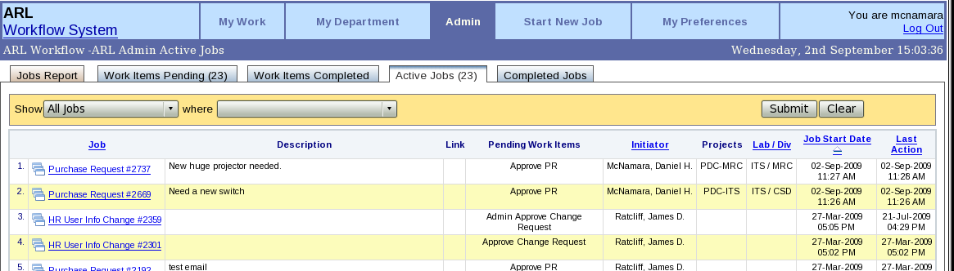Illustration 2.16

Tab 5: Completed Jobs

This list shows all finished Jobs in the system (Or all Job Types authorized for that Job Administrator). The completed jobs panel shows the Final State of the Job, and the Job End Date.
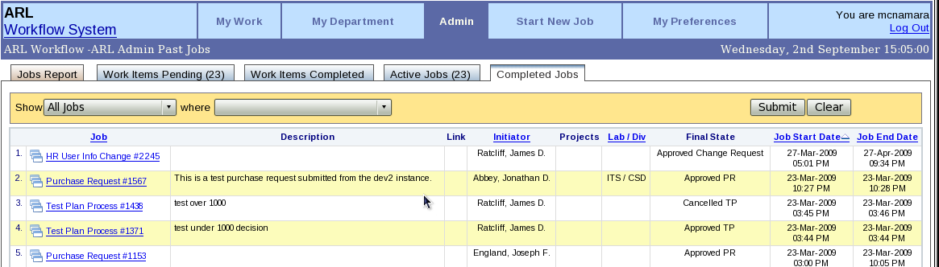Illustration 2.17

Section 4: My Preferences
The My Preferences section allows you to change certain preferences in the user interface, and how the workflow system interacts with you.
You can:
Change the number of items that show on each page with the “Display items per page.” option.
Choose behavior after you perform an action on a Work Item:
Automatically move to next item.
Remain on current item.
Close popup window and return to list.
Select email Notification Preferences:
Notify me of New Workflow Work Items: (select one)
Single email for every new Work Item
Daily Digest Email
Digest Email every X minutes
No Emails.

7. Advanced and Other Topics
Filtering Results
You can set a number of filters on the panels to limit the display to a more select set of Jobs or Work Items in the dark yellow box filter at the top of the panel.
To show only "Purchase Request" type Jobs, select it from the first pulldown that says “All Jobs”, and it will show only those Job Types. You can also filter by Lab, Div, Initiator, project, DocID, start/end dates and other variables by using the second pulldown list.
Multiple filters may be added by selecting the “+” button at the end of the filter, and any filter line may be removed by clicking the “-” button. You can match the values using partial text matching for any text fields, and ==, <, >, <=, >=, != for all number fields. A pulldown calendar widget is provided to allow easy selection of dates to filter by.
After filtering on a Job Type, the display may change slightly, adding in additional Job specific variables to the panel. In this example it now shows an Amount column for the purchase request.

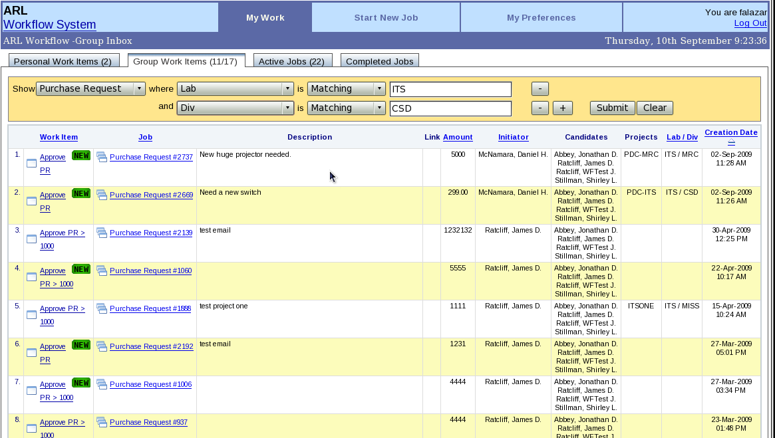Illustration 2.18
Sorting Results
You can sort most panel displays by clicking the column title you wish to sort on. The default sort field is by creation date, with the most current item first. The triangle icon next to “Creation Date” in Figure 21 is used to show which column is being sorted currently. Clicking the column again will reverse the sort order, and flip the image over.
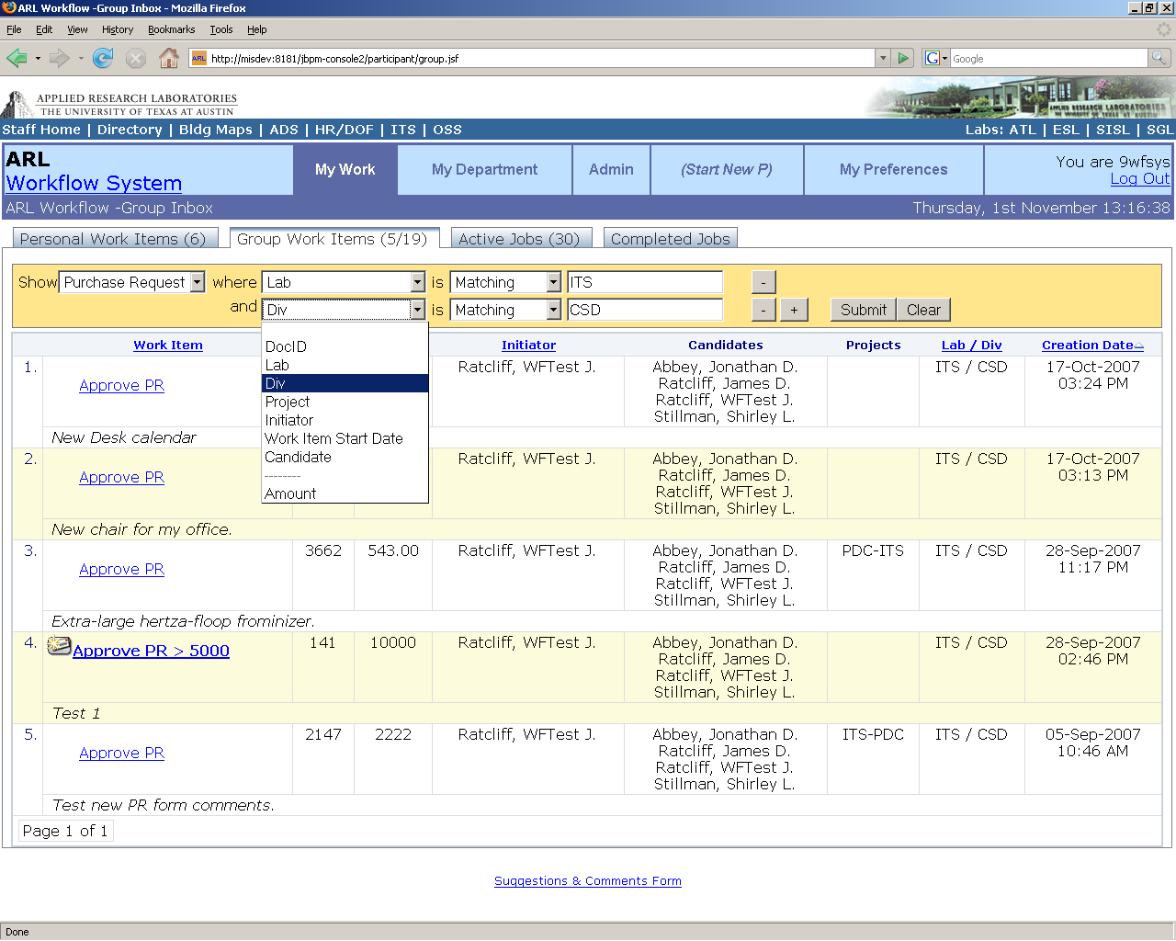Illustration 2.19
Workflow Actors and Swimlanes
Work Items are assigned to specific people or groups of people within the lab by the Workflow when it is defined. These Work Items can be assigned directly to a person, to any member of a group of people, or to a swimlane group.
A swimlane is a group of people who has permission to take action on a series of Work Items within a Job. Once someone in the group has taken an action, further Work Items in that swimlane for that Job will be assigned to that same actor.
Often, one person is responsible for multiple Work Items in one Job. In the Workflow system this is expressed by creating a 'swimlane' and assigning all Jobs for that actor to the swimlane. A swimlane in a business process can be seen as a role-name for an actor within the process. The first time when execution arrives in a state for a given swimlane, the actor is set.

Starting a Workflow Job
Many workflows will be created directly from the IRIS system, such as Purchase Requests or Journal Vouchers. You may also start some other workflows on the web. To start a new workflow Job, you must navigate to a start workflow link for the process type (currently under Start New Section for Development) and click to start. You will be presented with a Work Item page showing a start form that needs to be filled in to start the Workflow Job. After you fill in and submit the form, it will save the information, initialize a Workflow Job, and alert the next users in the workflow that they have a pending Work Item available.

Email Notifications
The Workflow system sends email notices out for every new Work Item that is added to your Personal Work Items or Group Work Items pages. You can change how often, or if you want to receive these notices from the My Preferences page.

External URL Links
A Job or Work Item can be called directly from a browser (user must still login) by using one of the following two formatted URLs:
For Jobs:
http://workflow/jbpm-console/common/viewprocess.jsf?jobid=*JOBID*
Where *JOBID* is the Unique Job Id for that item.
For Work Items:
http://workflow/jbpm-console/common/viewtaskpopup.jsf?workitemid=*WORKITEMID*
Where *WORKITEMID* is the Unique Work Item Id for that item.
To Create a new Job Instance from External Link, use the format
http://workflow/jbpm-console/common/taskform.jsf?startProcessName=Purchase%20Request
where Purchase Request can be replaced by any Job Name.

8. Development Team and Feedback
Any suggestions, questions, complaints or other feedback is appreciated at
WF-Team@arlut.utexas.edu.

The ITS Workflow Development Team consists of:
- Jonathan Abbey
- James Ratcliff
- Shirley Stillman
- Carrie Woodworth
Consulting on User Interface:
- David Wick

