Multi Paragraph Selection confuses paragraph order

Short description
If you select several not joint areas and try to “Print Selection only”, Paragraph order will be confused

Step By Step
- Below select all “select this” paragraphs without selecting red “Do Not Select!” Paragraphs:
Control+Click in empty line before of first paragraph, then Shift+Click into empty line behind paragraph, same procedure for next 2 paragraphs to be selected
- Menu 'Print → Selection
- Check Print Preview
> Paragraph order mangled

Test Area

select this 1 select this 1 select this 1 select this 1 select this 1 select this 1 select this 1 select this 1 select this 1 select this 1 select this 1 select this 1 select this 1 select this 1 select this 1 select this 1 select this 1 select this 1 select this 1 select this 1 select this 1 select this 1 select this 1 select this 1 select this 1 select this 1 select this 1 select this 1 select this 1 select this 1 select this 1 select this 1 select this 1

Do Not Select! Do Not Select! Do Not Select! Do Not Select! Do Not Select! Do Not Select! Do Not Select! Do Not Select! Do Not Select! Do Not Select! Do Not Select! Do Not Select! Do Not Select! Do Not Select! Do Not Select! Do Not Select! Do Not Select! Do Not Select! Do Not Select! Do Not Select! Do Not Select! Do Not Select! Do Not Select! Do Not Select! Do Not Select! Do Not Select! Do Not Select! Do Not Select! Do Not Select! Do Not Select! Do Not Select! Do Not Select! Do Not Select!

select this 2 select this 2 select this 2 select this 2 select this 2 select this 2 select this 2 select this 2 select this 2 select this 2 select this 2 select this 2 select this 2 select this 2 select this 2 select this 2 select this 2 select this 2 select this 2 select this 2 select this 2 select this 2 select this 2 select this 2 select this 2 select this 2 select this 2 select this 2 select this 2 select this 2 select this 2 select this 2 select this 2

Do Not Select! Do Not Select! Do Not Select! Do Not Select! Do Not Select! Do Not Select! Do Not Select! Do Not Select! Do Not Select! Do Not Select! Do Not Select! Do Not Select! Do Not Select! Do Not Select! Do Not Select! Do Not Select! Do Not Select! Do Not Select! Do Not Select! Do Not Select! Do Not Select! Do Not Select! Do Not Select! Do Not Select! Do Not Select! Do Not Select! Do Not Select! Do Not Select! Do Not Select! Do Not Select! Do Not Select! Do Not Select! Do Not Select!

select this 3 select this 3 select this 3 select this 3 select this 3 select this 3 select this 3 select this 3 select this 3 select this 3 select this 3 select this 3 select this 3 select this 3 select this 3 select this 3 select this 3 select this 3 select this 3 select this 3 select this 3 select this 3 select this 3 select this 3 select this 3 select this 3 select this 3 select this 3 select this 3 select this 3 select this 3 select this 3 select this 3

Screenshot
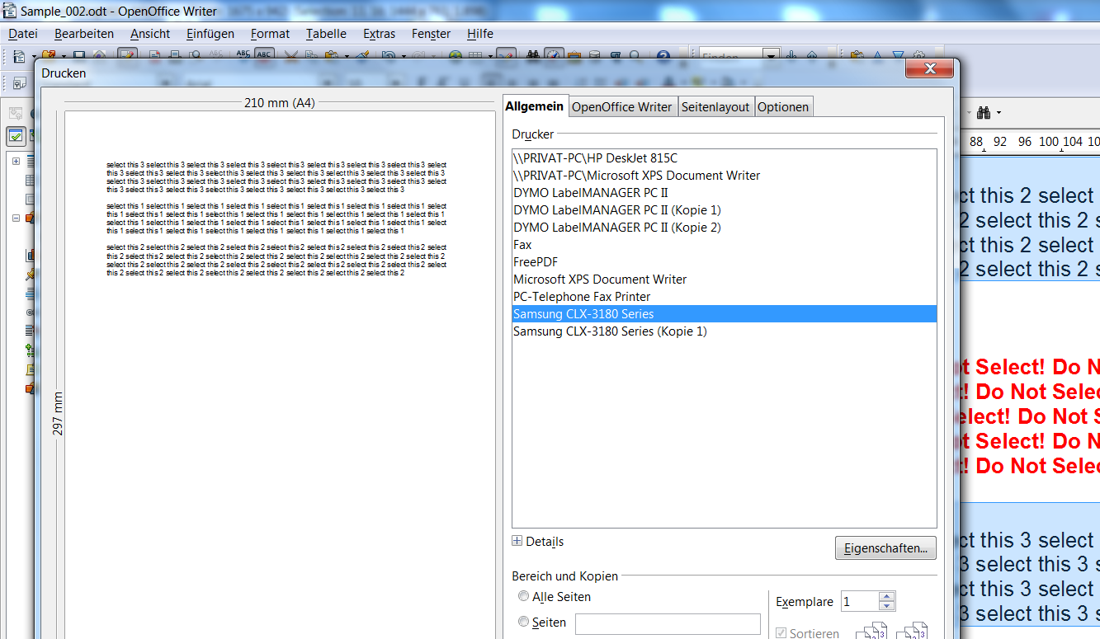
Wrong order 3-1-2
instead of
1-2-3

