Steps to reproduce the crash of Open Office Writer.
- Start Open Office Writer version 4.1.1
- Open this document “.odt”
- This document has been populated with enough User Defined Fields (UDF, for short going forward) to reproduce the crash. The fields are listed below. The filed names the same as the text and populated with the field name wrapped with a opening and closing pair of curly brackets “{{“ and “}}”.
  - Text_field_one: {{Text_field_one}}
  - Text_field_two: {{Text_field_two}}
  - Text_field_three: {{Text_field_three}}
  - Text_field_four: {{Text_field_four}}
  - Text_field_five: {{Text_field_five}}
  - Text_field_six: {{Text_field_six}}
  - Text_field_seven: {{Text_field_seven}}
  - Text_field_eight: {{Text_field_eight}}
  - Text_field_ten: {{Text_field_ten}}
  - Text_field_eleven: {{Text_field_eleven}}
  - Text_field_twelve: {{Text_field_twelve}}
- Open the Fields dialog with a CTL+F2.
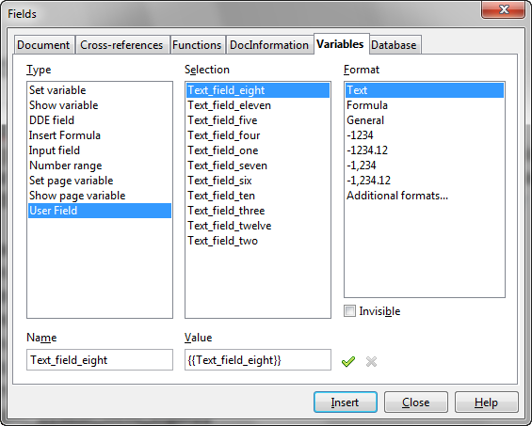
- Navigate to the “Variables” tab.
- Notice the fields.
- Close the Fields Dialog box.
- Select the first field on the Writer document and delete it.
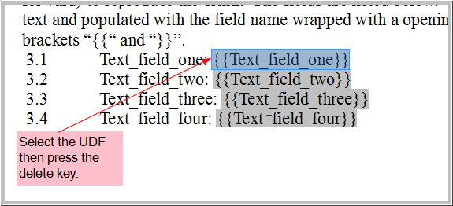
- Notice how the filed “Text_field_one” is gone from the document.
  - 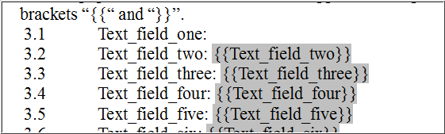
- Repeat the delete for fields “Text_field_two” and “Text_field_three”.
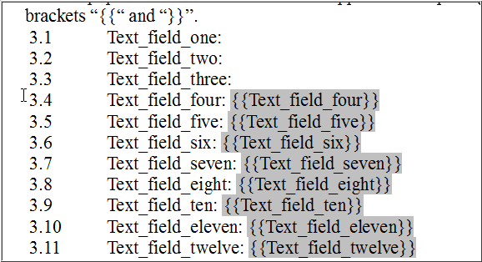
- Open the UDF Dialog by pressing CTL+F2
- Select the field just deleted “Text_field_one” and notice how the “delete” red x icon is now enabled.
- Press the red x to delete the field.
  - Notice how the UDF is now gone as one would expect.
  - 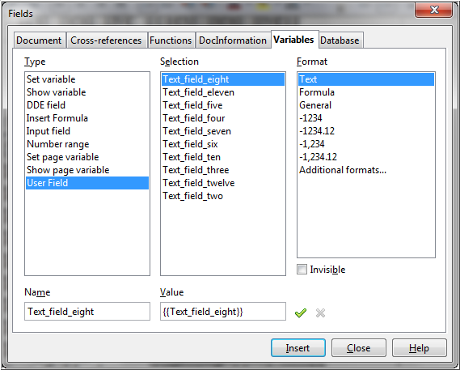
- Clear the Name field.
  - 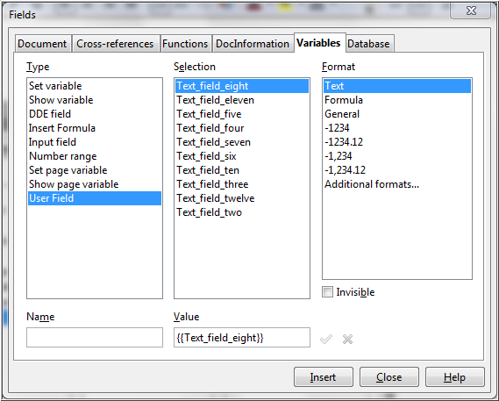
- Type in the field name “Text_field_two”.
- Notice how the red x delete icon is now enabled.
- Press the red x delete icon.
- Close the “Fields” dialog.
- Press CTL+S to save the changes.
- Crash!!!

Open the User defined field dialog box.

