HELP SEARCH BAR I TESTED:
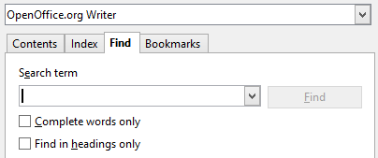

SCREENSHOT OF SEARCH FOR ‘columns’:
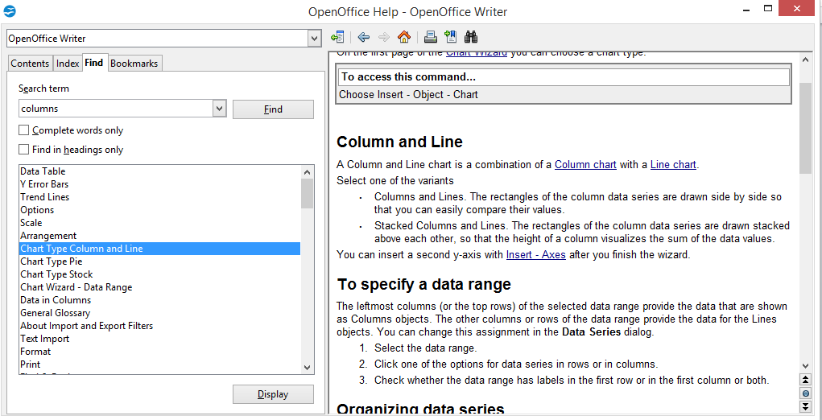

SCREENSHOT OF SEARCH FOR ‘column’:
